CERT Firefighter Rehab

In this module you will learn about:
- Introduction and Overview. What firefighter rehab is. The physiological stress on firefighters. The purpose of firefighter rehab. The CERT’s role in firefighter rehab.
- Physiological Threats to Firefighters. The heat and cold stresses on firefighters: what causes them and what the symptoms are. Three other conditions that CERT members need to be alert to: dehydration, altered mental state, and cardiac events.
- The Incident Scene. A snapshot of what happens at the scene of a fire.
- The Rehab Area. A discussion of what the rehab area is: the characteristics of a good location, what facilities might serve as a rehab area, the supplies and equipment that are needed, and the requirements for laying out the rehab area.
- The Rehab Process. A step-by-step discussion of what happens and what CERT members do in the rehab area.

[This page intentionally left blank]

Introduction and Overview

Module Purpose
The purpose of the CERT Firefighter Rehab module is two-fold:
- To train CERT members to recognize signs of physiological distress in firefighters
- To train CERT members to safely set up and perform the non-medical functions of firefighter rehabilitation

What You Will Learn
This module will cover the following topics:
- Physiological Threats to Firefighters
- The Incident Scene
- The Rehab Area
- The Rehab Process

Module Objectives
At the end of this module, you will be able to:
- Define firefighter rehab
- Identify the purpose of firefighter rehab
- Describe the physiological threats to firefighters
- Describe the primary components of firefighting
- Set up a rehab area
- Conduct rehab operations

Introduction and Overview (continued)

Definition of Firefighter Rehabilitation
Firefighter rehabilitation is the process of providing rest, rehydration, nourishment, and medical evaluation to members who are involved in extended or extreme incident scene operations.

Physiological Stress of Firefighting
Here are the reasons why rehab is needed:
- Firefighting is hot and strenuous work.
- The combination of high temperatures, hard work, and heavy equipment makes it hard for a body to cool through normal sweating.
- As a result, dehydration occurs and heat builds up. The body’s core temperature rises.
- This causes heat stress.
The effects of heat stress are:
- Fatigue
- Overexertion and strain
- Reduced situational awareness
The effects of heat stress lead to the two leading causes of injury and death for firefighters:
- Slips, trips, and falls
- Cardiac (heart attack) or cerebrovascular (stroke) events
Sometimes this hot work is done in very hot or very cold conditions and that adds additional stress.
Always consider the fitness of the firefighter. Risk factors include hypertension, high lipids, high blood glucose, overweight/obesity, inactivity, and smoking.

Introduction and Overview (continued)
About 80,000 firefighters are injured every year.
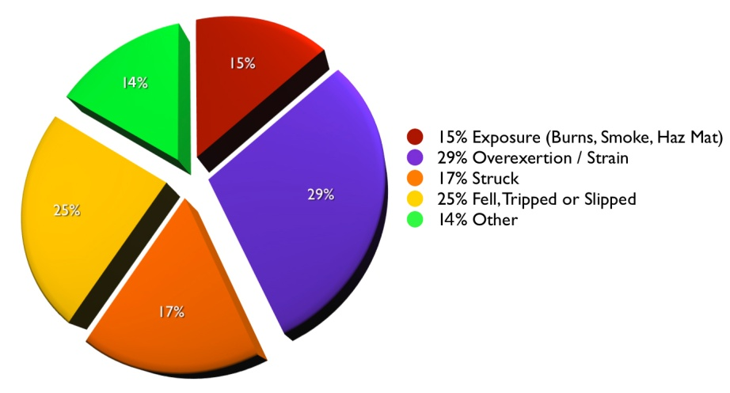
Citation: Karter, M.J., Patterns of Firefighter Fireground Injuries, NFPA 2009
About 100 firefighters die each year. Cardiac or cerebrovascular events account for approximately 50% of all annual line of duty deaths.
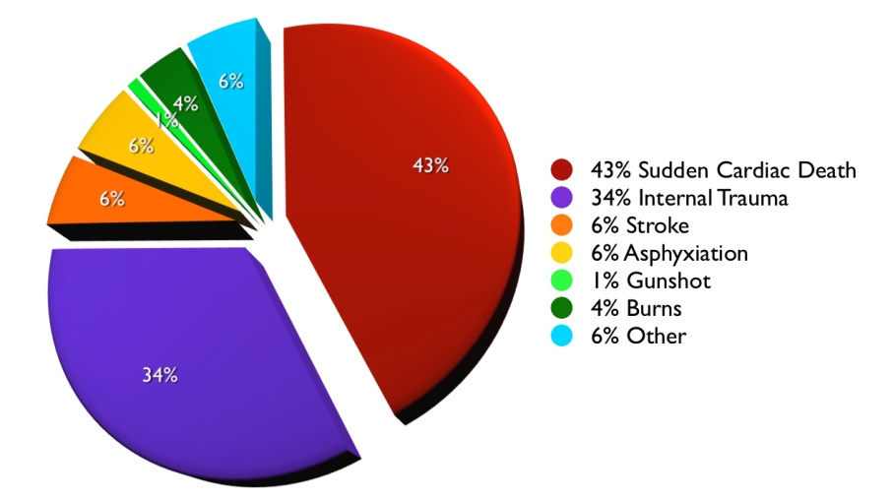
Citation: National Fire Protection Association

Introduction and Overview (continued)

Purpose of Rehab
The firefighting community is working to reduce the stress of firefighting. One way is to provide rehab during a fire.
- Firefighter rehab improves performance.
- Firefighter rehab decreases the likelihood of onscene injury or death.
- Done properly, firefighter rehab ensures that the physical and mental condition of members operating at the scene of an emergency or a training exercise does not deteriorate to a point that affects the safety of each member or that jeopardizes the safety and integrity of the operation.

NFPA 1584 Guidelines
This training is consistent with and based on NFPA 1584: Standard on the Rehabilitation Process for Members During Emergency Operations and Training Exercises. 2008 Edition. NFPA 1584 provides the following two guidelines for company or crew rehabilitation in terms of work-to-rest ratio and/or self-contained breathing apparatus (SCBA) usage:
Guideline #1: The company or crew must self-rehab (rest with hydration) for at least 10 minutes following the depletion of one 30-minute SCBA cylinder or after 20 minutes of intense work without wearing an SCBA. The Company Officer (CO) or crew leader must ensure that all assigned members are fit to return to duty before resuming operations.
Guideline #2: The company or crew must enter a formal rehab area, drink appropriate fluids, be medically evaluated, and rest for a minimum of 20 minutes after any of the following:
- Depletion of two 30-minute SCBA cylinders
- Depletion of one 45- or 60-minute SCBA cylinder
- Whenever encapsulating chemical protective clothing is worn
- Following 40 minutes of intense work without an SCBA

Introduction and Overview (continued)
Variation
According to NFPA 1584, if members enter the rehab area prior to going through two 30-minute SCBA cylinders (or any other of the criteria listed above in Guideline #2):
- They still must be medically evaluated and drink fluids.
- However, their rest period may be lowered to only 10 minutes before they are allowed to return to duty, if they are fit to do so.

CERT Members and Rehab
Many fire departments may need additional help to effectively handle the rehab when responding to an incident. So they are turning to their CERTS for help.
CERT members will provide a critical service that directly affects the health and safety of firefighters.
- Rest and recovery
- Relief from incident, environmental conditions
- Rehydration
- Nourishment
- Documentation
- May assist with medical monitoring
If you can do firefighter rehab, you can do any kind of rehab.

Physiological Threats to Firefighters
In this topic, you will look in more detail at the stresses on a firefighter. Those threats include prolonged exposure to extreme thermal conditions as well as the firefighter’s personal protective equipment (PPE). It’s important to look at those conditions in more detail so CERT members understand what they will see in the rehab area.

Heat Stress

Definition
Heat stress is a group of conditions caused by overexposure to or overexertion in excess environmental temperatures.
Heat stress is covered in CERT Basic Training. Types of heat stress in increasing severity include:
- Heat cramps or muscle spasms
- Heat exhaustion, when working in extreme heat causes heavy sweating and loss of body fluids. Blood flow to the skin increases, causing blood flow to decrease to the vital organs.
- Heat stroke, when the individual’s temperature reaches 104°F. or higher and the body’s temperature control system shuts down. The body temperature can rise so high that brain damage and death may result.
Causes
The amount of heat exposure is affected by a number of things. Here are some questions that CERT members in a firefighter rehab should ask themselves:
- What is the outside temperature? The hotter day will be worse.
- How humid is it? The higher the relative humidity, the less evaporation can occur to remove heat.
- How windy is it? Moving air transfers more heat than still air.
- Are they working in direct sunlight? Exposure to direct sunlight will also increase apparent temperature by about 10°F.

Physiological Threats to Firefighters (continued)
- How close are they to the flame front? Working inside a structure is hot work.
- Are they kneeling or crawling on hot surfaces?
- Is this a chemical or flammable fuel fire? Exposure is much more severe in those fires.
In addition to the air temperature itself, water and steam transfer heat many times faster than air. This creates additional heat exposure for firefighters.

Symptoms
The following are symptoms of heat stress:
- “Beet red” face
- Heavy sweating
- Lack of perspiration
- Headache
- Muscle cramping
- Nausea or vomiting
- Altered mental state
- Shortness of breath
- Dizziness
- Extreme weakness or exhaustion
- Seizure

Physiological Threats to Firefighters (continued)

Cold Stress
Causes
Issues related to cold are primarily frostbite, slips, and falls. It doesn’t take sub-freezing temperatures to make the mixture of wet and cold very dangerous. Temperatures between 32°F and 55°F can cause cold injuries. Here are some questions that CERT members in a firefighter rehab should ask themselves:
- What is the outside temperature? The colder the temperature the greater chance of localized cold injuries.
- How windy is it? The wind increases the transfer of heat away from a person’s body. It also can harm exposed skin.

Symptoms
The following are symptoms of cold stress:
- Altered mental status/confusion
- Extreme weakness/exhaustion
- Headache
- Numbness
- Waxy, pale skin
- Muscle rigidity

Three Other Conditions
Three other conditions have been mentioned that CERT members need to be alert for. These are:
- Dehydration
- Altered mental state
- Cardiac event

Physiological Threats to Firefighters (continued)
Signs of Dehydration
Other than expressions of thirst, signs of dehydration include low urine volume, urine with a strong odor, and urine of a dark color.
Signs of Altered Mental State
- Confusion
- Disorientation (to self, time, place)
- Loss of alertness
- Poor judgment
- Erratic thought process
- Disruptions in perception and behavior
Signs of a Cardiac Event
- Altered mental status
- Ashen/gray/white skin color
- Chest pain
- Jaw pain
- Unexplained neck/shoulder/arm pain
- Headache
- Nausea/vomiting
- Shortness of breath
- Excessive perspiration
- Heartburn/indigestion

Physiological Threats to Firefighters (continued)
- Person may say “I just don’t feel well” or “I just don’t feel right”
- Holding fist to chest is the universal sign of cardiac stress

Firefighter PPE Demonstration
- Protective garments
- Helmet
- Hood
- Eye/face protection
- Gloves
- Footwear
- Respiratory protective devices
- SCBA (self-contained breathing apparatus)

The Incident Scene
There is an unlimited range of fire situations. What one might find at a fire scene will depend on several factors:
- Type and extent of incident
  - Single-family residence
  - Commercial
  - High-rise
  - Wildland
  - Hazmat
- Length of time to fight fire
  - Depends on the extent of the fire
- Environmental elements
  - Climatic conditions
Regardless of the scene, firefighting follows the same protocols:
- Provide fire support (truck work/ladder)
  - Rescue
  - Salvage
  - Overhaul
  - Ventilation
- Extinguish the fire (engine work/water)

The Rehab Area
Before learning what to do in the rehab area, CERT members need to understand what the rehab area is. This section covers the following topics:
- Location
- Facilities
- Equipment and Supplies
- Setup
Protocols in your local area will be provided.
In some fire departments, CERTs will come in and assist with a rehab unit that is already set up. In other fire departments, CERTs may set up and run the rehab themselves, under directions from the Incident Commander (IC).

Location
In most situations the IC will specify where to set up the rehab area. However, there may be occasions where the CERT is told to set up the rehab area. Here are the requirements for the rehab area location:
- It must be approved by the IC.
- It must protect from the elements.
  - For hot environments, it must include shade and/or air conditioning and a place to sit.
  - For cold or wet environments, it must provide dry protected areas out of the wind, heated areas, and a place to sit.
- It must provide refuge from the incident.
  - It must be a sufficient distance from the effects of the operation that firefighters can safely remove their PPE and can be afforded physical and mental rest.
- It must provide protection from the prevailing environmental conditions.
  - Free from exhaust fumes, smoke, and toxins

The Rehab Area (continued)
- It must be large enough to accommodate multiple crews and rehabilitation personnel.
  - Rehabilitation personnel include Emergency Medical Services (EMS) and CERT members.
- It must be located near or with EMS.
  - There will be medical monitoring at the rehab area.
  - There must be easy access to medical treatment and transport if necessary.
Multiple Locations
If the location becomes inundated with smoke, the IC must be alerted and the location must be changed.
There may be a need for more than one location:
- If the incident is big
- If there are barriers that keep firefighters from getting to the rehab area
If there is more than one rehab area, each area is given a geographic name consistent with its location at the incident site. For example: Rehab North is on the north side of the incident.

Facilities

Options for Rehab Facilities (Reminder: The facility must meet the requirements discussed earlier [see Location]).
- Preexisting structures (lobby, building, garage)
- Tent or awning
- Tarps
- Large tree or overhang
- School or municipal bus, or any enclosed vehicle

The Rehab Area (continued)

Equipment and Supplies
Here is the list of supplies and equiment that are needed for rehab. CERT members should know that all of these supplies are not always available.
- Cover
  - Awnings or tents
  - Tarps
- Seating
  - Folding chairs
  - Benches with a back
- Cooling and heating
  - Buckets and freezers for ice and water
  - Fans or misting machines
  - Forearm immersion equipment
  - Portable heaters
  - Blankets and towels
- Washing equipment
  - Basins
  - Soap
  - Water
  - Towels
  - Hand sanitizer

The Rehab Area (continued)
- Other
  - Flood lights
  - Clipboards, forms, writing implements
  - Cups (hot and cold)
  - Beverage serving equipment
  - Paper towels
  - Electrical generating equipment
  - Large clock
  - Traffic cones, signs, fireline tape
  - Sanitary facilities
  - Trash receptacles
- Dry gloves, socks, and sweatshirts
- Food
  - Nutritious food that is calorie dense or contains a mix of carbohydrate and protein
  - Examples: power bars, protein bars, meal replacement bars, granola bars, trail mix, frozen peanut butter and jelly sandwiches, hot soup (in cold weather)
- Beverages
  - Water
  - Sports drinks (for electrolyte replacement)
  - Hot fluids in cold weather (coffee, tea, hot chocolate, hot lemonade, hot cider)
  - Fluids at a range of temperatures (room temperature, cold, iced)

The Rehab Area (continued)
The following food and beverages should not be provided:
- Caffeinated and carbonated beverages
- Simple sugars (candy, baked goods) (absorbed too quickly)
- Complex carbohydrates (raw fruit, vegetables, whole grains, beans) (take too long to digest)
- Tobacco

Sample Setup

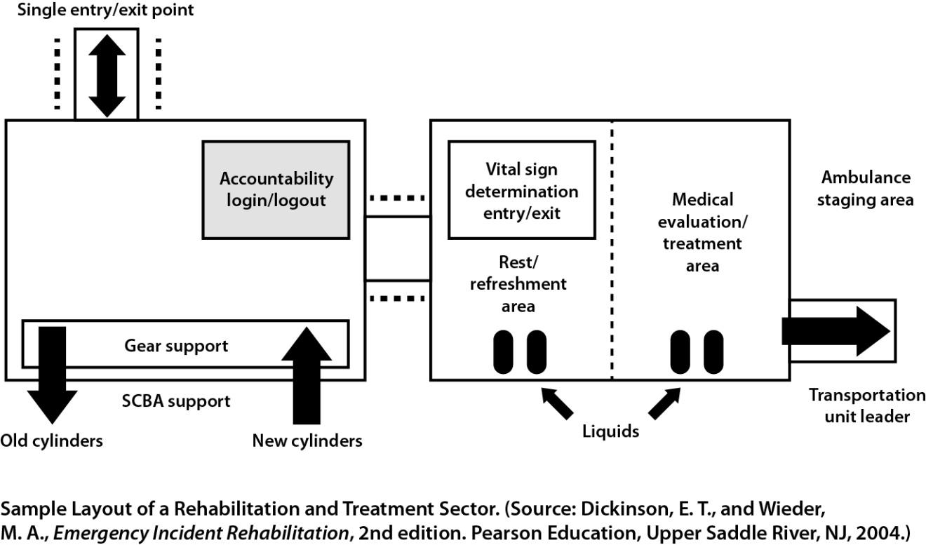

The Rehab Area (continued)
This sample shows what areas are needed, but the layout will vary depending on the incident location and the facilities available.
Entry/exit
- There should be a single point of entry to and exit from the rehab area.
Accountability login/logout
- Firefighters will be checked in and out.
Gear storage area and hand washing area
- Firefighters must remove soiled gear and wash or sanitize hands before entering the rest and refreshment area.
- Firefighters may need some assistance removing gear.

Vital sign determination entry/exit
- All firefighters are evaluated as they enter the rehab area and before they leave the rehab area.

Rest/recovery area
- Food and beverages are provided.
- There is a place for firefighters to sit.
- Cooling and heating are provided as needed.

Medical evaluation/treatment area and ambulance staging area
- Self-explanatory

Wildland Fires
If a CERT is ever called to assist in a wildland fire, Incident Command will tell the CERT where the rehab should be located and how the rehab will be run.

The Rehab Area (continued)

Activity: Establishing a Rehab Area
Purpose: To think about how to establish a rehab area.
Instructions: Follow the steps below.
- As a group, discuss each the three questions for each of the scenarios:
- There is space to record responses on the worksheets.
Scenario #1:
A single-family home in a suburban neighborhood is on fire. Houses in this neighborhood are about 50 feet apart. There are no driveways. The house is near the intersection with another quiet street. The temperature is in the 50s.

What do you need to consider when looking for a rehab area location?

What kind of facility might be available?

What supplies will you need?

Scenario #2:
Several floors of a six-story apartment building are on fire. The building is between two moderately busy four-lane roads in a mixed commercial and residential area. It is a hot and humid day.

What do you need to consider when looking for a rehab area location?

What kind of facility might be available?

What supplies will you need?

Scenario #3:
A tanker truck and several cars have crashed on an interstate highway in a fairly rural area. It is a windy day – steady at 25 mph from the southwest. The temperature is in the 40s. The tanker contents are unknown.

What do you need to consider when looking for a rehab area location?

What kind of facility might be available?

What supplies will you need?

Scenario #4:
There is a fire in a free standing shopping mall surrounded by parking lots. The fire is in the northeast corner, involving three stores. The temperature is in the upper 20s. Light snow and sleet are falling.

What do you need to consider when looking for a rehab area location?

What kind of facility might be available?

What supplies will you need?

The Rehab Process
In this topic you will learn what happens in each part of the rehab area and what the CERT members’ roles are.

CERT Safety
The CERT member’s first responsibility is personal safety. Follow these safety guidelines in the rehab area.
- PPE
  - Wear reflective vests and gloves.
  - Hard hats are not needed in the rehab area, but keep them nearby in case of flying debris.
- Avoid smoke as it may contain hazardous chemicals.
- Wear exam gloves to remove a firefighter’s gear.
  - The gear may contain hazardous material.
- Rehab for CERT members
  - Team members may be working long hours.
  - Take breaks and replenish food and water.

Overview of Rehab Operations
Reminder: A standard operating guideline for rehab has been developed by the National Fire Protection Association (NFPA). This training is based on that operating guideline – NFPA 1584 Standard on the Rehabilitation Process for Members During Emergency Operations and Training Exercises. 2008 Edition.
Rehab and Incident Command Structure (ICS)
See the two flowcharts in the Participant Manual and on the next page of the Instructor Guide.
In a large operation, rehab operations will fall under the Medical Unit. In a small operation, rehab could fall directly under the IC.
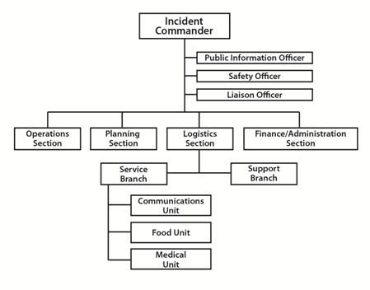

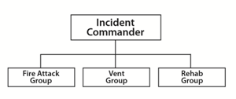

The Rehab Process (continued)

Putting It All Together (Order of Rehab Operations)
- CERT members are mobilized for firefighter rehab.
- CERT members arrive on the scene dressed in PPE.
- The IC chooses a rehab leader.
- If setup is required, the IC chooses a rehab location or directs CERT members to choose a location.
- CERT members set up a rehab area with the equipment and supplies that are available.
- As firefighters head to the rehab area, CERT members direct them where to enter and sign them in.
- CERT members assist with gear removal and offer water immediately.
- EMS provides medical assessment while CERT members record data.
- CERT members continually do the following in the rest and recovery area:
  - Offer beverages and nutrition.
  - Provide cooling and heating as appropriate.
  - Monitor for signs of distress.
- If a firefighter is distressed:
  - CERT members alert rehab leader immediately.
  - The firefighter is moved to the medical area.
- Firefighters ready to go back to active duty are signed out by CERT members and leave through the rehab exit area.

The Rehab Process (continued)

1. CERT members are mobilized
Firefighter rehab is never mobilized through self-deployment. The CERT will be notified by Incident Command through local protocol when it is needed for firefighter rehab.

2. CERT members arrive in PPE
Appropriate PPE includes reflective vest, gloves, and helmet.
CERT members report to the Incident Command Post.

3. IC chooses a rehab leader
Following NIMS/ICS protocol, the IC designates a supervisor/leader for the rehab area. This person is the liaison to the IC.
Ideally, a firefighter will be in charge of the rehab area, as firefighters may not listen to a CERT member or EMS member telling them not to go back into the fire. However, this may not always be possible.
Rehab Leader Responsibilities
- Responsible for the safety of the rehab team
- Responsible for setup, operations, and stand down
- Notifies EMS when a firefighter needs additional assistance
- Handles logistics and ensures that there are sufficient supplies
- Has a plan in place for replenishing water and supplies
Rehab Team Accountability
Accountability is a key component of the NFPA 1584 standard operating guideline. There must be an accountability system for the rehab team.
- The rehab leader knows who to report to.

The Rehab Process (continued)
- The names of all team members are recorded.
- The rehab leader briefs team members on their roles and tasks.
- All documentation is returned to the rehab leader at the end of the operation.

4. Rehab location chosen
- Protects from the elements (hot and cold)
- Provides refuge from the incident
- Provides protection from the prevailing environmental conditions (exhaust, smoke, toxins)
- Is large enough to accommodate multiple crews and rehabilitation personnel
- Is located near or with EMS
- Is approved by IC

5. Set up rehab area
The rehab area is set up with supplies that are already available.

6. Firefighters sign in
CERT members may need to establish a way or a person to direct firefighters to the correct entry point where they will need to sign in.
Just as with the rehab team, there must be an accountability system for the firefighters.
- Firefighters check in as they arrive at the rehab area.
- The names of the firefighters and their arrival times are recorded on an official rehab check-in and check-out sheet.
See the sample Rehab Area Check-In/Check-Out Sheet on the next page.

Rehab Area Check-In/Check-Out Sheet
Crews operating on the scene: ________________________________________________________________________________________________________________________________________________________________
Unit No. | Member | Time In | Time Out |  |  | Unit No. | Member | Time In | Time Out

The Rehab Process (continued)

7. Gear is removed; water is provided
Water should be offered immediately.
As soon as the firefighter checks in, he or she removes his or her gear, including the empty SCBA cylinder.
- Firefighters should “dress down” by removing their bunker coats, helmets, and hoods, and by opening their bunker pants to promote cooling.
- CERT members may need to help with gear removal, making sure to wear gloves.
Firefighters should wash or sanitize their hands and face before moving into the rest and refreshment area. This prevents contaminating food and beverages with remnants of the fire.

8. EMS provides medical assessment
As the firefighter enters the rest and nourishment area, EMS personnel will do an initial assessment of vital signs (heart rate, blood pressure, respiration, and pulse). A CERT member may be asked to assist by recording the vitals.
This assessment is repeated every 10 minutes.
See the sample report, Incident Rehab – Individual Rehabilitation Report, on the next page.

Incident Rehab - Individual Rehabilitation Report

Incident Location __________________________ Date ______________ Time _________Rehab Manager _______________
Name  Age/Height/Weight | Time  In/Out | # SCBA  Cylinders | Exam  Period | BP | Pulse | Resp | SpO₂ | SpCO | Temp | Skin | COOLING/  HEATING | HYDRATION /  NOURISHMENT | MEDICAL  COMPLAINTS | Transport  Y / N
 |  |  | INITIAL
 |  |  | 10 Min.
 |  |  | 20 Min. |  |  |  |  |  |  |  |  |  | (Glucose _____)
 |  |  | 30 Min. |  |  |  |  |  |  |  |  |  | (Glucose _____)
 | Prior Activity:
 |  |  | INITIAL
 |  |  | 10 Min.
 |  |  | 20 Min. |  |  |  |  |  |  |  |  |  | (Glucose _____)
 |  |  | 30 Min. |  |  |  |  |  |  |  |  |  | (Glucose _____)
 | Prior Activity:
 |  |  | INITIAL
 |  |  | 10 Min.
 |  |  | 20 Min. |  |  |  |  |  |  |  |  |  | (Glucose _____)
 |  |  | 30 Min. |  |  |  |  |  |  |  |  |  | (Glucose _____)
 | Prior Activity:
 |  |  | INITIAL
 |  |  | 10 Min.
 |  |  | 20 Min. |  |  |  |  |  |  |  |  |  | (Glucose _____)
 |  |  | 30 Min. |  |  |  |  |  |  |  |  |  | (Glucose _____)
 | Prior Activity:

The Rehab Process (continued)

9. Rest and recovery activities
Firefighters need to rest in the rehab area for at least 10-20 minutes. Having a large clock makes it easier to monitor time. During that time it is best if the firefighters can sit.
CERT members have three tasks in the rest and recovery area:
- Offer beverages and nutrition.
- Provide cooling and heating as appropriate.
- Monitor for signs of distress.
Rehydration
Follow these guidelines.
- Have fluids available at all times.
  - Firefighters are often dehydrated at the start of their work.
  - Firefighting activities cause profuse sweating.
  - Fluids must be replaced quickly and aggressively.
- Always offer water.
- After the first hour of firefighting, provide a sports drink containing electrolytes.
Nourishment
Follow these guidelines.
- Have appropriate food available in the rehab area (see the section on Equipment and Supplies).
- During long operations, encourage firefighters to eat.

The Rehab Process (continued)
Cooling
There are two kinds of cooling:
- Passive
- Active
Passive cooling is enough in many situations:
- Remove gear and allow the body to cool naturally.
- Sit in a shaded area.
- Drink cool or iced fluids.
Some situations require active cooling:
- Whenever there is the potential for heat stress (temperatures, conditions, and/or workload)
- After the second and each subsequent SCBA tank
Follow these guidelines for active cooling:
- Apply wet towels around the firefighter’s head and neck.
- Have firefighters sit in front of a misting system/fan or in an air-conditioned area.
- Submerge the firefighter’s hands and arms in water. (NOTE: Do not add bleach to water as it can damage PPE.) This method has been found to lower core temperatures quickly.

The Rehab Process (continued)
Warming
Follow these guidelines for how to help warm up firefighters:
- Have firefighters move to a dry, heated area that is protected from the elements (wind, snow, rain).
- ONLY remove wet gear if there is a heated area and warm, dry clothing available.
  - Offer dry socks or clothing if gear is removed.
- Encourage firefighters to drink warm fluids.
Monitor physical status
CERT members will continuously monitor a firefighter’s physical status while he or she is in the rehab area as it can change suddenly.
Firefighters coming out of a fire are expected to be hot, flushed, sweaty, and tired. However, conditions should improve pretty quickly. One tip is to get a sense of how the firefighter looks when first leaving the fire in order to gauge improvement.
- Check mental status
  - See if the firefighter can make eye contact.
  - Ask questions to see if the firefighter is oriented to person, place, and time.
  - See if the firefighter can respond coherently and logically.
- Watch for signs of distress. (See Physiological Threats to Firefighters for details on what to look for.)
  - Look for signs of heat stress/dehydration.
  - In cold weather, look for signs of cold stress.
  - Watch for signs of a cardiac event.

The Rehab Process (continued)

10. If a firefighter is distressed
Follow these guidelines:
- If a CERT member sees any indication that a firefighter is in trouble, the CERT member must notify the rehab leader immediately.
  - The indication may be as simple as a firefighter saying, “I don’t feel good.”
- The rehab leader will notify EMS immediately and may alert Incident Command if appropriate.
- EMS will then be responsible for treatment.

11. Firefighters sign out
The firefighters sign out at the same place they signed in.
See sample Rehab Area Check-In/Check-Out Sheet.

One Exception
Some jurisdictions may allow a member of the rehab team to leave the rehab area. If that is the case, CERT members should provide water closer to the fire scene to assist firefighters with self-rehab.

Activity: Rehab Area Operations
Purpose: To practice setting up and running a rehab area.
Instructions:
- See the instructions on the next page on how the activity will run.
- Start the activity.
  - Identify initial roles: 3-4 minutes
  - Set up rehab area: no more than 5 minutes
  - Process firefighters: about 25 minutes

The Rehab Process (continued)
Instructions:
Break into groups of 10. Each group will do the following:
- Identify a rehab leader.
- Identify who will begin the activity in the following roles. NOTE: During the activity each person will play at least two roles:
  - Someone to check in and check out firefighters
  - Someone to work in the gear removal area
  - Someone to be an EMT
  - Someone to assist the EMT
  - Two people to work in the rest and recovery area
  - Three people to be firefighters
- As a group, set up the rehab area. This should take no more than 5 minutes. You can use materials in the room.
  - Entry/exit point
  - Gear storage area
  - Initial medical assessment area
  - Rest and recovery area
- When the area is set up, begin to process the firefighters by following steps 6-11 of the Order of Rehab Operations on p. xx in your Participant Manual. Also use the sample Rehab Area Check-In/Check-Out Sheet and Incident Rehab – Individual Rehabilitation Report form.
- Each firefighter should be cleared to return to the fire after 2-3 minutes in the rehab area.
- After a firefighter exits, he or she should replace one of the rehab team members who then becomes a firefighter.
- The activity concludes when everyone has had a chance to be a firefighter.

Module Summary
Review of CERT Basic Training Concepts
These topics were discussed in this module:
- Introduction and Overview
  - Definition of firefighter rehab
  - Stresses on firefighters
  - Purpose of firefighter rehab
  - CERT’s role in firefighter rehab
- Physiological Threats to Firefighters
  - Heat stress
  - Cold stress
  - Resulting dehydration, altered mental state, and cardiac events
- The Incident Scene
  - What happens at the scene of a fire
- The Rehab Area
  - The characteristics of a good location
  - What facilities might serve as a rehab area
  - The supplies and equipment that are needed
  - The requirements for laying out the rehab area
- The Rehab Process
  - An overview and details of the steps of rehab operations

[This page intentionally left blank]

