CERT Firefighter Rehab

In this module you will learn about:

- Introduction and Overview. What firefighter rehab is. The physiological stress on firefighters. The purpose of firefighter rehab. The CERT’s role in firefighter rehab.
- Physiological Threats to Firefighters. The heat and cold stresses on firefighters: what causes them and what the symptoms are. Three other conditions that CERT members need to be alert to: dehydration, altered mental state, and cardiac events.
- The Incident Scene. A snapshot of what happens at the scene of a fire.
- The Rehab Area. A discussion of what the rehab area is: the characteristics of a good location, what facilities might serve as a rehab area, the supplies and equipment that are needed, and the requirements for laying out the rehab area.
- The Rehab Process. A step-by-step discussion of what happens and what CERT members do in the rehab area.

[This page intentionally left blank]
Learning Objectives/ Performance Outcomes | At the conclusion of this module, the participants will be able to:  - Define firefighter rehab.  - Identify the purpose of firefighter rehab.  - Describe the physiological threats to firefighters.  - Identify the primary causes of injury to firefighters.  - Identify the primary injuries resulting from firefighting.  - Describe the primary components of firefighting.  - Set up a rehab area.  - Identify the characteristics required of a rehab location.  - Identify the types of equipment and supplies needed for firefighter rehab.  - Explain how to set up a safe firefighter rehab operation.  - Conduct rehab operations.  - Describe how to maintain personal safety at the fire scene.  - Identify how rehab fits into the Incident Command structure.  - Describe the responsibilities of the rehab leader.  - Describe the rest and recovery component of firefighter rehab.  - Explain how to provide firefighters with relief from the incident and environmental conditions.  - Describe how to encourage rehydration in firefighters.  - Identify types of nourishment to provide at firefighter rehab.  - Describe signs to watch out for when monitoring the physical status of firefighters.  - Explain what CERT members should do if they recognize signs of a distressed firefighter.  - Describe the systems used to account for the rehab team and the fire team.  - Describe the order of operations for firefighter rehab.  - Demonstrate the ability to perform various functions of firefighter rehab.
Scope |  | The topics that will be discussed in this module are:  - Introduction and Overview  - Physiological Threats to Firefighters  - The Incident Scene  - The Rehab Area  - The Rehab Process  - Module Summary
Estimated Completion Time |  | 4 hours
Training Methods |  | In the Introduction and Overview section, the instructor welcomes participants to the training session, facilitates participant introductions, and reviews the module purpose, objectives, and agenda. The instructor then conducts a discussion of what firefighter rehab is, the physiological stress on firefighters, the purpose of firefighter rehab, and the CERT’s role in firefighter rehab.  In the Physiological Threats to Firefighters section, the instructor and class explore the stresses on a firefighter: heat stress and cold stress. In particular, three conditions are highlighted that are related to heat and cold stress: dehydration, altered mental state, and cardiac events. At the end of this section, a firefighter demonstrates all the gear that a firefighter wears. Participants try on and handle the gear.  In The Incident Scene section, the instructor talks about 2-3 fires he or she has fought to give CERT members an appreciation for the fire scene: what happens and what it feels like.  In The Rehab Area section, the instructor and class look at specifics about the rehab area: the characteristics of a good location, what facilities might serve as a rehab area, the supplies and equipment that are needed, and the requirements for laying out the rehab area. This section should be modified as needed to be consistent with local policies and procedures.
Training Methods (continued) |  | The section ends with an exercise in which the instructor reads four scenarios and participants respond to three questions about each scenario:  - What do you need to consider when looking for a rehab area location?  - What kind of facility might be available?  - What supplies will you need?  In the final section, The Rehab Process, the instructor first reviews CERT safety in the firefighter rehab area. The instructor then provides an overview of rehab operations and provides more details on each:  - CERT members are mobilized for firefighter rehab  - CERT members arrive in personal protective equipment (PPE)  - Incident Commander (IC) chooses a rehab leader  - Rehab location chosen  - CERT members set up rehab area  - Firefighters sign in  - Gear is removed and water is provided  - Emergency Medical Services (EMS) provides medical assessment  - Rest and recovery activities  - If a firefighter is distressed  - Firefighters sign out  This section concludes with a large-group (10 people) activity in which participants role play setting up and running a rehab area.  This section must be tailored to be consistent with local policies and procedures. Note that participants will use the sample Rehab Area Check-In/Check-Out Sheet and Incident Rehab – Individual Rehabilitation Report form from the Participant Manual during this activity. If participants will use local forms, provide blank copies.
Resources Required |  | - Community Emergency Response Team Firefighter Rehab Instructor Guide (for instructors)  - Community Emergency Response Team Firefighter Rehab Participant Manual (for participants)  - PowerPoint slides 0 to 62
Equipment |  | The following equipment is required for this module:  - A computer with PowerPoint software  - A computer projector and screen  - Masking tape  - Easel pad and easel or whiteboard  - Markers  - A firefighter in full gear  - Bunker coats, if possible
Preparation |  | - Identify potential liability issues for CERT volunteers assisting with firefighter rehab.  - Coordinate with the Fire Chief or designee before the training is given.  - Inform the Fire Chief or designee of the services CERT members would be able to provide after taking this training.  - Ask the Fire Chief or designee to review the training to see if it aligns with the needs of the fire department.  - Review this module and add local information wherever requested.  Introduction and Overview  In the first section, Introduction and Overview, the instructor provides details about the role CERT members will play locally in rehab. You will need to identify what those roles will be.
Preparation (continued) |  | Physiological Threats to Firefighters  In the second section, Physiological Threats to Firefighters, arrange for a firefighter to demonstrate his or her full gear and tank. The purpose of the demonstration is for CERT members to understand how heavy the gear is, how difficult it is to remove, and how it should be removed. The firefighter should explain what he or she is wearing and how it is removed (CERT members may need to assist with removal in rehab). He or she should demonstrate:  - Protective garments (gear)  - Helmet  - Hood  - Eye/face protection  - Gloves  - Footwear  - Respiratory protective devices  - SCBA (self-contained breathing apparatus)  Participants should be able to pick up and handle the equipment.  The Incident Scene  CERT members have limited understanding of the fire scene. Prepare 2-3 descriptions of fires you have fought to give CERT members an appreciation for the fire scene: what happens, what it feels like.  The Rehab Area and The Rehab Process  The fourth section, The Rehab Area, and the fifth section, The Rehab Process, are generic. Modify them to make them consistent with local policy and procedures.
Preparation (continued) | For example, you will need to know:  - How the CERT will be activated (pagers, phone system, etc.)  - When the CERT will be activated (for every fire, only after the fire has been burning a certain amount of time, etc.)  - How the rehab equipment will be supplied and how resources will be replenished  - The role CERT will play in rehab (setting up, choosing location, checking vitals, etc.)  The Rehab Process Activity  If possible, provide 2-3 coats per group for the firefighter role-players.  - Determine when to take a 20-minute break. A good time would be right before the fourth section, The Rehab Area.
Participant Prerequisites | Participants must have completed CERT Basic Training and FEMA ICS-100, Introduction to Incident Command System (ICS).
Instructor Qualifications | Instructors for the CERT Firefighter Rehab module should have the following qualifications:  - Familiarity with CERT  - Anatomy and physiology background  - Fire service background  - Familiarity with the local emergency management system  - Instructional experience  The ideal instructor for this module is a CERT instructor with a background in fire service or a firefighter with instructional experience and familiarity with CERT.  If the primary instructor for the CERT Firefighter Rehab module has not completed CERT Basic Training and CERT Train-the-Trainer, it is recommended that either the CERT Program Manager or a CERT-qualified instructor also be present in the classroom.
Notes | A suggested time plan for this module is as follows:  Introduction and Overview 30 minutes  Physiological Threats to Firefighters 45 minutes  The Incident Scene 20 minutes  The Rehab Area 20 minutes  Activity: Establishing a Rehab Area 25 minutes  The Rehab Process 45 minutes  Activity: Rehab Area Operations 50 minutes  Module Summary 5 minutes  Total Time: 4 hours (includes 20 minutes for breaks)
Remarks | The National CERT Program would like to thank the following people who participated in a focus group to develop this training module:  Craig A. Haigh  Hanover Park (IL) Fire Chief  University of Illinois Fire Service Institute Field Staff Instructor  Clark Hurlburt  Hamden (CT) Dep. Fire Chief (ret)  John Moede  Scottsdale (AZ) Emergency Manager  Dr. Denise Smith  Skidmore College (NY) Professor  Illinois Fire Service Research Scientist  Robert Swofford  Spartanburg County (SC) Emergency Management Research Analyst/CERT Coordinator

[This page intentionally left blank]

CERT Firefighter Rehab

Instructor guidance | Content
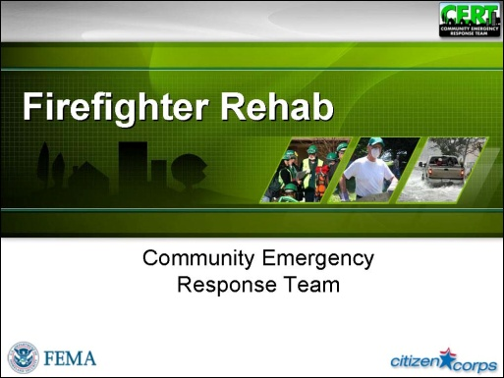  Display Slide 0 | Introduction and Overview  Welcome and Introductions  Welcome the participants to the CERT Firefighter Rehab supplemental training.  Introduce yourself and provide some background information about your past experience with the fire service and with CERT.  Ask other instructors to introduce themselves in the same way.
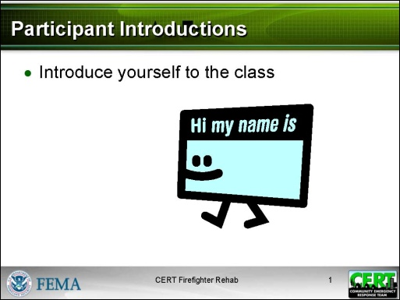  Display Slide 1 | Participant Introductions  Develop a class roster by passing around a sheet of paper and asking the participants to write down their contact information, or having them check in on a roster already developed from pre-registration information.  If participants do not already know each other, have participants introduce themselves by giving their names.
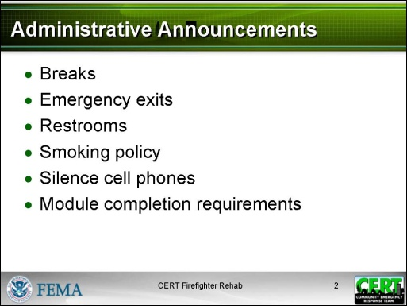  Display Slide 2 | Administrative Announcements  Make any necessary announcements such as:  - Schedule of breaks for this session  - Emergency exits  - Restroom locations, smoking policy, silencing cell phones, etc.  - Module completion requirements (must attend entire session)
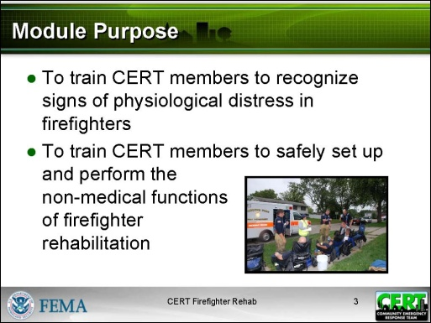  Display Slide 3 | Module Purpose  Explain that the purpose of the CERT Firefighter Rehab module is two-fold:  - To train CERT members to recognize signs of physiological distress in firefighters  - To train CERT members to safely set up and perform the non-medical functions of firefighter rehabilitation
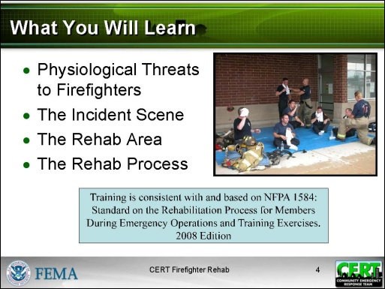  Display Slide 4 | What You Will Learn  List the topics that will be covered in the module:  - Physiological Threats to Firefighters  - The Incident Scene  - The Rehab Area  - The Rehab Process
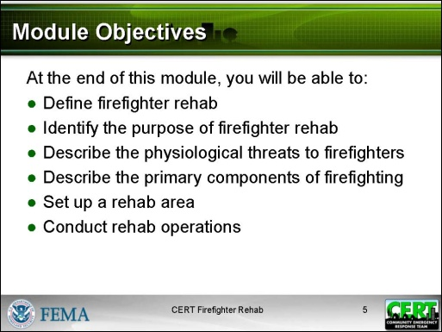  Display Slide 5 | Module Objectives  Say that, at the end of this module, participants will be able to:  - Define firefighter rehab.  - Identify the purpose of firefighter rehab.  - Describe the physiological threats to firefighters.  - Describe the primary components of firefighting.  - Set up a rehab area.  - Conduct rehab operations.
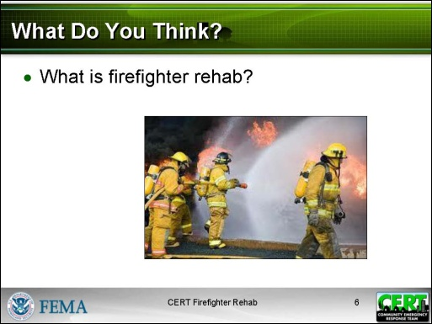  Display Slide 6  Conduct a short discussion based on this question. | What Do You Think?  Ask participants:  - What is firefighter rehab?
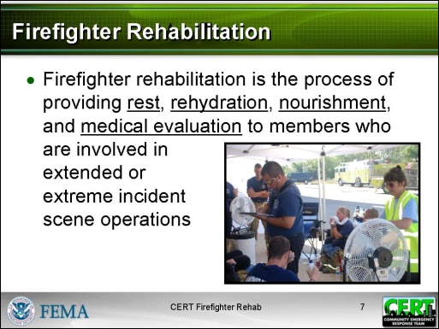  Display Slide 7 | Provide a definition of firefighter rehabilitation.  - Firefighter rehabilitation is the process of providing rest, rehydration, nourishment, and medical evaluation to members who are involved in extended or extreme incident scene operations.
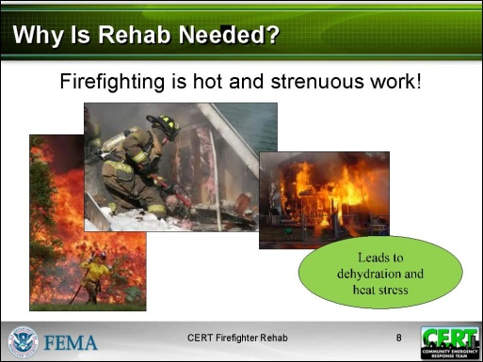  Display Slide 8 | Physiological Stress of Firefighting  Explain why rehab is needed.  - Firefighting is hot and strenuous work.  - The combination of high temperatures, hard work, and heavy equipment makes it hard for a body to cool through normal sweating.  - As a result, dehydration occurs and heat builds up. The body’s core temperature rises.  - This causes heat stress.
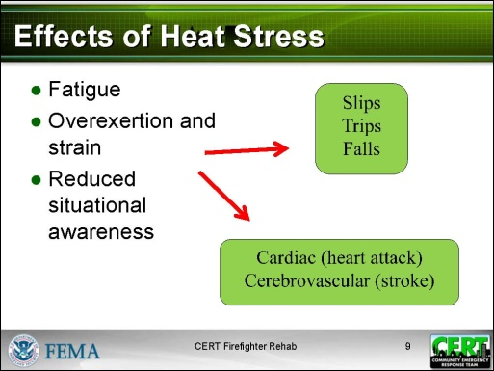  Display Slide 9 | Describe the effects of heat stress.  - Fatigue  - Overexertion and strain  - Reduced situational awareness
Explain that the effects of heat stress lead to the two leading causes of injury and death for firefighters:
- Slips, trips, and falls
- Cardiac (heart attack) or cerebrovascular (stroke) events
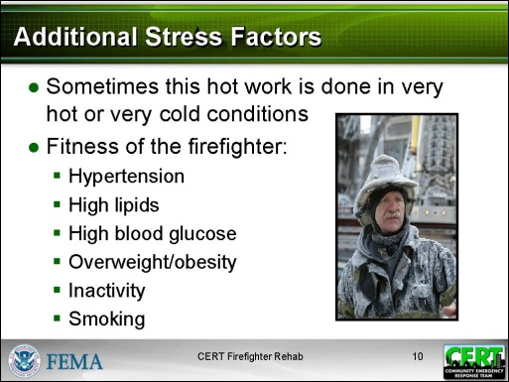  Display Slide 10 | Describe additional stress factors.  - Sometimes this hot work is done in very hot or very cold conditions and that adds additional stress.  - Always to be considered is the fitness of the firefighter. Risk factors include hypertension, high lipids, high blood glucose, overweight/obesity, inactivity, and smoking.
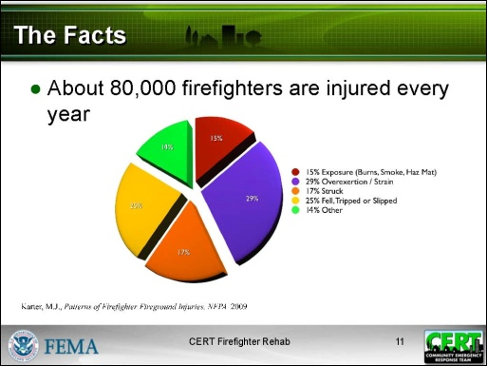  Display Slide 11  Citation: Karter, M.J., Patterns of Firefighter Fireground Injuries, NFPA 2009 | Give statistics on annual firefighter injuries and deaths, according to the National Fire Protection Association (NFPA).  - About 80,000 firefighters are injured every year.  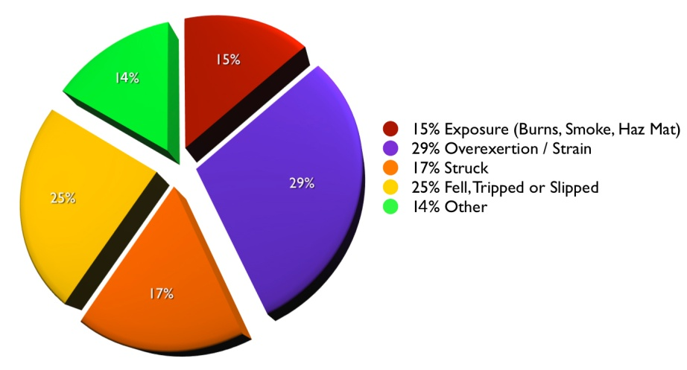
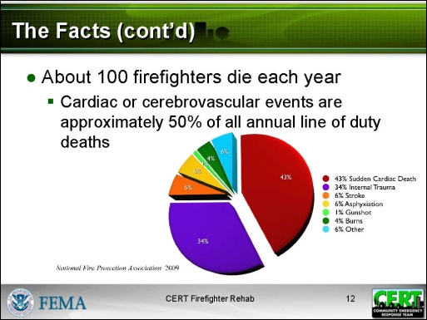  Display Slide 12  Citation: National Fire Protection Association | - About 100 firefighters die each year.  - Cardiac or cerebrovascular events account for approximately 50% of all annual line of duty deaths.  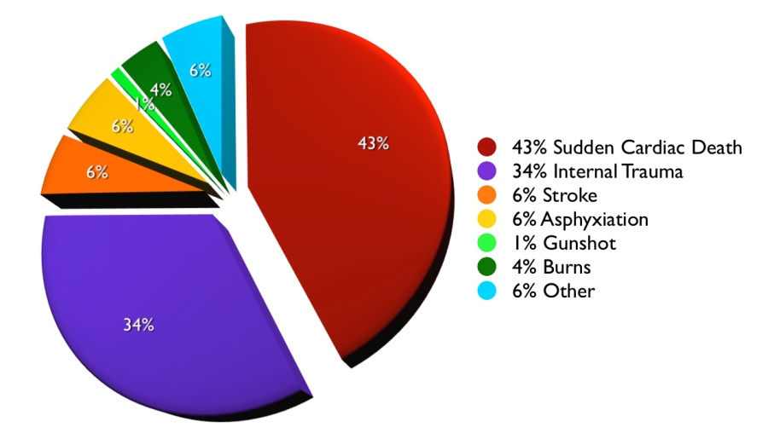
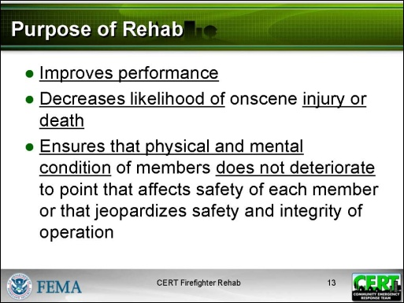  Display Slide 13 | Purpose of Rehab  Say that the firefighting community is working to reduce the stress of firefighting. One way is to provide rehab during a fire.  - Firefighter rehab improves performance.  - Firefighter rehab decreases the likelihood of onscene injury or death.  - Done properly, firefighter rehab ensures that the physical and mental condition of members operating at the scene of an emergency or a training exercise does not deteriorate to a point that affects the safety of each member or that jeopardizes the safety and integrity of the operation.
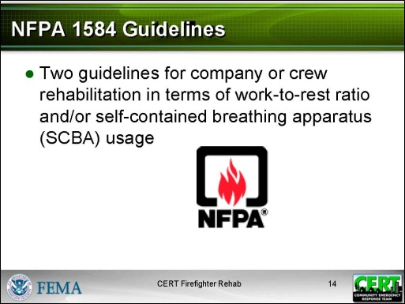  Display Slide 14  NFPA stands for National Fire Protection Association. NFPA’s mission is to reduce the worldwide burden of fire and other hazards on the quality of life by providing and advocating consensus codes and standards, research, training, and education. | NFPA 1584 Guidelines  Explain that this training is consistent with and based on NFPA 1584: Standard on the Rehabilitation Process for Members During Emergency Operations and Training Exercises. 2008 Edition.  Say that NFPA 1584 provides the following two guidelines for company or crew rehabilitation in terms of work-to-rest ratio and/or self-contained breathing apparatus (SCBA) usage:
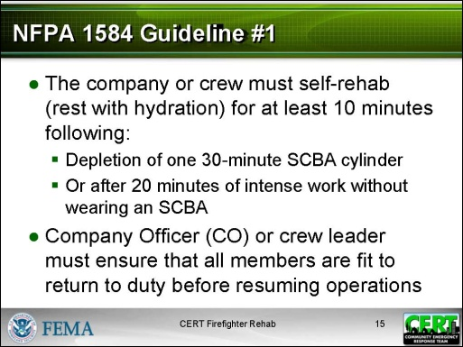  Display Slide 15 | Guideline #1: The company or crew must self-rehab (rest with hydration) for at least 10 minutes following the depletion of one 30-minute SCBA cylinder or after 20 minutes of intense work without wearing an SCBA. The Company Officer (CO) or crew leader must ensure that all assigned members are fit to return to duty before resuming operations.
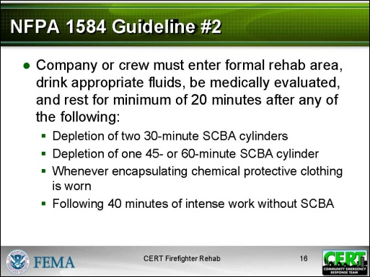  Display Slide 16 | Guideline #2: The company or crew must enter a formal rehab area, drink appropriate fluids, be medically evaluated, and rest for a minimum of 20 minutes after any of the following:  - Depletion of two 30-minute SCBA cylinders  - Depletion of one 45- or 60-minute SCBA cylinder  - Whenever encapsulating chemical protective clothing is worn  - Following 40 minutes of intense work without an SCBA
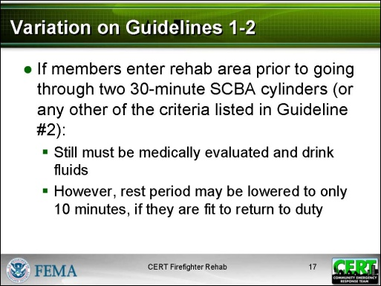  Display Slide 17 | Variation  Explain that, according to NFPA 1584, if members enter the rehab area prior to going through two 30-minute SCBA cylinders (or any other of the criteria listed above in Guideline #2):  - They still must be medically evaluated and drink fluids.  - However, their rest period may be lowered to only 10 minutes before they are allowed to return to duty, if they are fit to do so.  Note that the class will have an opportunity later in the module to check out a self-contained breathing apparatus and other personal protective equipment used by firefighters.
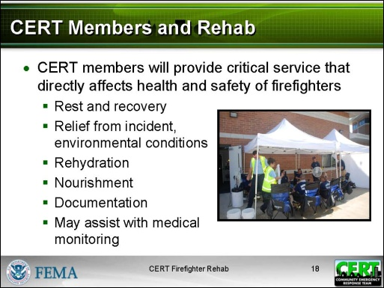  Display Slide 18  Provide details about the role CERT members will play locally in rehab. | CERT Members and Rehab  Say that many fire departments may need additional help to effectively handle the rehab when responding to an incident. So they are turning to their CERTS for help.  Explain that CERT members will provide a critical service that directly affects the health and safety of firefighters.  - Rest and recovery  - Relief from incident, environmental conditions  - Rehydration  - Nourishment  - Documentation  - May assist with medical monitoring
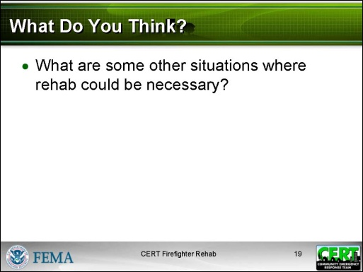  Display Slide 19  Conduct a short discussion based on this question. Responses should include any extended and/or extreme incident scene operation, e.g., crime scene investigation, criminal standoff situations, civil unrest situations, search operations, and support for major events (sporting, parades, festivals, conventions). | What Do You Think?  Tell participants that what they learn in this training can be used for other types of rehab.  Ask participants:  - What are some other situations where rehab could be necessary?  Tell participants that, if they can do firefighter rehab, they can do any kind of rehab.
 | Ask if there are any questions about what rehab is and its purpose.
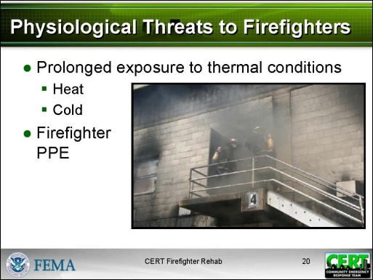  Display Slide 20 | Physiological Threats to Firefighters  Remind participants that you spoke earlier about the stresses on a firefighter. Those threats include prolonged exposure to extreme thermal conditions as well as the firefighter’s personal protective equipment (PPE).  It’s important to look at those conditions in more detail so CERT members understand what they will see in the rehab area.
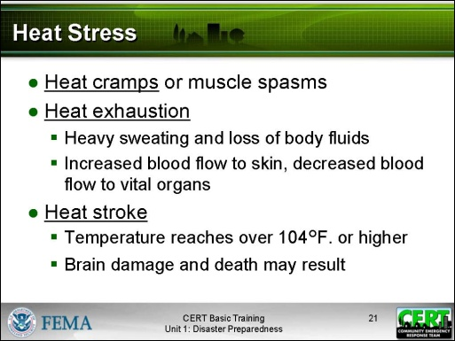  Display Slide 21 | Heat Stress  Definition  Say that heat stress is a group of conditions caused by overexposure to or overexertion in excess environmental temperatures.  Remind participants that they learned about heat stress in CERT Basic Training. Types of heat stress in increasing severity include:  - Heat cramps or muscle spasms  - Heat exhaustion, when working in extreme heat causes heavy sweating and loss of body fluids. Blood flow to the skin increases, causing blood flow to decrease to the vital organs.  - Heat stroke, when the individual’s temperature reaches 104°F. or higher and the body’s temperature control system shuts down. The body temperature can rise so high that brain damage and death may result.
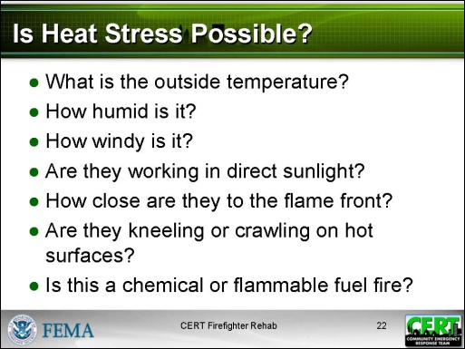  Display Slide 22 | Causes  Say that the amount of heat exposure is affected by a number of things. Here are some questions that CERT members in a firefighter rehab should ask themselves:  - What is the outside temperature? The hotter day will be worse.  - How humid is it? The higher the relative humidity, the less evaporation can occur to remove heat.  - How windy is it? Moving air transfers more heat than still air.  - Are they working in direct sunlight? Exposure to direct sunlight will also increase apparent temperature by about 10°F.  - How close are they to the flame front? Working inside a structure is hot work.  - Are they kneeling or crawling on hot surfaces?  - Is this a chemical or flammable fuel fire? Exposure is much more severe in those fires.
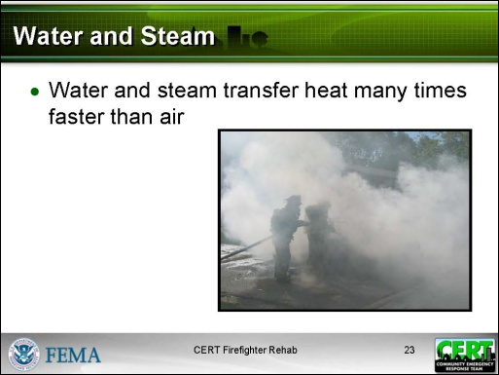  Display Slide 23 | Point out that, in addition to the air temperature itself, water and steam transfer heat many times faster than air. This creates additional heat exposure for firefighters.
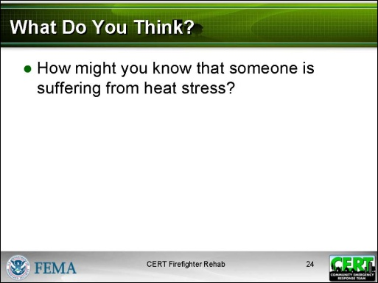  Display Slide 24  Brainstorm a list of symptoms. This was covered in CERT Basic Training Unit 4. | What Do You Think?  Ask participants:  - How might you know that someone is suffering from heat stress?
After the discussion, refer participants to the list in the Participant Manual. | Symptoms  The following are symptoms of heat stress:  - “Beet red” face  - Heavy sweating  - Lack of perspiration  - Headache  - Muscle cramping  - Nausea or vomiting  - Altered mental state  - Shortness of breath  - Dizziness  - Extreme weakness or exhaustion  - Seizure
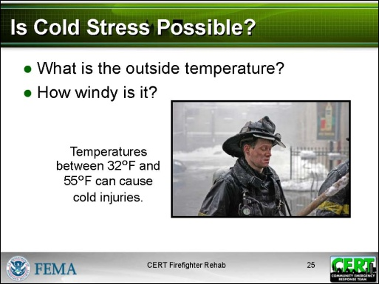  Display Slide 25 | Cold Stress  Causes  Say that issues related to cold are primarily frostbite, slips, and falls. It doesn’t take sub-freezing temperatures to make the mixture of wet and cold very dangerous. Temperatures between 32°F and 55°F can cause cold injuries. Here are some questions that CERT members in a firefighter rehab should ask themselves:  - What is the outside temperature? The colder the temperature the greater chance of localized cold injuries.  - How windy is it? The wind increases the transfer of heat away from a person’s body. It also can harm exposed skin.
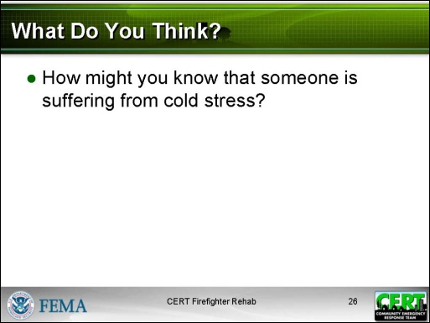  Display Slide 26  Brainstorm a list of symptoms. This was covered in CERT Basic Training Unit 4. | What Do You Think?  Ask participants:  - How might you know that someone is suffering from cold stress?
After the discussion, refer participants to the list in the Participant Manual. | Symptoms  The following are symptoms of cold stress:  - Altered mental status/confusion  - Extreme weakness/exhaustion  - Headache  - Numbness  - Waxy, pale skin  - Muscle rigidity
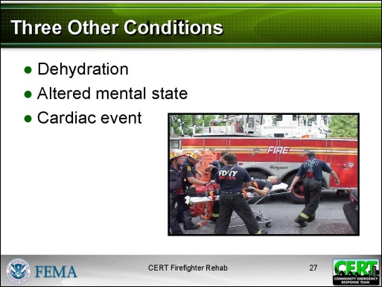  Display Slide 27 | Three Other Conditions  Say that three other conditions have been mentioned that CERT members need to be alert for. These are:  - Dehydration  - Altered mental state  - Cardiac event
PM, P. 9  Review the three other conditions with participants. Discuss any questions. | Signs of Dehydration  Explain that, other than expressions of thirst, signs of dehydration include low urine volume, urine with a strong odor, and urine of a dark color.
Signs of Altered Mental State
- Confusion
- Disorientation (to self, time, place)
- Loss of alertness
- Poor judgment
- Erratic thought process
- Disruptions in perception and behavior
Signs of a Cardiac Event
- Altered mental status
- Ashen/gray/white skin color
- Chest pain
- Jaw pain
- Unexplained neck/shoulder/arm pain
- Headache
- Nausea/vomiting
- Shortness of breath
- Excessive perspiration
- Heartburn/indigestion
- Person may say “I just don’t feel well” or “I just don’t feel right”
- Holding fist to chest is the universal sign of cardiac stress
A firefighter wearing full gear and tank should explain what he or she is wearing and how it is removed. The firefighter should demonstrate:  - Protective garments  - Helmet  - Hood  - Eye/face protection  - Gloves  - Footwear  - Respiratory protective devices  - SCBA (self-contained breathing apparatus)  When the firefighter is done, participants should be able to try on and handle the equipment. | Firefighter PPE Demonstration  Explain that PPE is critical gear for firefighter safety. However, PPE is also extremely heavy and hot. PPE becomes even hotter in the extreme heat of a fire.
 | Ask if there are any questions about the physiological threats to firefighters.
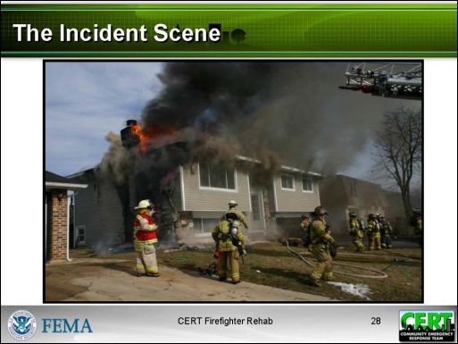  Display Slide 28 | The Incident Scene  Ask:  - How many of you have ever been on the scene of a fire?
 | Say that you want to help people who are unfamiliar with a fire scene understand what it is like.
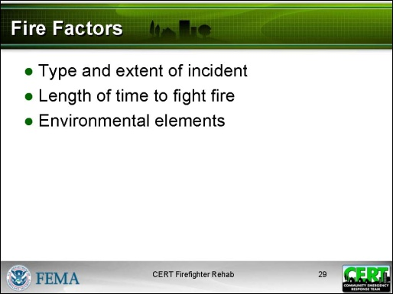  Display Slide 29 | Explain that there is an unlimited range of fire situations. What one might find at a fire scene will depend on several factors:  - Type and extent of incident  - Single-family residence  - Commercial  - High-rise  - Wildland  - Hazmat  - Length of time to fight fire  - Depends on the extent of the fire  - Environmental elements  - Climatic conditions

Explain that, regardless of the scene, firefighting follows the same protocols:
- Provide fire support (truck work/ladder)
  - Rescue
  - Salvage
  - Overhaul
  - Ventilation
- Extinguish the fire (engine work/water)
Talk about 2-3 fires that you have fought to give CERT members an appreciation for the fire scene: what happens, what it feels like. (Take about 10 minutes.)
Expect many questions from participants. Limit the discussion to 5 minutes. | Ask if there are any questions about the incident scene.
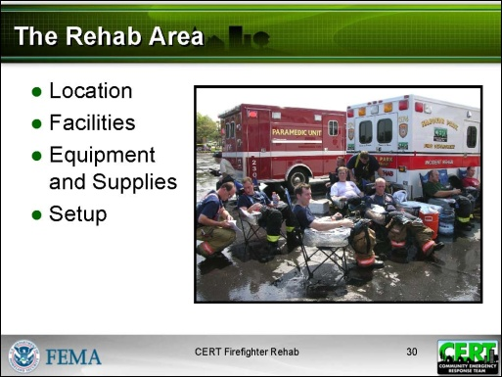  Display Slide 30  This section is generic. Make this section consistent with local policy. | The Rehab Area  Say that, before learning what to do in the rehab area, CERT members need to understand what the rehab area is. This section covers the following topics:  - Location  - Facilities  - Equipment and Supplies  - Setup
Explain the protocol in your local area. | Explain that, in some fire departments, CERTs will come in and assist with a rehab unit that is already set up. In other fire departments, CERTs may set up and run the rehab themselves, under directions from the Incident Commander (IC).
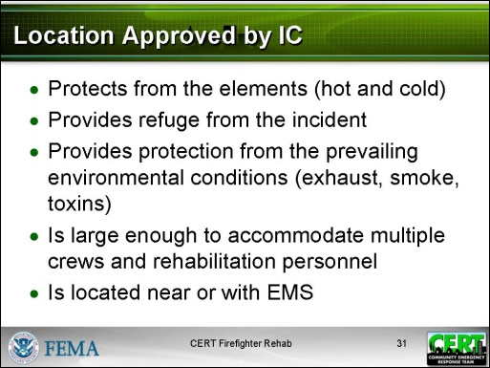  Display Slide 31 | Location  Say that in most situations the IC will specify where to set up the rehab area. However, there may be occasions where the CERT is told to set up the rehab area. Here are the requirements for the rehab area location:  - It must be approved by the IC.  - It must protect from the elements.  - For hot environments, it must include shade and/or air conditioning and a place to sit.  - For cold or wet environments, it must provide dry protected areas out of the wind, heated areas, and a place to sit.  - It must provide refuge from the incident.  - It must be a sufficient distance from the effects of the operation that firefighters can safely remove their PPE and can be afforded physical and mental rest.  - It must provide protection from the prevailing environmental conditions.  - Free from exhaust fumes, smoke, and toxins  - It must be large enough to accommodate multiple crews and rehabilitation personnel.  - Rehabilitation personnel include Emergency Medical Services (EMS) and CERT members.  - It must be located near or with EMS.  - There will be medical monitoring at the rehab area.  - There must be easy access to medical treatment and transport if necessary.
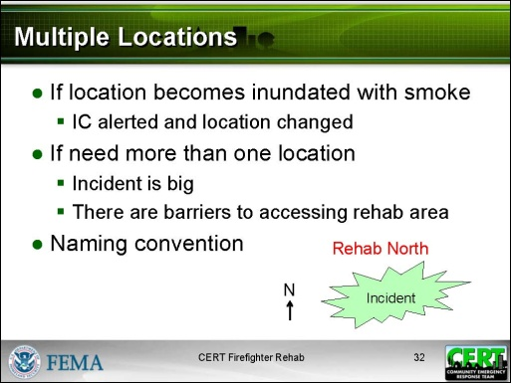  Display Slide 32 | Multiple Locations  Explain that, If the location becomes inundated with smoke, the IC must be alerted and the location must be changed.  Tell participants there may be a need for more than one location:  - If the incident is big  - If there are barriers that keep firefighters from getting to the rehab area  Say that, if there is more than one rehab area, each area is given a geographic name consistent with its location at the incident site. For example: Rehab North is on the north side of the incident.
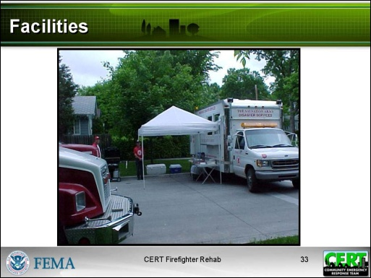  Display Slide 33  Conduct a discussion, asking participants to think of the best options first and then others.  Add any local policy/guidance. | Facilities  Ask participants:  - What facility/structure would be good for a rehab area?
PM, P. 13  Refer participants to the list in the Participant Manual. | Options for Rehab Facilities  - Preexisting structures (lobby, building, garage)  - Tent or awning  - Tarps  - Large tree or overhang  - School or municipal bus, or any enclosed vehicle
 | Remind participants that the facility must meet the requirements discussed earlier (see Location).
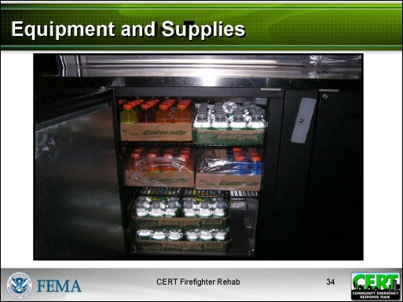  Display Slide 34  PM. P. 14  Add any local policy/guidance.  Be sure to idenitfy equipment and supplies that are or will be supplied by the local fire department. | Equipment and Supplies  Review with participants the list of supplies and equiment that are needed for rehab. CERT members should know that all of these supplies are not always available.  - Cover  - Awnings or tents  - Tarps  - Seating  - Folding chairs  - Benches with a back  - Cooling and heating  - Buckets and freezers for ice and water  - Fans or misting machines  - Forearm immersion equipment  - Portable heaters  - Blankets and towels  - Washing equipment  - Basins  - Soap  - Water  - Towels  - Hand sanitizer
- Other
  - Flood lights
  - Clipboards, forms, writing implements
  - Cups (hot and cold)
  - Beverage serving equipment
  - Paper towels
  - Electrical generating equipment
  - Large clock
  - Traffic cones, signs, fireline tape
  - Sanitary facilities
  - Trash receptacles
- Dry gloves, socks, and sweatshirts
- Food
  - Nutritious food that is calorie dense or contains a mix of carbohydrate and protein
  - Examples: power bars, protein bars, meal replacement bars, granola bars, trail mix, frozen peanut butter and jelly sandwiches, hot soup (in cold weather)
- Beverages
  - Water
  - Sports drinks (for electrolyte replacement)
  - Hot fluids in cold weather (coffee, tea, hot chocolate, hot lemonade, hot cider)
  - Fluids at a range of temperatures (room temperature, cold, iced)

The following food and beverages should not be provided:
- Caffeinated and carbonated beverages
- Simple sugars (candy, baked goods) (absorbed too quickly)
- Complex carbohydrates (raw fruit, vegetables, whole grains, beans) (take too long to digest)
- Tobacco

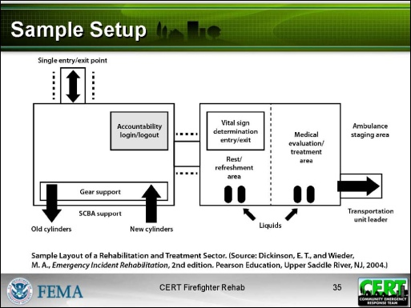  Display Slide 35  PM, P.16  Add any local policy/guidance on the layout of the rehab area.  Defer any discussion about process and procedures (how and what to do) to the next section, The Rehab Process.  The layout grapic is also included on the next page of the Instructor Guide. | Sample Setup  Discuss the layout of the rehabilitation area and treatment area on the slide and in the Participant Manual.  Emphasize that this sample shows what areas are needed, but the layout will vary depending on the incident location and the facilities available.  Make the following points:  Entry/exit  - There should be a single point of entry to and exit from the rehab area.  Accountability login/logout  - Firefighters will be checked in and out.  Gear storage area and hand washing area  - Firefighters must remove soiled gear and wash or sanitize hands before entering the rest and refreshment area.  - Firefighters may need some assistance removing gear.

Vital sign determination entry/exit
- All firefighters are evaluated as they enter the rehab area and before they leave the rehab area.

Rest/recovery area
- Food and beverages are provided.
- There is a place for firefighters to sit.
- Cooling and heating are provided as needed.

Medical evaluation/treatment area and ambulance staging area
- Self-explanatory
 | Ask if there are any questions about the rehab area: location, facility, equipment and supplies, and setup.

PM, P. 16 | Sample Rehab Area Layout

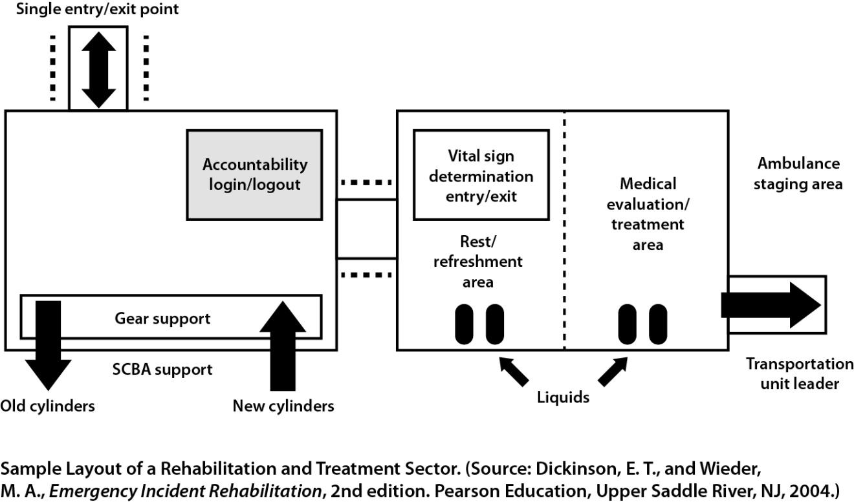
Instructor guidance | Content
Wildland Fires
Say that, if a CERT is ever called to assist in a wildland fire, Incident Command will tell the CERT where the rehab should be located and how the rehab will be run.

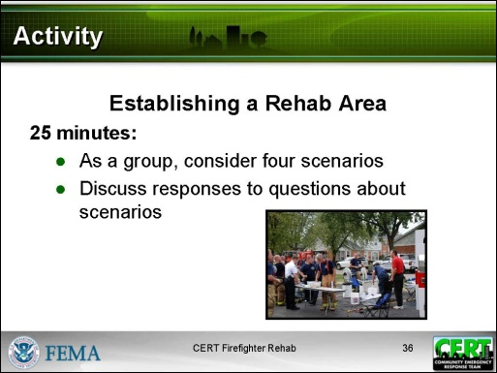  Display Slide 36  PM, P.18  The worksheet is also provided on the next page of the Instructor Guide with suggested answers in italics. The answers do not appear in the Participant Manual.  NOTE: The supply list does not have to be a comprehensive list. Focus on the key supplies, especially those that will be particular to the scenario. | Activity: Establishing a Rehab Area  Purpose: The purpose of this activity is to give participants an opportunity to think about how they would establish a rehab area. This is an activity for the whole class.  Time: 25 minutes  Instructions:  - Refer participants to the worksheet in the Participant Manual.  - Explain that you will read each of the scenarios. As a group, participants will discuss responses to each of the questions. Participants can record the responses on the worksheet if they want.
Debrief:
Remind participants that where and how you set up the rehab area depends on the incident, the weather, and the surrounding area.
 | Ask if there are any questions about the rehab area and how to set it up.

PM, P. 18 | Establishing a Rehab Area
Instructions: The instructor will read each scenario. As a group, you will discuss responses to each of the questions.
Scenario #1:
A single-family home in a suburban neighborhood is on fire. Houses in this neighborhood are about 50 feet apart. There are no driveways. The house is near the intersection with another quiet street. The temperature is in the 50s.

What do you need to consider when looking for a rehab area location?

- Access to fireground
- Far enough to be away from smoke
- Street can be blocked off easily but there can be access for EMS

What kind of facility might be available?

- Sidewalk or front yard of another house
- Street
- Under tree
- Somebody’s porch

What supplies will you need?

- Seating
- Tarps
- Water
- Sports drinks
- Food
- Hand washing equipment (may be able to get a hose)
- Portable toilets (unless neighbor has one that can be easily accessed)

Scenario #2:
Several floors of a six-story apartment building are on fire. The building is between two moderately busy four-lane roads in a mixed commercial and residential area. It is a hot and humid day.

What do you need to consider when looking for a rehab area location?

- Access to fireground
- Need shade and the coolest place possible
- Accessible to EMS
- Far enough to be away from smoke
- Large enough for several crews
- May need at least two rehab areas, one on each street

What kind of facility might be available?

- Parking garage
- Store with air conditioning
- Lobby of another high-rise

What supplies will you need?

- Tarps
- Water
- Sports drinks
- Food
- Hand washing equipment
- Misting machines or fans
- Forearm immersion equipment
- Portable toilets (unless able to have access to one at commercial establishment)

Scenario #3:
A tanker truck and several cars have crashed on an interstate highway in a fairly rural area. It is a windy day – steady at 25 mph from the southwest. The temperature is in the 40s. The tanker contents are unknown.

What do you need to consider when looking for a rehab area location?

- Access to fireground
- Should be on western side of crash (depending on location of exits, this may not be accessible to EMS)
- Large enough for several crews
- Protection from wind, smoke, and possible fumes

What kind of facility might be available?

- Tent
- Bus

What supplies will you need?

- Seating
- Tarps
- Water
- Sports drinks
- Food
- Hand washing equipment
- Portable toilets
- Dry gloves, socks, and sweatshirts

Scenario #4:
There is a fire in a free standing shopping mall surrounded by parking lots. The fire is in the northeast corner, involving three stores. The temperature is in the upper 20s. Light snow and sleet are falling.

What do you need to consider when looking for a rehab area location?

- Access to fireground
- Protection from snow/sleet and from cold
- Accessible to EMS
- Far enough to be away from smoke
- Large enough for several crews
- May need several rehab areas, depending on how fire can be accessed

What kind of facility might be available?

- Vehicle in parking lot
- Interior area of mall, near exit (to get to EMS)

What supplies will you need?

- Seating
- Tarps
- Water
- Sports drinks
- Food
- Hand washing equipment
- Blankets, heaters
- Dry gloves, socks, and sweatshirts
- Portable toilets (unless able to have access to one at mall)

Instructor guidance | Content
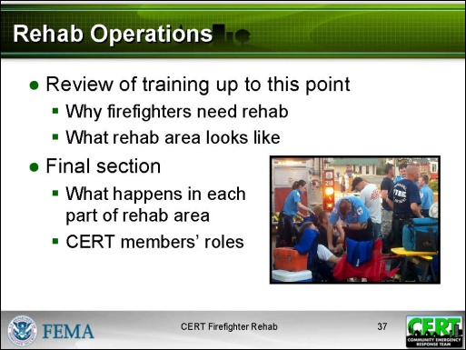  Display Slide 37 | The Rehab Process  Tell participants that they now have some background on rehab, including:  - Why firefighters need rehab  - What the rehab area looks like  Say that in this final section of the training participants will learn what happens in each part of the rehab area and what the CERT members’ roles are.
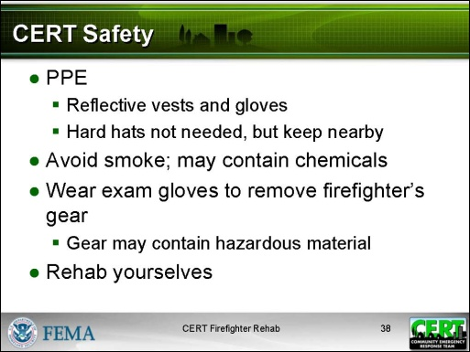  Display Slide 38 | CERT Safety  Remind participants that the CERT member’s first responsibility is personal safety. So, before discussing rehab operations, you want to talk about CERT safety in the rehab area.  - PPE  - Wear reflective vests and gloves.  - Hard hats are not needed in the rehab area, but keep them nearby in case of flying debris.  - Avoid smoke as it may contain hazardous chemicals.  - Wear exam gloves to remove a firefighter’s gear.  - The gear may contain hazardous material.  - Rehab for CERT members  - Team members may be working long hours.  - Take breaks and replenish food and water.
 | Ask if there are any questions about CERT safety.
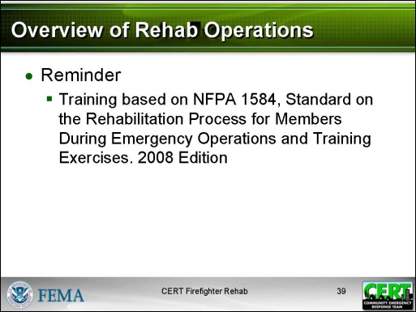  Display Slide 39 | Overview of Rehab Operations  Remind participants that a standard operating guideline for rehab has been developed by the National Fire Protection Association (NFPA). This training is based on that operating guideline – NFPA 1584 Standard on the Rehabilitation Process for Members During Emergency Operations and Training Exercises. 2008 Edition.
PM, P. 23  Explain local policy and procedures if they differ from this. | Rehab and Incident Command Structure (ICS)  Before providing an overview of rehab operations, refer participants to the two flowcharts in the Participant Manual and on the next page of the Instructor Guide.  Explain that in a large operation, rehab operations will fall under the Medical Unit. In a small operation, rehab could fall directly under the IC.

PM, P. 23 | Rehab and Incident Command Structure (ICS)
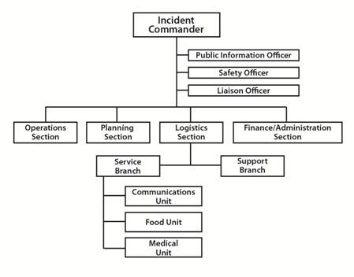

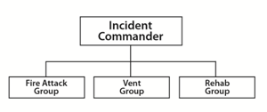

Instructor guidance | Content
PM, P. 24  Walk through the overview that is in the Participant Manual and on the next page of the Instructor Guide. | Explain that you will provide an overview of rehab operations and you will then go back and discuss each step in more detail.

PM, P. 24 | Putting It All Together (Order of Rehab Operations)

- CERT members are mobilized for firefighter rehab.
- CERT members arrive on the scene dressed in PPE.
- The IC chooses a rehab leader.
- If setup is required, the IC chooses a rehab location or directs CERT members to choose a location.
- CERT members set up a rehab area with the equipment and supplies that are available.
- As firefighters head to the rehab area, CERT members direct them where to enter and sign them in.
- CERT members assist with gear removal and offer water immediately.
- EMS provides medical assessment while CERT members record data.
- CERT members continually do the following in the rest and recovery area:
  - Offer beverages and nutrition.
  - Provide cooling and heating as appropriate.
  - Monitor for signs of distress.
- If a firefighter is distressed:
  - CERT members alert rehab leader immediately.
  - The firefighter is moved to the medical area.
- Firefighters ready to go back to active duty are signed out by CERT members and leave through the rehab exit area.
Instructor guidance | Content
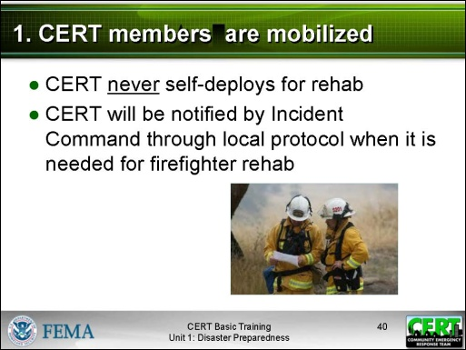  Display Slide 40  As you provide additional details about each of the steps of rehab operations, be sure to adjust the details to fit local protocols. | 1. CERT members are mobilized  Emphasize that firefighter rehab is never mobilized through self-deployment. The CERT will be notified by Incident Command through local protocol when it is needed for firefighter rehab.
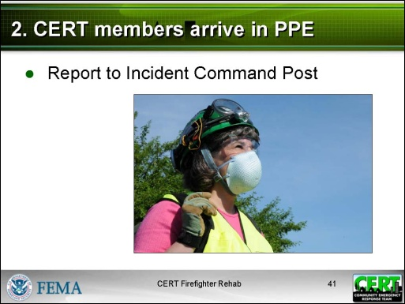  Display Slide 41 | 2. CERT members arrive in PPE  Remind participants that appropriate PPE includes reflective vest, gloves, and helmet.  Explain that CERT members report to the Incident Command Post.
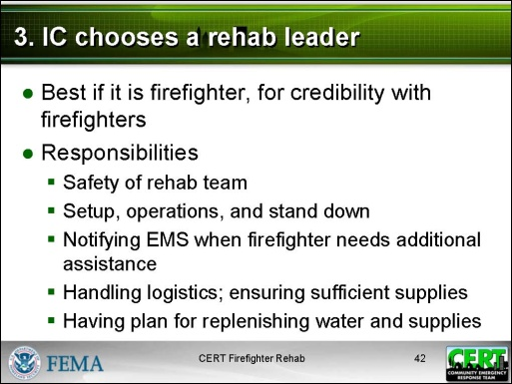  Display Slide 42 | 3. IC chooses a rehab leader  Explain that, following NIMS/ICS protocol, the IC designates a supervisor/leader for the rehab area. This person is the liaison to the IC.  - Ideally, a firefighter will be in charge of the rehab area, as firefighters may not listen to a CERT member or EMS member telling them not to go back into the fire. However, this may not always be possible.
Rehab Leader Responsibilities
- Responsible for the safety of the rehab team
- Responsible for setup, operations, and stand down
- Notifies EMS when a firefighter needs additional assistance
- Handles logistics and ensures that there are sufficient supplies
- Has a plan in place for replenishing water and supplies
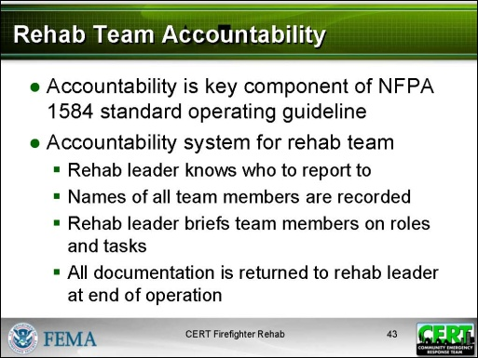  Display Slide 43 | Rehab Team Accountability  Say that accountability is a key component of the NFPA 1584 standard operating guideline. There must be an accountability system for the rehab team.  - The rehab leader knows who to report to.  - The names of all team members are recorded.  - The rehab leader briefs team members on their roles and tasks.  - All documentation is returned to the rehab leader at the end of the operation.
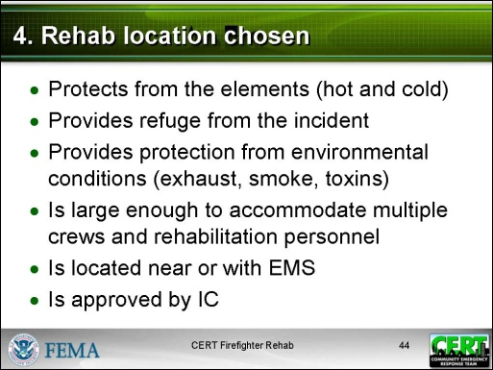  Display Slide 44  This slide is animated. The responses below appear on the second click.  This is a review question. Responses should include:  - Protects from the elements (hot and cold)  - Provides refuge from the incident  - Provides protection from the prevailing environmental conditions (exhaust, smoke, toxins)  - Is large enough to accommodate multiple crews and rehabilitation personnel  - Is located near or with EMS  - Is approved by IC | 4. Rehab location chosen  Say that the requirements for the rehab area have already been covered.  Ask:  - What characteristics are required for a rehab location?
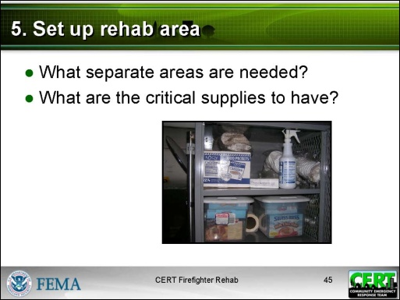  Display Slide 45  Use these questions to conduct a group discussion. There will probably be some differences of opinion of what is critical.  - At a minimum, there should be an entry/exit point and separate areas for removing gear and food/drink/monitoring.  - At a minimum, the rehab area should have drinking water, a place to sit, some protection from the elements, and a way to cool people down. | 5. Set up rehab area  Say that the rehab area is set up with supplies that are already available.  Remind participants that the list of needed supplies was discussed earlier.  Ask:  - Based on what you know so far, what separate areas are needed?  - Based on what you know so far, what are the critical supplies to have?
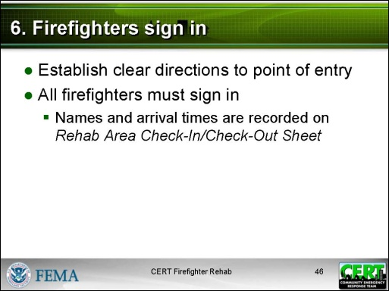  Display Slide 46  PM, P. 27  Substitute local procedure if difference from this and local form if available. | 6. Firefighters sign in  Explain that CERT members may need to establish a way or a person to direct firefighters to the correct entry point where they will need to sign in.  Just as with the rehab team, there must be an accountability system for the firefighters.  - Firefighters check in as they arrive at the rehab area.  - The names of the firefighters and their arrival times are recorded on an official rehab check-in and check-out sheet.  Refer participants to the sample Rehab Area Check-In/Check-Out Sheet in the Participant Manual and on the next page in the Instructor Guide.

Rehab Area Check-In/Check-Out Sheet
Crews operating on the scene: ________________________________________________________________________________________________________________________________________________________________
Unit No. | Member | Time In | Time Out |  |  | Unit No. | Member | Time In | Time Out

Instructor guidance | Content
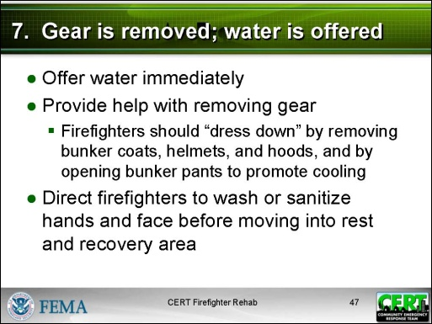  Display Slide 47 | 7. Gear is removed; water is provided  Say that water should be offered immediately.  Say that as soon as the firefighter checks in, he or she removes his or her gear, including the empty SCBA cylinder.  - Firefighters should “dress down” by removing their bunker coats, helmets, and hoods, and by opening their bunker pants to promote cooling.  - CERT members may need to help with gear removal, making sure to wear gloves.  Tell participants that firefighters should wash or sanitize their hands and face before moving into the rest and refreshment area. This prevents contaminating food and beverages with remnants of the fire.
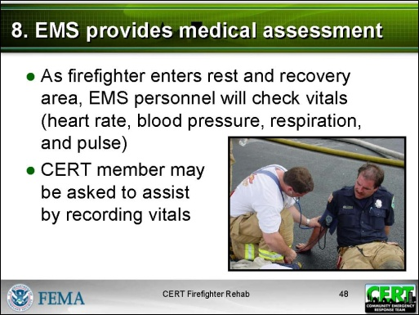  Display Slide 48  PM, P. 29  Substitute local procedure if different from this and local form that CERT members would use to assist in EMS assessment. | 8. EMS provides medical assessment  Explain that, as the firefighter enters the rest and nourishment area, EMS personnel will do an initial assessment of vital signs (heart rate, blood pressure, respiration, and pulse). A CERT member may be asked to assist by recording the vitals.  Say that this assessment is repeated every 10 minutes.  Refer participants to a sample report, Incident Rehab – Individual Rehabilitation Report, in the Participant Manual and on the next page in the Instructor Guide.

Incident Rehab - Individual Rehabilitation Report

Incident Location __________________________ Date ______________ Time _________Rehab Manager _______________
Name  Age/Height/Weight | Time  In/Out | # SCBA  Cylinders | Exam  Period | BP | Pulse | Resp | SpO₂ | SpCO | Temp | Skin | COOLING/  HEATING | HYDRATION /  NOURISHMENT | MEDICAL  COMPLAINTS | Transport  Y / N
 |  |  | INITIAL
 |  |  | 10 Min.
 |  |  | 20 Min. |  |  |  |  |  |  |  |  |  | (Glucose _____)
 |  |  | 30 Min. |  |  |  |  |  |  |  |  |  | (Glucose _____)
 | Prior Activity:
 |  |  | INITIAL
 |  |  | 10 Min.
 |  |  | 20 Min. |  |  |  |  |  |  |  |  |  | (Glucose _____)
 |  |  | 30 Min. |  |  |  |  |  |  |  |  |  | (Glucose _____)
 | Prior Activity:
 |  |  | INITIAL
 |  |  | 10 Min.
 |  |  | 20 Min. |  |  |  |  |  |  |  |  |  | (Glucose _____)
 |  |  | 30 Min. |  |  |  |  |  |  |  |  |  | (Glucose _____)
 | Prior Activity:
 |  |  | INITIAL
 |  |  | 10 Min.
 |  |  | 20 Min. |  |  |  |  |  |  |  |  |  | (Glucose _____)
 |  |  | 30 Min. |  |  |  |  |  |  |  |  |  | (Glucose _____)
 | Prior Activity:

Instructor guidance | Content
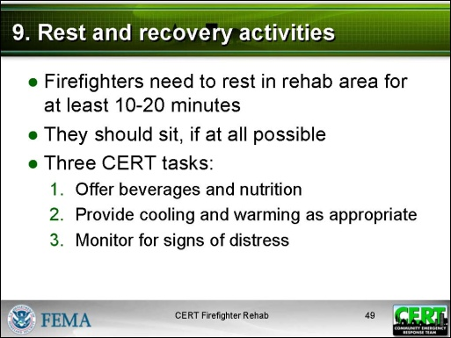  Display Slide 49 | 9. Rest and recovery activities  Explain that firefighters need to rest in the rehab area for at least 10-20 minutes. Having a large clock makes it easier to monitor time. During that time it is best if the firefighters can sit.  Say that CERT members have three tasks in the rest and recovery area:  - Offer beverages and nutrition.  - Provide cooling and warming as appropriate.  - Monitor for signs of distress.
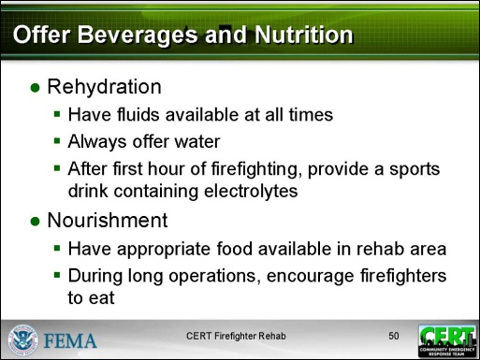  Display Slide 50 | Rehydration  Provide these guidelines.  - Have fluids available at all times.  - Firefighters are often dehydrated at the start of their work.  - Firefighting activities cause profuse sweating.  - Fluids must be replaced quickly and aggressively.  - Always offer water.  - After the first hour of firefighting, provide a sports drink containing electrolytes.
Nourishment
Provide these guidelines.
- Have appropriate food available in the rehab area (see the section on Equipment and Supplies).
- During long operations, encourage firefighters to eat.
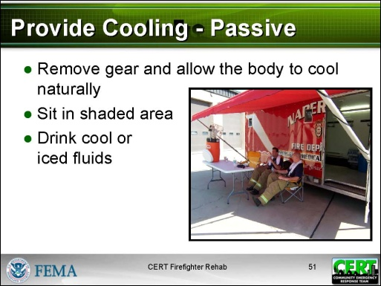  Display Slide 51 | Cooling  Explain that there are two kinds of cooling:  - Passive  - Active  Say that passive cooling is enough in many situations:  - Remove gear and allow the body to cool naturally.  - Sit in a shaded area.  - Drink cool or iced fluids.
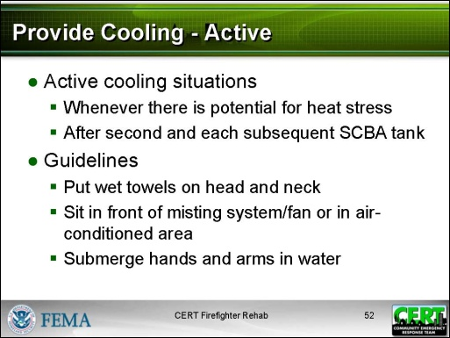  Display Slide 52  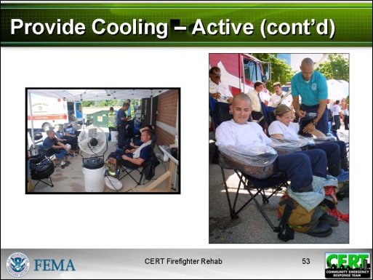  Display Slide 53 | Say that some situations require active cooling:  - Whenever there is the potential for heat stress (temperatures, conditions, and/or workload)  - After the second and each subsequent SCBA tank  Provide these guidelines for active cooling:  - Apply wet towels around the firefighter’s head and neck.  - Have firefighters sit in front of a misting system/fan or in an air-conditioned area.  - Submerge the firefighter’s hands and arms in water. (NOTE: Do not add bleach to water as it can damage PPE.) This method has been found to lower core temperatures quickly.
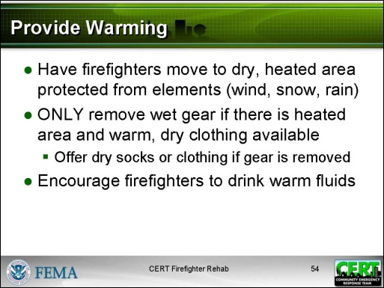  Display Slide 54 | Warming  Provide these guidelines for how to help warm up firefighters:  - Have firefighters move to a dry, heated area that is protected from the elements (wind, snow, rain).  - ONLY remove wet gear if there is a heated area and warm, dry clothing available.  - Offer dry socks or clothing if gear is removed.  - Encourage firefighters to drink warm fluids.
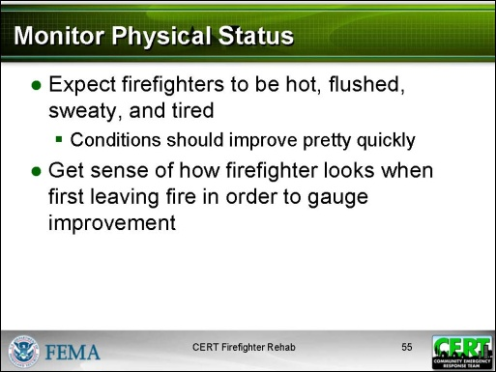  Display Slide 55 | Monitor physical status  Explain that CERT members will continuously monitor a firefighter’s physical status while he or she is in the rehab area as it can change suddenly.  Say that firefighters coming out of a fire are expected to be hot, flushed, sweaty, and tired. However, conditions should improve pretty quickly. One tip is to get a sense of how the firefighter looks when first leaving the fire in order to gauge improvement.
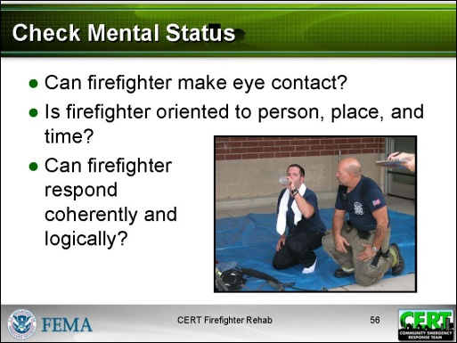  Display Slide 56 | - Check mental status  - See if the firefighter can make eye contact.  - Ask questions to see if the firefighter is oriented to person, place, and time.  - See if the firefighter can respond coherently and logically.
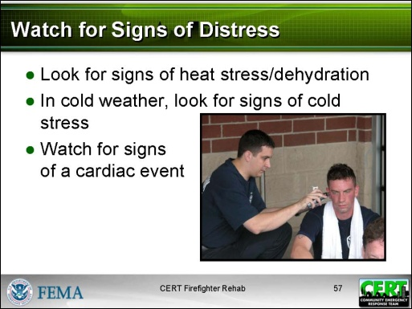  Display Slide 57 | - Watch for signs of distress. (See Physiological Threats to Firefighters for details on what to look for.)  - Look for signs of heat stress/dehydration.  - In cold weather, look for signs of cold stress.  - Watch for signs of a cardiac event.
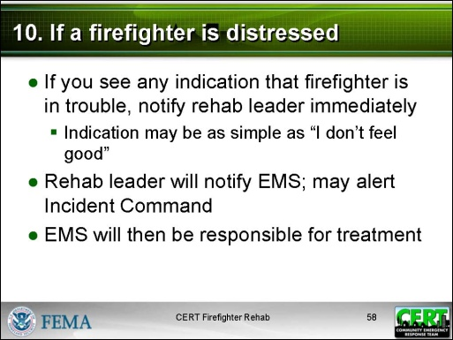  Display Slide 58  Tailor to local policies and procedures. | 10. If a firefighter is distressed  Provide these guidelines:  - If a CERT member sees any indication that a firefighter is in trouble, the CERT member must notify the rehab leader immediately.  - The indication may be as simple as a firefighter saying, “I don’t feel good.”  - The rehab leader will notify EMS immediately and may alert Incident Command if appropriate.  - EMS will then be responsible for treatment.
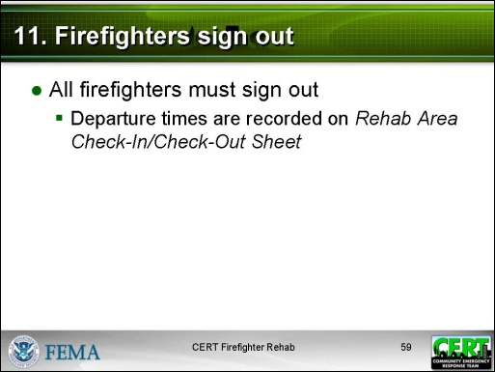  Display Slide 59 | 11. Firefighters sign out  Explain that the firefighters sign out at the same place they signed in.  See sample Rehab Area Check-In/Check-Out Sheet in the Participant Manual.
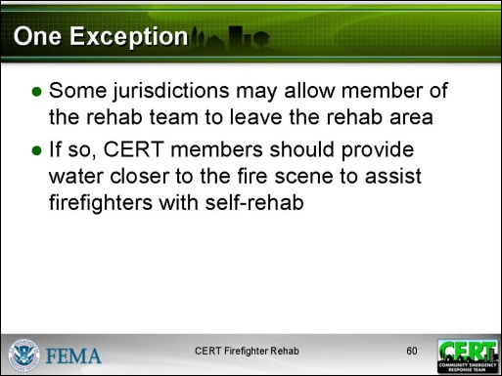  Display Slide 60  Discuss local policy relating to CERT members assisting with self-rehab. | One Exception  Tell participants that some jurisdictions may allow a member of the rehab team to leave the rehab area. If that is the case, CERT members should provide water closer to the fire scene to assist firefighters with self-rehab.
 | Ask if there are any questions about the rehab process.
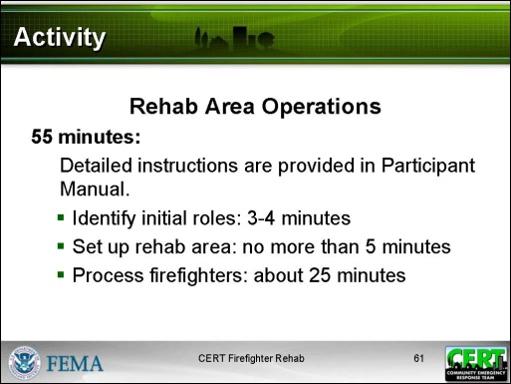  Display Slide 61  PM, P.33  Refer participants to the instructions in the Participant Manual. The instructions are also provided in the Instructor Guide on the page following the debrief instructions. | Activity: Rehab Area Operations  Purpose: The purpose of this activity is to practice setting up and running a rehab area.  Time: 50 minutes  Instructions:  - Refer participants to the instructions in the Participant Manual on how the activity will run.  - Walk through the instructions, making sure that everyone understands how the activity will unfold.  - Start the activity.  - Identify initial roles: 3-4 minutes  - Set up rehab area: no more than 5 minutes  - Process firefighters: about 25 minutes  - Stop the activity after 35 minutes.  - Conduct the debrief (15 minutes).
Debrief:
Ask these questions:
- In your role as firefighter, did you feel taken care of?
- How did it feel to play the other roles?
- Were there challenges you did not expect?
- Did any firefighter exhibit stress? How was it handled?
 | Ask participants to find a chair for the Module Summary.

PM, P. 33 | Activity: Rehab Area Operations
Purpose: The purpose of this activity is to practice setting up and running a rehab area.
Instructions:
Break into groups of 10. Each group will do the following:
- Identify a rehab leader.
- Identify who will begin the activity in the following roles. NOTE: During the activity each person will play at least two roles:
  - Someone to check in and check out firefighters
  - Someone to work in the gear removal area
  - Someone to be an EMT
  - Someone to assist the EMT
  - Two people to work in the rest and recovery area
  - Three people to be firefighters
- As a group, set up the rehab area. This should take no more than 5 minutes. You can use materials in the room.
  - Entry/exit point
  - Gear storage area
  - Initial medical assessment area
  - Rest and recovery area
- When the area is set up, begin to process the firefighters by following steps 6-11 of the Order of Rehab Operations on p. xx in your Participant Manual. Also use the sample Rehab Area Check-In/Check-Out Sheet and Incident Rehab – Individual Rehabilitation Report form.
- Each firefighter should be cleared to return to the fire after 2-3 minutes in the rehab area.
- After a firefighter exits, he or she should replace one of the rehab team members who then becomes a firefighter.
- The activity concludes when everyone has had a chance to be a firefighter.
Instructor guidance | Content
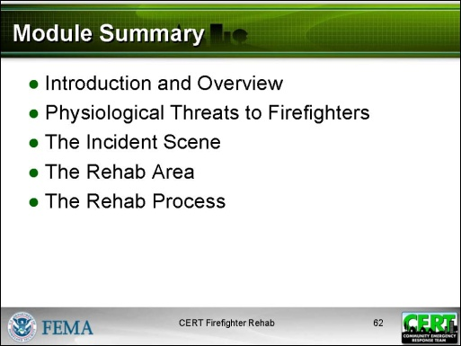  Display Slide 62 | Module Summary  Summarize the topics that were discussed in this module:  - Introduction and Overview  - Definition of firefighter rehab  - Stresses on firefighters  - Purpose of firefighter rehab  - CERT’s role in firefighter rehab  - Physiological Threats to Firefighters  - Heat stress  - Cold stress  - Resulting dehydration, altered mental state, and cardiac events  - The Incident Scene  - What happens at the scene of a fire  - The Rehab Area  - The characteristics of a good location  - What facilities might serve as a rehab area  - The supplies and equipment that are needed  - The requirements for laying out the rehab area  - The Rehab Process  - An overview and details of the steps of rehab operations  Explain to participants any next steps in qualifying them to assist in firefighter rehab. These will have been determined by the local fire department and the CERT program.

Closing
Provide information on any upcoming training or other CERT activities.
Present the certificates to participants, and thank them for attending the session.

[This page intentionally left blank]

