CERT Exercise Swaps

In this module you will learn about:

- FEMA Exercise Guidance. The types of exercises conducted by CERT. The advantages of operations-based exercises. What an exercise swap is and its benefits. How the Homeland Security Exercise and Evaluation Program (HSEEP) sets the standard for the design and conduct of systematic emergency response exercises.
- Criteria for Well-Designed Exercise. The criteria to determine if an exercise plan is carefully and thoughtfully crafted.
- Steps and Documents. The steps an exercise designer follows to ensure that the plan is complete and the documents that allow for consistency in design plans across the country.
- Best Practices. Ways to address challenges that occur while conducting the exercise and suggestions for implementing an exercise swap.

[This page intentionally left blank]
Learning Objectives/ Performance Outcomes | At the conclusion of this module, the participants will be able to:  - Explain the value of designing, conducting, and evaluating exercises in a systematic way.  - Explain the value of exercise swapping.  - Explain that the Federal Emergency Management Agency (FEMA) has developed national guidance for the design, conduct, and evaluation of exercises.  - Identify the basic steps in the exercise process.  - Create an operations-based exercise that meets the criteria of good exercise design.  - Explain how to conduct an exercise.  - Explain how to evaluate an exercise.
Scope | The topics that will be discussed in this module are:  - Introduction and Overview  - Overview: Exercise Types, Players, and Format  - Criteria for a Well-Designed Exercise  - Steps and Documents  - Best Practices  - Module Summary
Estimated Completion Time | 8 hours (Part 1 and Part 2 are each 4 hours)
Exercise Swap Concept | In an exercise swap, two neighborhood teams from the same CERT program or jurisdiction work together to design and develop exercises for one another. Each team designs, conducts, and evaluates an exercise for a partner team in a partner team’s neighborhood. The CERT Exercise Swaps module teaches participants how to prepare for and conduct an exercise swap. The actual exercises occur after completion of the module.  A table of how the process works is shown on the next page.

Exercise Swap Process
During the exercise swap, each partner team will perform both Design Team and Player Team functions.
Step | Exercise Design Functions | Exercise Player Functions
1 | After the partner team completes its own Needs Assessment, review the results with them. | Acting as Player Team, conduct Need Assessment to identify the capabilities the team needs to practice. The Needs Assessment will be used by the partner team to develop exercise objectives.
2 | Begin designing Exercise Plan for the partner team by drafting Objectives based on their Needs Assessment. | After Design Team drafts Objectives, review and discuss possible revisions with them. Each team must approve the Objectives for the exercise to be designed for it.
3 | Continue to design exercise for partner team by developing the Exercise Plan including Scope, Scenario, and Events to address the Objectives.
4 | Develop Logistics Plan based on Exercise Plan.
Exercise Swaps classroom training ends. Each team continues to meet to plan an exercise for the other team.
5 | Finalize Exercise Plan and get approval of CERT Program Coordinator/Manager.
6 | Facilitate and evaluate the exercise. | Play the role of CERT responders in the exercise.
6 | Facilitate hot wash and document feedback. | Participate in hot wash and provide feedback to Lead Facilitator.
6 | Confirm date, time, and location of second exercise at which teams will switch roles.

7 | Develop draft After Action Report and submit to Player Team. | Review draft After Action Report and provide any additional comments and feedback to Design Team.
8 | Incorporate feedback from Player Team into After Action Report. Submit final After Action Report and other documentation to Player Team and CERT Program Coordinator/Manager
9 |  | Use After Action Report to consider additional practice and training needs.
Following an interval of at least two weeks, the partner teams switch roles for Steps 6 – 9 for the second exercise.

Training Methods | In Part 1, the instructor welcomes participants to the training session, facilitates participant introductions, reviews the module purpose, and leads a discussion on participant experience with emergency training exercises.  Next, the instructor provides an overview of exercise types and the various roles in an exercise. The instructor specifically discusses the benefits of operations-based exercises. Exercise swaps are defined. The instructor will explain the relationship between HSEEP (Homeland Security Exercise and Evaluation Program), FEMA’s guidance for exercise design, and CERT’s exercises that are patterned after it. Participants then list the elements of a well-designed exercise.  The remainder of the module introduces participants to the steps to creating an exercise and the documents used by exercise designers and players.  Because the goal of the module is to allow both teams to make substantial progress on the development of a plan that meets the needs of the other team, much of the remaining class time will be devoted to activities.

Training Methods (continued) | Step 1: Assess Needs  The instructor and participants walk through the team’s Needs Assessment and discuss how to complete it. Participants break into teams. Each team discusses its needs and writes a Needs Assessment and then shares it with their partner team.  Step 2: Design an Exercise  The instructor and participants walk through the Exercise Plan and discuss how to complete it. Participants break into their teams. Each team begins to develop an Exercise Plan for its partner team in two activities: Develop Objectives and Develop an Exercise Plan. The team should be able to complete all but the Events and Evaluation Form for Facilitator(s) and Evaluator(s) before the end of Part 1.  The instructor recaps what was covered in Part 1 and reviews what will be covered in Part 2.  In Part 2, the instructor begins by reviewing the topics that will be covered. Participants then complete any remaining work on the Write an Exercise Plan activity.  Step 3: Plan for the Exercise  The instructor and participants walk through the Logistics Plan and discuss how to complete it. Participants break into their teams. Each team develops selected portions of the Logistics Plan for the exercise it is designing.  Step 4: Conduct the Exercise, Step 5: Debrief the Exercise With a Hot Wash, Step 6: Write the After Action Report  The instructor quickly reviews the last three steps in the exercise process and the forms that can be used.  Finally, the instructor conducts a discussion of best practices: unexpected challenges that may occur during the exercise and possible solutions, and the best way to conduct an exercise swap.  The instructor will conclude the module by summarizing important points learned in each topic. Participants will receive certificates.  Note that each team will be expected to continue developing the exercise after the training is over and then conduct the exercise for their partner team. During the post-training activities, the team should seek guidance as needed from the CERT Program Coordinator/Manager or designee.
Resources Required | - Community Emergency Response Team Exercise Swaps Instructor Guide (for instructors)  - Community Emergency Response Team Exercise Swaps Participant Manual (for participants)  - Appendix with templates for developing a full-scale exercise  - PowerPoint slides 0 to 52
Equipment | The following equipment is required for this module:  - A computer with PowerPoint software  - A computer projector and screen  - Masking tape  - Easel pad and easel or whiteboard  - Markers
Preparation | Review this module and add local information wherever requested.  Determine when to take breaks. In Part 1, a good place would be half way through the Conduct a Needs Assessment activity (before the teams brief each other on their Needs Assessments). In Part 2 a good place to take a break would be before the Develop the Logistics Plan activity.  Arrange for a way to make copies. In Part 1 for the Write an Exercise Plan activity, it will be helpful if each Design Team member can have a copy of the Player Team’s Needs Assessment.
Participant Prerequisites | Participants must have completed CERT Basic Training and FEMA ICS-100, Introduction to Incident Command System (ICS).
Instructor Qualifications | Instructors for the CERT Exercise Swaps module should have the following qualifications:  - Demonstrated knowledge of the CERT Program  - Instructional experience  - Leadership experience  - Experience interacting with volunteers  - Experience with designing and conducting exercises
Instructor Qualifications (continued) | Completion of FEMA Independent Study course entitled An Introduction to Exercises (IS-120.a) is recommended but not required.
Notes | A suggested time plan for this module is as follows:  Part 1: (4 hours, with 20 minutes for break)  Introduction and Overview 20 minutes  Overview: Exercise Types, Players, and Format 40 minutes  Steps and Documents: Step 1: Assess Needs 10 minutes  Activity: Conduct a Needs Assessment 70 minutes  Steps and Documents: Step 2: Design an Exercise 5 minutes  Activity: Write Objectives 40 minutes  Steps and Documents: Step 2 (continued) 10 minutes  Activity: Write an Exercise Plan 20 minutes  Part 1 Summary 5 minutes  Part 2: (4 hours, with 20 minutes for break)  Recap 10 minutes  Activity: Write an Exercise Plan (continued) 45 minutes  Steps and Documents: Step 3: Plan for the Exercise 45 minutes  Activity: Develop the Logistics Plan 75 minutes  Steps and Documents: Step 4: Conduct the Exercise 10 minutes  Steps and Documents: Step 5: Debrief the Exercise  with a Hot Wash 5 minutes  Steps and Documents: Step 6:  Write the After Action Report 5 minutes  Best Practices 15 minutes  Module Summary 10 minutes  Total Time: 8 hours
Remarks | - This module is designed for CERT volunteers who are interested in designing and conducting operations-based exercises for another team and in having exercises designed and conducted for their team.  Participants should register as geographic-specific groups. The CERT Program Manager may identify teams that can partner. Ideally, teams attending this module will have been paired ahead of time. There must be an even number of teams participating in each delivery of this training. If your CERT volunteers are not organized into teams, temporarily please do so for the purpose of the exercise swaps.  Participants need to understand that they will work as groups and that group identity will extend beyond the duration of the class and through the execution of two exercises, likely to occur in the months following the module.  - Because the module is taught in two parts, sometimes a week apart, participants must register for both Part 1 and Part 2 of the module. Enrollment in only one part will not be allowed.  - The recommended class size is 20 students per instructor. Larger class sizes can be accommodated only with more instructors added. The maximum class size recommended is 60 students per session.  - Some reminders to instructors:  - Exercise planning is a long and substantial process requiring weeks of planning. This module provides a high-level explanation of the process to be followed. It will be important not to exceed the lesson length by providing too much detail.  - Exercises are conducted to test new and existing plans and procedures rather than to test the skills or knowledge of individuals or teams of individuals.  - Exercises help improve the efficiency and effectiveness of executing plans and procedures. They offer a safe and simulated environment where participants can make mistakes without consequence.
Remarks (continued) | - CERT exercises are modeled after DHS Homeland Security Exercise and Evaluation Program (HSEEP) doctrine and are tailored accordingly. While HSEEP provides a useful model for plan development and execution, instruction must emphasize simplicity and accessibility over strict adherence to the HSEEP process. Outside of this module, the CERT Program Manager or a representative will provide supervision and ongoing guidance to the teams as they design and implement their exercises.  - The word “team” is used in two ways in the CERT world. To some, a team is synonymous with an entire region and can include perhaps hundreds of volunteers. For others, a team designates a much smaller neighborhood group. For the purposes of this module, “team” will indicate the Design Team or the Player Team. Each is made up of a group of volunteers that can be identified geographically.  - Most of the activities in this module require participants to produce documents as a group or team. Instructors should circulate during activities and supervise the development of these documents, providing guidance as needed.

CERT Exercise Swaps

Instructor guidance | Content
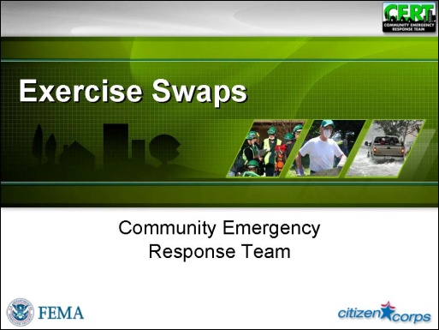  Display Slide 0 | Introduction and Overview  Welcome and Introductions  Welcome the participants to the CERT Exercise Swaps supplemental training.  Introduce yourself and provide some background information about your past experience with CERT and with CERT exercises.  Ask other instructors to introduce themselves in the same way.
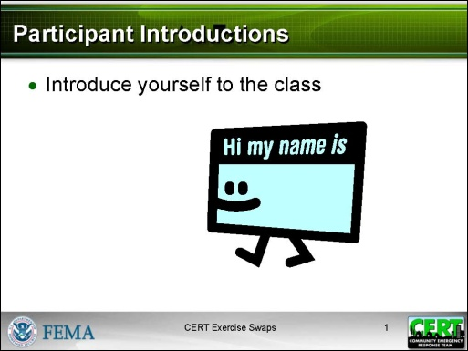  Display Slide 1 | Participant Introductions  Develop a class roster by passing around a sheet of paper and asking the participants to write down their contact information, or having them check in on a roster already developed from pre-registration information.  If participants do not already know each other, have participants introduce themselves by giving their names.
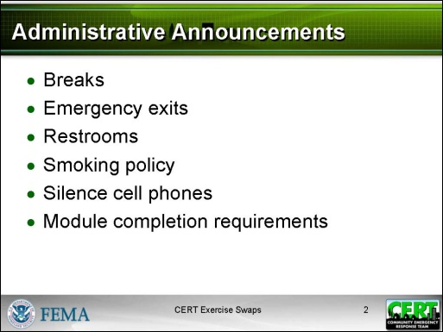  Display Slide 2 | Administrative Announcements  Make any necessary announcements such as:  - Schedule of breaks for this session  - Emergency exits  - Restroom locations, smoking policy, silencing cell phones, etc.  - Module completion requirements (must attend both sessions)
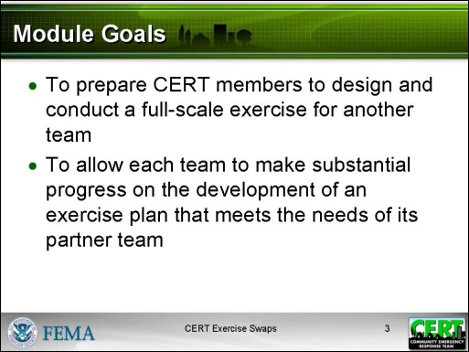  Display Slide 3 | Module Goals  Explain that this module has two goals:  - To prepare CERT members to design, conduct, and evaluate a full-scale exercise for another team  - To allow each team to make substantial progress on the development of an exercise plan that meets the needs of its partner team  Say that, although there is not sufficient time in this module to take a full-scale exercise from beginning to end (concept through evaluation), participants will leave the class with a mostly developed exercise plan. They will understand what the remaining tasks are and how to complete them.
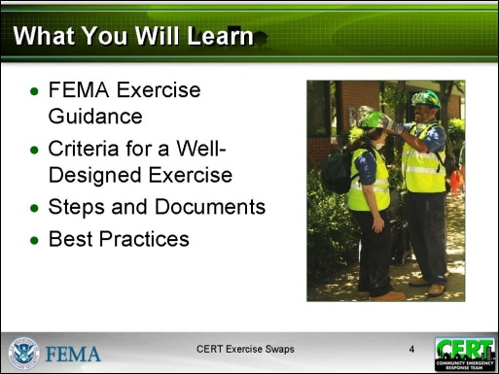  Display Slide 4 | What You Will Learn  List the topics that will be covered in the module:  - FEMA Exercise Guidance – CERT follows guidance developed by FEMA, though CERT exercise plans are usually smaller in scale.  - Criteria for a Well-Designed Exercise – An exercise of any size should still meet certain standards.  - Steps and Documents – CERT follows a simple six-step process for developing exercises that can be swapped.  - Best Practices – Exercises developed and conducted by CERT members should follow certain best practices to address challenges and to ensure good communication between teams participating in the exercise swap.
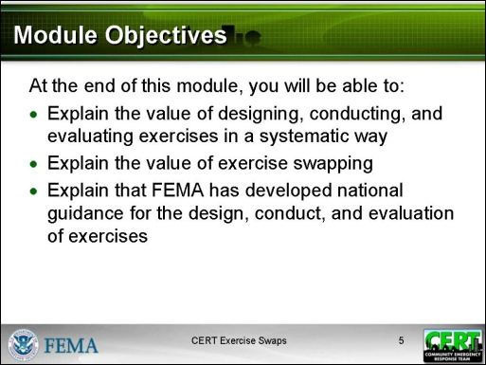  Display Slide 5 | Module Objectives  Say that, at the end of this module, participants will be able to:  - Explain the value of designing, conducting, and evaluating exercises in a systematic way.  - Explain the value of exercise swapping.  - Explain that the Federal Emergency Management Agency (FEMA) has developed national guidance for the design, conduct, and evaluation of exercises.
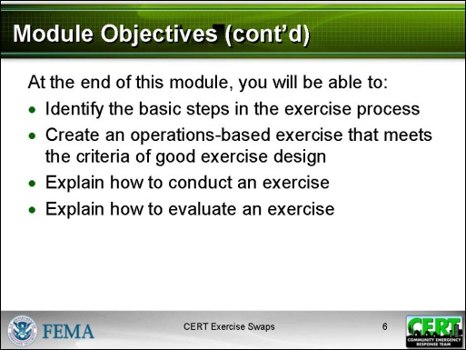  Display Slide 6 | Continue to review the objectives. Participants will be able to:  - Identify the basic steps in the exercise process.  - Create an operations-based exercise that meets the criteria of good exercise design.  - Explain how to conduct an exercise.  - Explain how to evaluate an exercise.
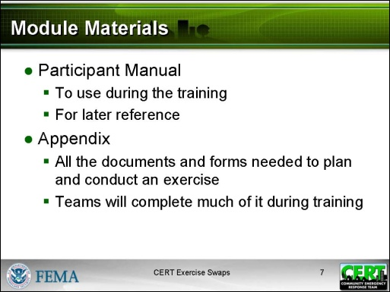  Display Slide 7 | Module Materials  Describe the training materials that the participants will use during the module:  - The Participant Manual contains the information that will be covered in the two parts of the training. This information will be useful as a reference.  - The Appendix contains all the documents and forms needed to plan and conduct an exercise. During the course of the module the teams will complete much of the information in the Appendix.
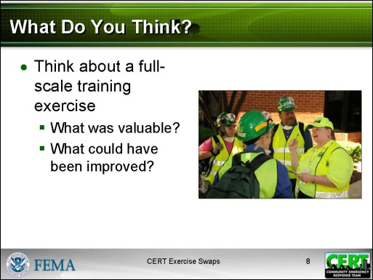  Display Slide 8  NOTE: Not everyone may have participated in a full-scale exercise outside of CERT Basic Training. However, depending on how their course was structured, the Unit 9 exercise in the CERT Basic Training course may have been a full-scale exercise.  Conduct a short discussion based on these two questions. | What Do You Think?  Ask participants:  Think about a full-scale training exercise you have participated in.  - What was personally valuable about participating?  - What elements of the exercise could have been improved?
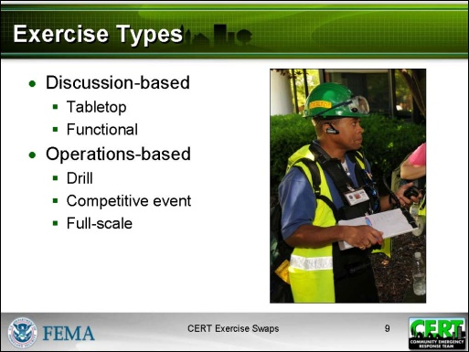  Display Slide 9 | Overview: Exercise Types, Players, and Format  Exercise Types  Explain to participants that “exercise” is a broad term for any activity that helps emergency responders plan for and practice their organizational response to an incident.  Say that there are two types of exercises: discussion-based and operations-based. First, explain the types of discussion-based exercises.  - Tabletop exercises  - Tabletop exercises are activities typically held in an informal setting and presented by the Facilitator to enhance general awareness, validate plans and procedures, rehearse concepts, and/or assess the types of systems needed to guide the prevention of, protection from, mitigation of, response to, and recovery from a defined incident.  - This type of exercise is delivered in a low-stress environment and intended to generate discussion of various issues regarding a hypothetical, simulated emergency.  - No hands-on practice or field work is involved.
- Functional exercises
- Functional exercises are typically focused on exercising plans, policies, procedures, for individuals involved in management, direction, command, and control functions for disasters.
- The key focus of a functional exercise is on the operational decisions made by the Incident Command Team. Other members of the team may be involved in the exercise, but to a lesser degree.
- Once the Facilitator has presented the initial scenario, the Incident Commander (IC) and the Command Team verbally respond to the scenario and simulate assigning tasks to others on the team.
- The Facilitator then talks through a developing scenario and the Command Team verbally responds to the scenario developments.
- There is typically no actual field work in a functional exercise; all the activity is verbal.
Now explain the three types of operations-based exercises.
- Drills
- Drills are supervised activities that provide the opportunity to practice and validate a specific disaster operation or function, usually focused on one or two key skills.
- Drills may or may not be based on a scenario and can also be used to determine if plans can be executed as designed, to assess whether more training is required, or to reinforce best practices.
- Competitive Events
- A competitive event is an opportunity to practice a variety of skills in a challenging, fun, and competitive environment.
- Usually involve a combination of skill stations and demonstrations, as well as multiple CERTs.
- Full-Scale exercises
- Full-scale exercises are typically the most complex and resource-intensive type of exercise because they are staged in a realistic field environment and involve many participants.
- Personnel and resources may be mobilized and deployed to the scene where actions would be conducted as if a real incident had occurred.
- The full-scale exercise simulates reality by presenting complex and realistic problems that require critical thinking, rapid problem solving, and effective responses.
- Throughout the duration of the exercise, many activities occur simultaneously and this provides an opportunity to practice and validate response plans, policies and a wide variety of disaster operations.
- Volunteers play the role of victims and moulage is used to add realism.
 | Remind participants that they will be developing and conducting a full-scale exercise.
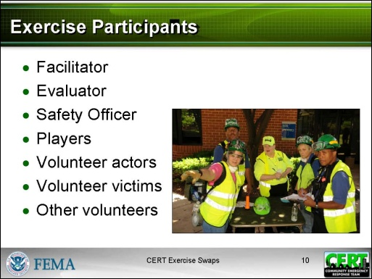  Display Slide 10 | Exercise Participants  Explain that it takes a lot of people to put on an exercise. Here are the players that you can expect to see during a full-scale exercise:  - Facilitator (the person who manages the exercise by keeping it on track and ensures all objectives are met)  NOTE: Depending on the number of players and locations there may be a Lead Facilitator for the whole exercise and additional Facilitators to manage specific exercise locations, e.g., the medical treatment area or an individual team.
- Evaluator (the person who observes each team and assesses the team’s implementation of plans and procedures)
- Safety Officer (the person responsible for ensuring safety at each exercise location)
- Players (CERT members who are responders in the exercise)
- Volunteer actors (the people who simulate specific roles in the exercise)
- Volunteer victims (the people who play the role of victims during the exercise)
- Other volunteers (the people who help with food, parking, etc.)

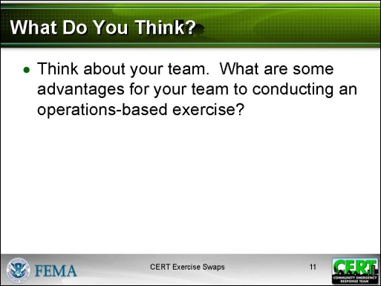  Display Slide 11  Conduct a short discussion based on this question. Record answers on an easel pad or whiteboard. The answers are recapped on the next two slides. | What Do You Think?  Ask participants:  - Think about your team. What are some advantages for your team to conducting an operations-based exercise?
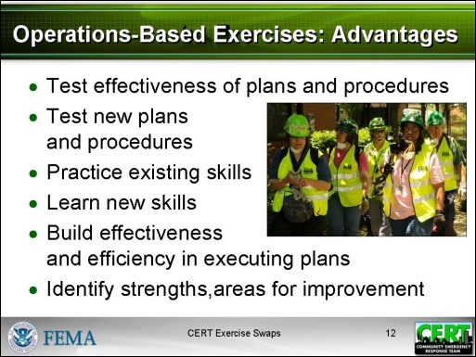  Display Slide 12 | Advantages of Conducting Operations-Based Exercises  Summarize the discussion by reviewing the slide.  Tell participants that conducting operations-based exercises has some direct benefits for a team. They allow each team to:  - Test the effectiveness of its current plans and procedures.  - Test new plans and procedures.  - Practice existing skills.  - Learn new skills.  - Build the team’s effectiveness and efficiency in executing plans and procedures.  - Identify strengths.  - Identify areas that need to be improved upon.
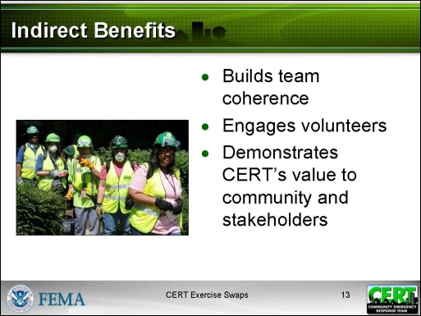  Display Slide 13 | Explain that conducting operations-based exercises can also have some indirect benefits.  - Builds team coherence  - Brings in people (as volunteers and victims) who didn’t previously know about CERT  - Demonstrates CERT’s value to the community and stakeholders
 | Ask if there are any questions about the types of exercises and the advantages of an operations-based exercise.
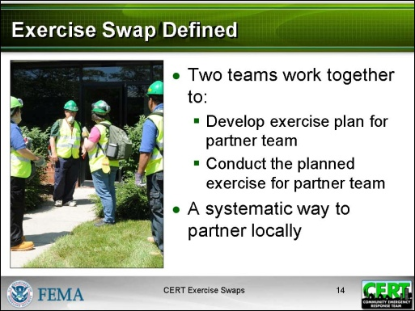  Display Slide 14 | Exercise Swap Defined  Say that an exercise swap is a systematic way to partner with another team.  - Each team develops an exercise for its partner team.  - Each team conducts the exercise it develops for its partner team.
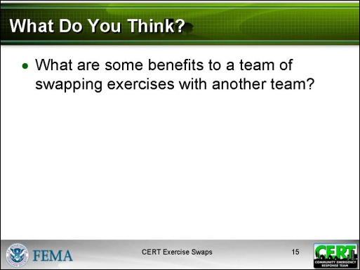  Display Slide 15  Conduct a short discussion based on this question. The answers appear on the next slide. | What Do You Think?  Ask participants:  - What are some benefits to a team of swapping exercises with another team?
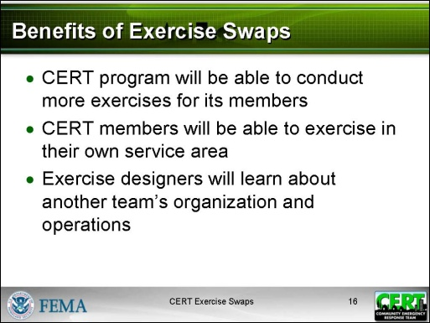  Display Slide 16 | Benefits of Exercise Swaps  Summarize the discussion by reviewing the slide.  Tell participants that:  - Each CERT program will be able to conduct more exercises for its members.  Designing and conducting exercises takes time. Typically the CERT Program Manager is the one who develops and plans exercises. With more people able to do this, more exercises can be scheduled.
- CERT members will be able to exercise in their own service area.
Since exercise design is so time-intensive, CERT members often have to travel considerable distance to participate in the few exercises available. The local exercise swap saves travel time.
- Exercise designers will learn about another team’s organization and operations.
The exercise swap is an opportunity for networking and for sharing lessons learned.
 | Explain that participants now have an overview of CERT exercises and the concept of exercise swaps. The next section will look briefly at the guidance that FEMA provides for conducting exercises in a systematic way.
 | Ask if there are any questions about what an exercise swap is and its benefits.
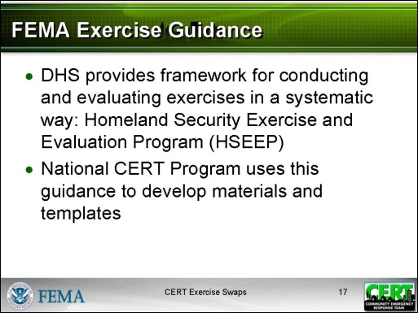  Display Slide 17 | FEMA Exercise Guidance  Explain that DHS provides exercise development guidance through the Homeland Security Exercise and Evaluation Program (HSEEP). The purpose of this initiative is to provide a framework for designing, conducting, and evaluating exercises in a systematic way.  Say that the National CERT Program uses this guidance to develop materials and templates on a more modest scale.
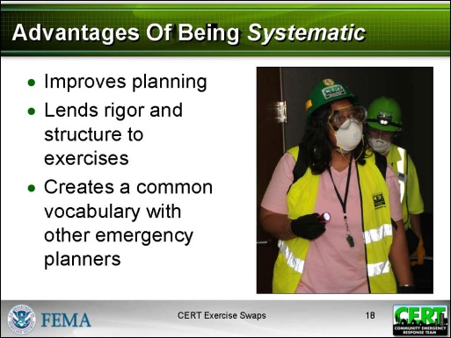  Display Slide 18 | Advantages Of Being Systematic  Explain that FEMA and CERT have learned that there are benefits to being systematic when designing, conducting, and evaluating operations-based exercises.  - It improves planning when you follow the same process every time.  - It lends rigor and structure to exercises.  - When an exercise is designed for an identified need and using specific objectives, it is much easier to evaluate the success of the exercise.  - It creates a common vocabulary with other emergency planners.
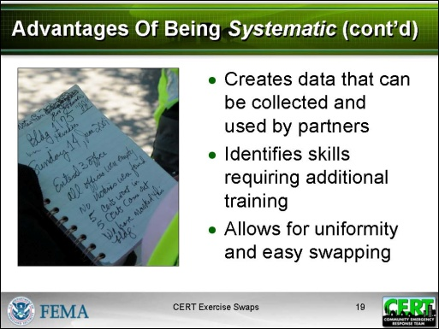  Display Slide 19 | Continue to summarize the advantages of being systematic.  Tell participants that being systematic:  - Creates data that can be collected and used by partners  - Identifies skills requiring additional training  - Allows for uniformity and easy swapping
 | Emphasize that an exercise that is useful and engaging is the result of lots of planning and preparation before volunteers arrive.
Transition to the activity. | Explain that participants will now have a chance to say what they think makes a good exercise.
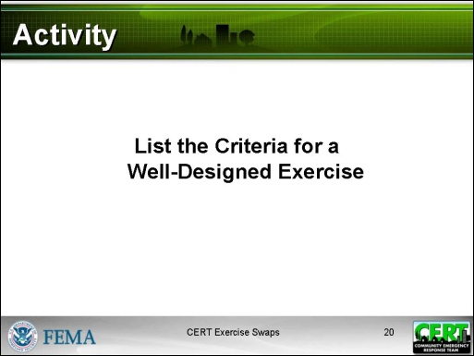  Display Slide 20  PM, P. 8 | Activity: List the Criteria for a Well-Designed Exercise  Purpose: The purpose of this activity is to have participants list the elements of a well-designed exercise.  Time: 5 minutes (individual work: 4 minutes, debrief: 1 minute)  Instructions:  - Tell participants to write down what they think are the criteria for a well-designed exercise in the space provided in the Participant Manual: “I know an exercise is designed well when: …”  - If people seem to be having trouble listing criteria, have them consider something analogous, such as planning a large-scale event.
Record the ideas on an easel pad or whiteboard. | Debrief:  Debrief the activity by going around the room and asking for ideas from the participants’ lists. Only allow one idea per person. Use the list below to add any ideas that were not suggested.
Refer participants to the list in the Participant Manual. | Criteria For A Well-Designed Exercise  - Is written down  - Addresses an identified training need  - Has one or more specific objectives  - Evaluates CERT plans, procedures, and capabilities  - Is manageable within the timeframe  - Has a schedule  - Defines the roles of and provides written guidance for CERT members, victims, Facilitators, Evaluators, and Safety Officers  - Ties evaluation to objectives  - Provides reasonable practice time
- Requires documentation
- Anticipates problems and incorporates contingencies
- Plans for logistical needs
 | Summarize by saying that the next section of the training will review the six steps teams follow to develop and conduct exercises.
 | Ask if there are any questions about exercises in general before you begin discussing the exercise process itself.
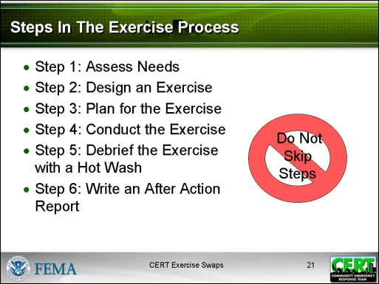  Display Slide 21 | Steps and Documents  Steps In The Exercise Process  Explain that there are six steps to developing and conducting exercises:  - Step 1: Assess Needs  - Step 2: Design an Exercise  - Step 3: Plan for the Exercise  - Step 4: Conduct the Exercise  - Step 5: Debrief the Exercise with a Hot Wash  - Step 6: Write the After Action Report  Explain that some of these steps take longer than others. However, each one is essential and no step should be skipped.
 | Say that the first three steps deal with developing an exercise. This training focuses on these steps. The exercise development process is a methodical, step-by-step building of information. Over the course of several meetings, developers plan for the coming together of many volunteers. They make decisions about everything from purpose and scope to equipment and signage.
A word about terms:
Explain that for the purposes of this training, the following terms are used:
- A team is a group of CERT members.
- Each team plays two roles:
- The team will be called the Design Team when developing an exercise for its partner team.
- The team will be called the Player Team when it plays out the exercise developed by the Design Team.
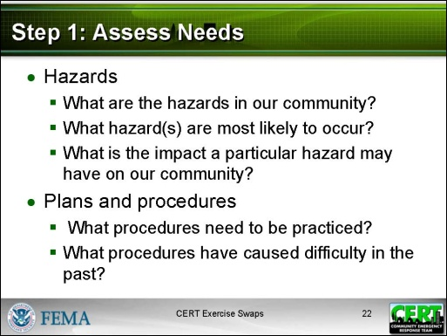  Display Slide 22 | Step 1: Assess Needs  Say that, even before designing an exercise, designers need to ask some fundamental questions.  - The first questions are about hazards.  - What are the hazards in our community?  - What hazard(s) are most likely to occur?  - What is the impact a particular hazard may have on our community?  - The next questions are about plans and procedures.  - What procedures need to be practiced?  - What procedures have caused difficulty in the past?
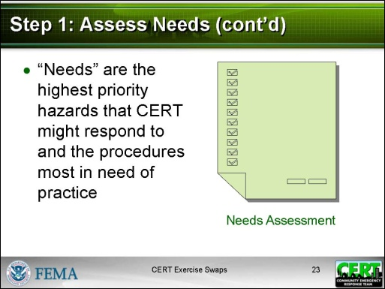  Display Slide 23 | Explain that, for the purposes of CERT exercise design, “needs” relate to the highest priority hazards that team might respond to and the procedures most in need of practice.  - The most experienced members of the team should be able to identify these needs.  - The needs may be based on previous activations or input from professional emergency responders in the community.
Appendix, Needs Assessment PP. 1-7  Before you introduce the exercise, walk participants through the entire CERT Needs Assessment. Make sure they understand what each part is for.  The Needs Assessment is the first document in the Appendix. | Refer participants to the CERT Needs Assessment and walk through it. Use the details below to describe each of these sections:  - Needs Assessment cover page, “How to Use this Template”  - Section 1: Think about the hazards in your community.  - Section 2: Write down your two highest priority hazards.  - Section 3: Identify the CERT capabilities or procedures most in need of rehearsal.  - Section 4: Provide additional details that will be useful to the Design Team.
Needs Assessment Cover Page, “How to Use this Template”:
Remind participants that an exercise swap involves two teams. Each team completes a CERT Needs Assessment for itself and provides it to its partner team. The partner team then develops an exercise based on the information in the other team’s Needs Assessment.
- Think about the hazards in your community.
  - This section provides information on how to identify hazards.
    - What hazards might occur (others can be added to the list provided)
    - What hazards are most likely to have serious consequences
    - What would be the impact of those hazards
- Write down your two highest priority hazards.
  - In this section you record your two highest priority hazards.
- Identify the CERT capabilities or procedures most in need of rehearsal.
  - In this section you identify the capabilities and procedures that your team most needs to practice.
- Provide additional details that will be useful to the Design Team.
  - This section provides other information that will be useful in designing an exercise for your team.
    - What plans and procedures you use
    - Who you partner with
    - A profile of your team
    - A description or map of your team’s geographic area
Transition to the activity. | Say that each team will now complete a Needs Assessment for its own team. It will then present the Needs Assessment to its partner team.
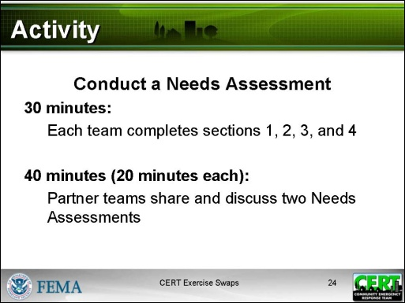  Display Slide 24 | Activity: Conduct a Needs Assessment  Purpose: The purpose of this activity is for each team to complete a Needs Assessment for itself so that its partner team can design an exercise that will meet its needs.  Time: 70 minutes  - Complete Needs Assessment: 30 minutes.  - Present Needs Assessments: 40 minutes, allowing 20 minutes for questions and discussion of each plan.
Instructions:
- Assign each team to work as a group on this activity. Participants should move chairs or tables as necessary to do this.
- Tell participants to appoint someone to record the group’s answers on a single document that will be shared with the partner team.
- Emphasize to the group that this activity is very important in the overall exercise process. Each team’s own Needs Assessment will be used by its partner team, acting as designers, to develop exercise objectives. The exercise objectives will become the foundation on which the partner team in its designer role will build an exercise.
Appendix, Needs Assessment PP. 1-7 | - Ask each team to work together to complete sections 1, 2, and 3. In the interests of time, for section 4 ask the groups to break into small groups of 1-2 to complete the four parts.  - At the end of the 30 minutes, each team should have completed its own Needs Assessment.  - For the next part of the activity, explain that now each team will have 20 minutes to share their Needs Assessment with its partner team. Emphasize that the Needs Assessment will guide each team in designing an exercise for its partner team.  - Allow each team 20 minutes to present its needs to its partner team. Questions and discussion should be encouraged.  - If needed, ask each team to explain in what ways its procedures or operations may be unique.
Transition to Step 2.
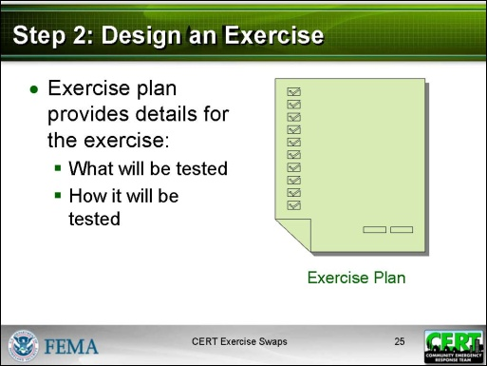  Display Slide 25 | Step 2: Design An Exercise  Explain that each team will now be focusing on its role as Design Team.  Tell the participants that, once the CERT Needs Assessment has been completed, the next step is to design an exercise based on the information. An exercise plan would be worthless unless it were based on a thorough and current Needs Assessment.  Explain that an exercise plan provides all the details for the exercise:  - What will be tested  - How it will be tested
Appendix, Exercise Plan PP. 1-10  Walk participants through the entire CERT Exercise Plan. Make sure they understand what each part is for and how to complete it.  NOTE: Instructions and examples on the form are in italics. | Refer participants to the CERT Exercise Plan and walk through these four sections:  - Section 1: Exercise Objectives  - Section 2: Scope  - Section 3: Scenario  - Section 4: Events and Evaluation Form for Facilitator(s) and Evaluator(s)  Use the information on the following pages to explain what is in the section and how it should be completed.  Explain that the Exercise Plan will be completed during the course of the training.
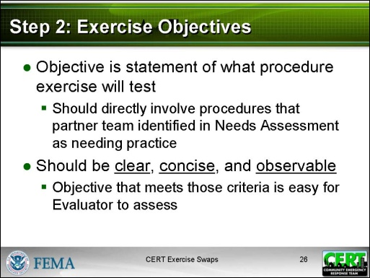  Display Slide 26 | Exercise Objectives  Describe what an objective is and its purpose: an objective is a statement of what procedure the exercise will test.  - Objectives should directly involve procedures that the partner team identified in the Needs Assessment as needing practice.  - Objectives should be clear, concise, and observable.  - An objective that meets those criteria is easy for the Evaluator to assess.
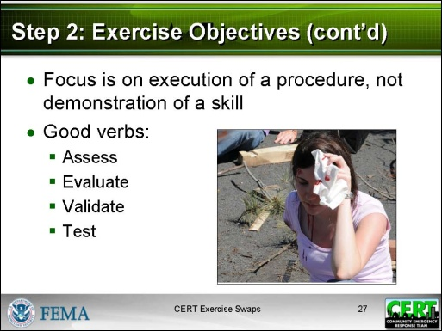  Display Slide 27 | Emphasize that objectives should focus on the team’s successful execution of a procedure, not on how well CERT members demonstrated a skill.  Say that the best way to ensure that objectives are focusing on procedures and not on individual skills is to begin an objective with a verb such as:  - Assess  - Evaluate  - Validate  - Test
PM, P. 15 | Give some examples of objectives that focus on a procedure:  - Validate the plan to establish an Incident Command structure.  - Assess plans and protocols for communicating between the team and professional responders, between the CERT Command Post and the field, and between team members.  - Assess application of search and rescue procedures.  - Assess application of medical procedures.  - Evaluate methods for documenting actions taken.  - Validate CERT sizeup procedures.
Share this example of how a CERT capability that needs practice can be translated into an objective.
- The Needs Assessment identifies “Communications” as a capability for practice.
- The objective that can be tested during an exercise is “Assess procedures for communication between the Incident Commander and the teams.”
Transition to the activity. | Say that each team will now write the objectives for the exercise it will develop.
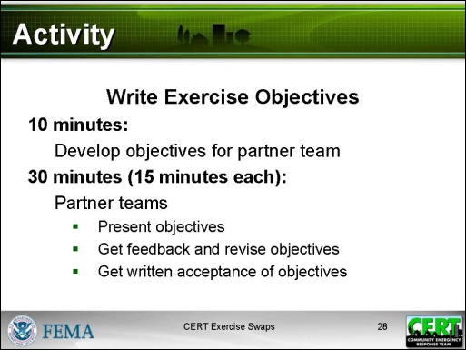  Display Slide 28 | Activity: Write Exercise Objectives  Purpose: The purpose of this activity is for each team in its role as Design Team to write objectives for the exercise it will develop for its partner team - the Player Team. The partner teams will then review the objectives, provide feedback, and accept the revised objectives.  Time: 40 minutes  - Develop objectives for partner team: 10 minutes.  - Present objectives, review, and revise: 30 minutes, allowing 15 minutes for discussion and acceptance of each team’s objectives.
Instructions:
- Assign each team to work as a group on this activity. Participants should move chairs or tables as necessary to do this.
- Tell participants to appoint someone to record the objectives on the Exercise Objectives sheet (Page Exercise Plan 3 in the Appendix).
- Ask each team to:
  - Review the capabilities noted on the Needs Assessment that was completed by its partner team.
  - Develop objectives (maximum of four).based on those capabilities and other information in the Needs Assessment.
- At the end of the 10 minutes, each team should have a maximum of four objectives to review with its partner team.
- For the next part of the activity, explain that now each team will have 15 minutes to share their objectives with its partner team, get their feedback, and develop revised objectives. The partner team will indicate its acceptance of the objectives by signing Exercise Plan Page 4 in the Appendix.
- Allow each team 15 minutes to get acceptance for the objectives it has written.
Debrief:
Ask these questions about developing the objectives.
- Did the Needs Assessment give you enough information to develop the objectives?
- If not, what more would you want?
Ask this question about reviewing the objectives with the partner team.
- Did your partner team revise your objectives?
 | Explain that now that the objectives are developed, the rest of the exercise plan can be developed. The sections still to be developed are the Scope, the Scenario, and the Events and Evaluation Form for Facilitator(s) and Evaluator(s).
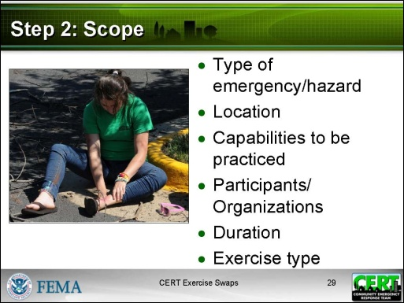  Display Slide 29 | Scope  Explain that scope gives a quick overview of the exercise.  - Type of emergency/hazard (comes from the Needs Assessment)  - Location (comes from the Needs Assessment)  - Capabilities to be practiced (comes from the Needs Assessment)  - Participants/Organizations (comes from the Needs Assessment)  - Duration (typically 3-6 hours)  - Exercise type (in this case, it is full-scale)
PM, P. 17 | Refer participants to the example of scope.
  Hazard: | High winds
  Location: | Cedar Knolls neighborhood
  Capabilities: | Incident Command System  Medical treatment area setup  Communications  Documentation  Sizeup
  Participants: | Bronxville CERT and Bronxville Fire Department
  Duration: | 4 hours
  Exercise Type: | Full-scale
PM, P. 18 | Point out the list of capabilities that might be exercised:  - Incident Command System  - Communications  - Between team members  - CERT Command Post to field  - Team to first responder  - Fire extinguishers  - Hazardous materials identification  - Gas shutoff  - Medical treatment area setup  - Medical triage
- Lifesaving interventions
- Splinting and bandaging
- Patient transport (carries)
- Search techniques – interior
- Search techniques – exterior
- Rescue procedures
- Documentation
- Scene management
- Sizeup
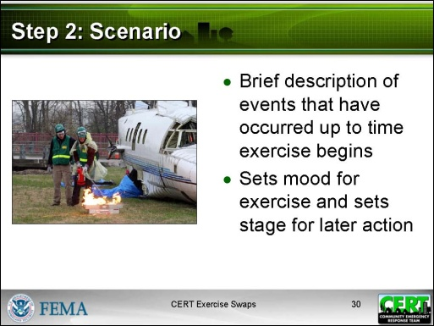  Display Slide 30 | Scenario  Explain that the scenario is a description of the events that happened right up until the exercise begins.  Say that a well-written scenario sets the stage and the mood for the exercise. It helps participants get into their roles and visualize the event as if it were real. Including multiple challenges in the scenario allows you to test more procedures.
PM, P. 19 | Refer participants to the example of a simple narrative scenario:  A strong wind storm has hit the community. Power lines and communications are down. Traffic signals all over town are not working. In your team’s service area a housing complex has been badly damaged. There are reports of numerous victims in the buildings.  The day is cool and cloudy. It has been raining lightly all day. The temperature is expected to fall sharply later.  Emergency services are managing responses in other parts of town. The local team has been activated to assess damage and to rescue and treat victims in the complex. CERT members have just arrived at the pre-designated meeting point. Many of them have brought damage reports with them.
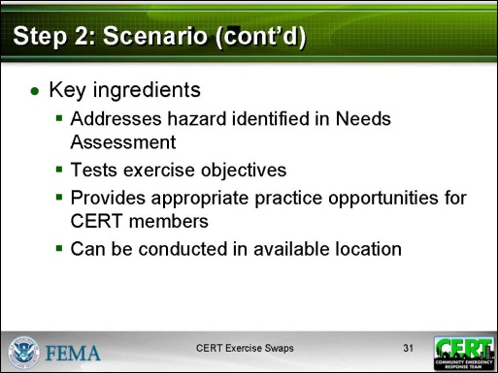  Display Slide 31 | Remind participants that developing scenarios can be a lot of fun and it is easy to get very elaborate. Be creative but realistic. The scenario should:  - Address the hazard identified in the Needs Assessment.  - Test the exercise objectives.  - Provide appropriate practice opportunities for CERT members.  - Be able to be conducted in an available location.
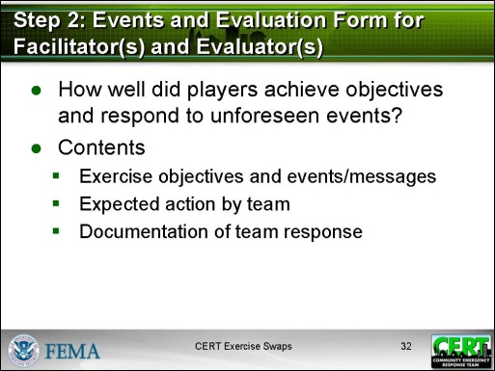  Display Slide 32  Sometimes these events/messages are called “injects.” | Events and Evaluation Form for Facilitator(s) and Evaluator(s)  Describe the final section of the exercise plan and how it is used.  - A key component of any exercise is the evaluation: how well did the players achieve the objectives and respond to unforeseen events?  - The Events and Evaluation Form for Facilitator(s) and Evaluator(s) should contain both the exercise objectives and unforeseen events that will be presented by the exercise Facilitators.  - In order to make the exercise more challenging, exercise Facilitators are given a list of events or messages to be communicated to exercise participants during the exercise.
- Messages and other events will require team members to adjust their plan and take some action or make a decision.
- Here are some examples of a message/event for the scenario above:
- “A team member has been injured during operations.”
- “A citizen volunteer walks up and asks how he/she can help.”
- A moderately damaged building with victims inside is reported at [street address].
- Each Evaluator is provided the Events and Evaluation Form for Facilitator(s) and Evaluator(s) at the briefing for the exercise. The form includes:
- Exercise objectives and messages/events
- What the expected action/response should be
- A place to document what actually occurred
Transition to the activity. | Say that each team will now begin to develop the remaining sections of the Exercise Plan for its partner team using the partner team’s Needs Assessment.
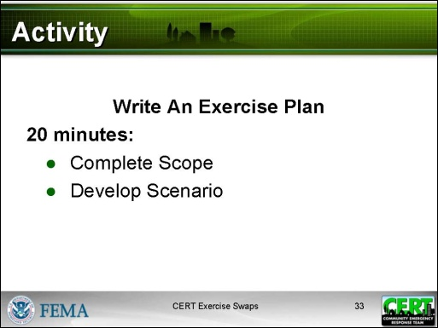  Display Slide 33  If possible, make enough copies of each team’s Needs Assessment so that each member of its partner team has one.  Circulate during the activity and provide assistance as needed.  This activity will be completed at the beginning of Part 2. The teams should have time to complete Scope and Scenario. They will not have time to complete the Events and Evaluation Form for Facilitator(s) and Evaluator(s). | Activity: Write An Exercise Plan  Purpose: The purpose of this activity is for each team to develop an Exercise Plan for its partner team using its partner team’s Needs Assessment.  Time: 20 minutes  Instructions:  - Assign each team to work as a group on this activity. Participants should move chairs or tables as necessary to do this.  - Tell participants to appoint someone to record the group’s answers on a single document that will be shared with its partner team.  - Ask each team to work together to complete their sections on Scope and Scenario.  - Remember to base the work on the partner team’s Needs Assessment.  - Record the capabilities for which objectives were developed.  - Develop a realistic scenario.  - Explain that the Events and Evaluation Form for Facilitator(s) and Evaluator(s) will be developed in Part 2.  - Stop the activity 5 minutes before the end of the Part 1 session.
Debrief:
When the time is up, assess where the teams are in developing their Exercise Plans so that you know where they will need to start in Part 2.
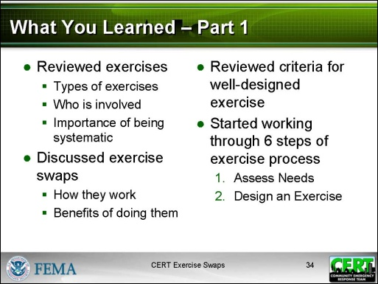  Display Slide 34 | Part 1 Summary  Review what was covered in this session:  - Reviewed exercises  - The types of exercises, with a focus on the full- scale exercise  - Who is involved in an exercise  - Why it is important to conduct exercises in a systematic way  - Discussed exercise swaps  - How they work  - The benefits of doing them  - Reviewed the criteria for a well-designed exercise  - Started working through the six steps of the exercise process.  - Step 1: Assess Needs  - Step 2: Design an Exercise
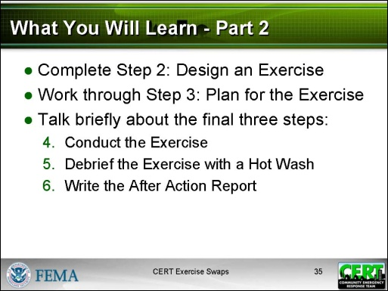  Display Slide 35 | Review what will be covered in the next session:  - Complete Step 2: Design an Exercise  - Work through Step 3: Plan for the Exercise  - Talk briefly about the final three steps:  - Step 4: Conduct the Exercise  - Step 5: Debrief the Exercise with a Hot Wash  - Step 6: Write the After Action Report
 | Provide details about the second part of the training, e.g., date and time, if it is not conducted on the same day as Part 1.
End of Part 1

Instructor guidance | Content
CERT Exercise Swaps Part 2
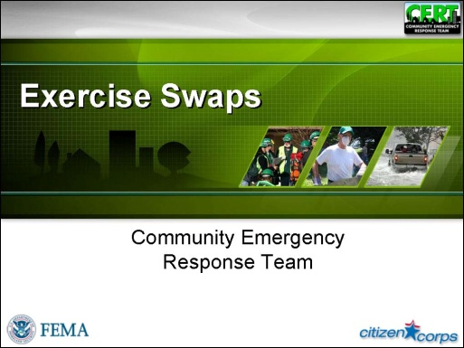  Display Slide 36  Keep this discussion brief. | Welcome the participants to the second part of the CERT Exercise Swaps supplemental training.  Ask if anyone had any questions or observations from the first session.
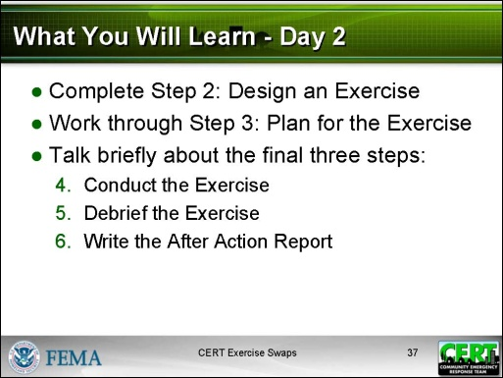  Display Slide 37 | Explain that the remaining steps of the exercise process will be covered in this session:  - Complete Step 2: Design an Exercise  - Work through Step 3: Plan for the Exercise  - Talk briefly about the final three steps:  - Step 4: Conduct the Exercise  - Step 5: Debrief the Exercise with a Hot Wash  - Step 6: Write the After Action Report
Transition to the activity. | Tell participants that the first activity is to complete the design activity that the teams began to develop in Part 1.
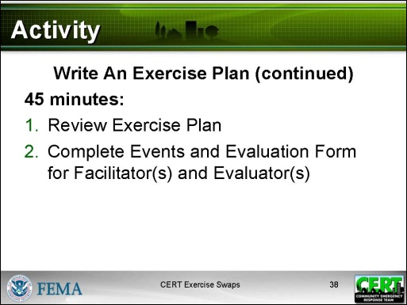  Display Slide 38 | Activity: Write An Exercise Plan (continued)  Purpose: The purpose of this activity is for each team to complete the Exercise Plan for its partner team using its partner team’s Needs Assessment.  Time: 45 minutes  - Review completed sections of Exercise Plan: 5 minutes.  - Develop Events and Expected Actions: 25 minutes.  - Debrief: 10 minutes.
Instructions:
- Remind each team to:
  - Work as a group on this activity. Participants should move chairs or tables as necessary to do this.
  - Appoint someone to record the group’s answers on a single document that will be shared with its partner team.
- Ask each team to FIRST review the part of the plan it has already completed: Exercise Objectives, Scope, and Scenario. Make any adjustments that might seem appropriate. This should take about 5 minutes.
- Then ask each team to create a list of events and expected actions and add them to the Events and Evaluation Form for Facilitator(s) and Evaluator(s).
- Provide these instructions:
  - Participants should complete the Message/Event column and the Expected Action column, but not the Actual Observed column.
  - Message/Event
    - Add each of the exercise objectives to the Events and Evaluation Form for Facilitator(s) and Evaluator(s) in the Message/Event column.
    - For each objective, write a few events beneath it that will test the objective. Be creative in developing these events, but also be realistic. Remember that the event/message is another opportunity to test the team’s application of its plans, procedures, and capabilities. See example on page Exercise Plan p. 7. There should be no more than 6 events under each exercise objective. If an event does not relate to an objective, it should be removed.
    - Every message/event must include the objective(s) it relates to.
    - Specify if the event is to happen at a specific location. For example, if the event is to happen at the Command Post, then the Lead Facilitator will know that he or she is responsible for giving that message.
    - Facilitators and Evaluators must be stationed at each location (i.e., Incident Command Post, Search and Rescue area, medical treatment area).
  - Expected Action
    - For each message/event, determine how the players would successfully respond to this event by entering the expected action in the Expected Action column.
    - Each event should trigger player actions that relate to exercise objectives. Expected actions are determined by the policies, procedures, and training of the team.
Debrief:
Debrief the activity by asking participants about the development process. Emphasize to the teams that they do not want to reveal exercise details to the Player Team for whom they are designing and will conduct the exercise:
- What were the challenges in developing a scenario?
- What were the challenges in developing exercise events and expected actions?
Transition to Step 3.
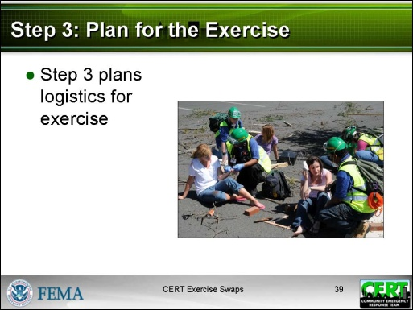  Display Slide 39 | Step 3: Plan For The Exercise  Say that planning an exercise requires a lot of coordination. Step 3 in the exercise process is to plan for the logistics of the exercise.
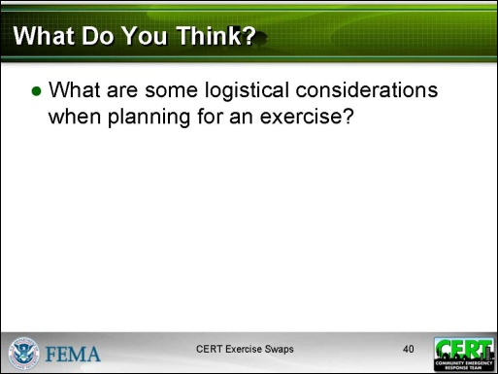  Display Slide 40  Conduct a short discussion based on this question. Use the easel pad or a whiteboard to record participant answers. | What Do You Think?  Ask participants:  What are some logistical considerations when planning for an exercise?
Appendix, Logistics Plan PP. 3-4  Refer participants to the Planning Considerations table in the Logistics Plan. | Planning Considerations  Summarize the discussion by reviewing the table.
 | Emphasize that the success of an exercise depends on the thorough completion of all the tasks of Step 3: Plan for the Exercise.
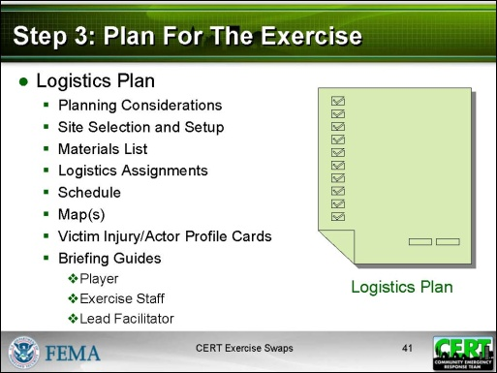  Display Slide 41  Appendix, Logistics Plan PP. 1-29  Refer participants to the Logistics Plan as you review it. Participants will also need to look at pages in the Participant Manual, so they should have both available. | The Logistics Plan  Walk through the Logistics Plan, using the information in the following pages to provide details.  - Planning Considerations  - Site Selection and Setup  - Materials List  - Logistics Assignments  - Schedule  - Map(s)  - Victim Injury Cards  - Actor Profile Cards  - Player Briefing Guide  - Exercise Staff Briefing Guide  - Lead Facilitator Guidelines
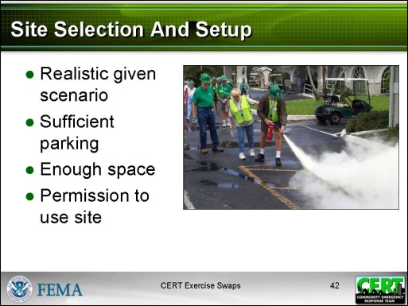  Display Slide 42  Appendix, Logistics Plan P. 5 | Site Selection And Setup  Tell participants that many of the decisions will depend on where the exercise is conducted.  Say that the site selected must:  - Be realistic given the scenario and hazard  - Have sufficient parking and space for all the staging locations  - Be approved well in advance by the authority or owner of the property  Explain that public schools, libraries, stadiums, a building scheduled for demolition, or a park might be good areas for an exercise.
 | Say that the site should be able to be subdivided into staging locations for sign-in, staff and player briefing, areas of play (for example, Command Post, medical treatment area, morgue), and break/refreshment area.
 | Say that permission to create a realistic incident site may include the ability to turn off utilities to simulate outages. Ask the facility to have a representative with knowledge of the facility’s infrastructure on hand during the exercise.
Appendix, Logistics Plan P. 6 | Materials List  Say that materials include both people and things.  Explain that some basic equipment will be required at all exercises regardless of the complexity and type:  - CERT PPE  - Signage  - Radio  - Maps  - Tables  - Tents  - Water  - Pens  - Method for documentation (forms)  - Restrooms  Say that the materials needed will depend on the scenario. For example, a search and rescue following a tornado would require moulage, props to simulate building damage, Victim Injury Cards, etc.  Tell participants that they will find themselves adding to the materials list as they prepare for the exercise.
Appendix, Logistics Plan P. 7 | Logistics Assignments  Review the logistics assignments and the job descriptions. Most of the categories on the Logistics Assignments sheet are straightforward but there is more information about two of the categories below:  - Rules of Play  - Communication  Emphasize that many logistics assignments will require planning and coordination weeks before the exercise.
PM, P. 26 | Rules Of Play  Explain that these are the most common rules of play:  - Safety is the paramount concern.  - The exercise will take place (Insert a description of the boundaries of the exercise area. Be very clear about what is in bounds and what is out of bounds.)  - The exercise will begin at (insert time) and will continue until either all victims have been rescued or time is up.  - The exercise will be terminated by three long whistle blasts. Return to the (insert location) at the end of the exercise.  - The same signal will be used if we need to terminate the exercise early.  - Return to the (insert location) at the end of the exercise.
PM, P. 27 | Communication  - All communications about the exercise must start and end with “This is an exercise.”  - Emergencies: Sometimes in a simulation, players will need to communicate outside the scope of the exercise. Here are some examples:  - Should a player need to communicate something outside the scope of the exercise, he or she prefaces the statement with “Real world . . .” So, for example, if a player twists an ankle, he or she says “Real world . . . I’ve twisted my ankle and need medical attention.”  - If exercise staff needs to communicate with a player outside the scope of the exercise, he or she will say “Facilitator says . . .” So, for example, if the Facilitator or Evaluator observed an unsafe carry technique, he or she would say “Facilitator says STOP.”
- Public information officer. Having a public information officer communicate the exercise’s goals and scenario in advance will help the exercise run with minimal interruption from the public.
- Sponsoring agency. Notify the CERT’s sponsoring agency well in advance of the exercise.
Appendix, Logistics Plan P. 8 | Scheduling  Say that the Design Team planning the exercise needs to arrive an hour before the exercise starts. Some of the activities that must be performed before the exercise are:  - Posting parking and directional signs  - Labeling staging areas  - Erecting tables, tents, and chairs
- Setting up refreshments
- Setting up the Command Post
Explain that the Design Team has responsibility for conducting the hot wash, collecting feedback forms, taking down signs, and returning equipment. This may take an hour after the exercise ends.
Explain that the facility should be scheduled for the duration of the exercise plus additional time for setting up and cleaning up.
Appendix, Logistics Plan P. 9 | Map  Explain that the Design Team should draw one or more maps that show the area of play and the placement of all role-players (volunteer victims) and exercise staff.
Appendix, Logistics Plan PP. 10-12 | Victim Injury Cards  Explain that Victim Injury Cards are intended to simplify the process of simulating victims. They can be used in two ways.  - If you have volunteer victims, use these descriptions to create roles for them. Brief the volunteers on the nature of their injuries, how they might behave, and any information you want them to share with search and rescue staff.  - If you are using simulated victims, such as mannequins or gingerbread cutouts, you can attach a label to each with one of the descriptions.  Point out that an exercise may not use all of these cards or the Design Team may choose to create its own.
Appendix, Logistics Plan  P. 13 | Actor Profile Cards  Say that sometimes your exercise events include someone who appears unexpectedly and that the Player Team members have to deal with, e.g., a spontaneous volunteer wanting to help or a hysterical person who needs attending to. Write a description of that person on an Actor Profile Card and give it to the person who will play the role.
Appendix, Logistics Plan  PP. 14-29 | Player Briefing Guide, Exercise Staff Briefing Guide, Lead Facilitator Guidelines  Tell participants that these guides provide key information for the various participants in the exercise. They are primarily a compilation of information already developed.
Player Briefing Guide (for CERT members and for volunteers)
- Player Guidance
- Scenario
- Exercise Objectives
- Rules of Play
- Communication Procedures
- Participant Feedback Form
NOTE: Because players must respond to information as it is revealed to them, many aspects of the exercise plan are withheld from their briefing guide.
IMPORTANT: Distribution of the Player Briefing Guide may be something you want to discuss. The briefing itself is mandatory. But some teams find that, since there is no clean place to put or keep the briefing guide, they prefer to do the briefing verbally and then distribute the Participant Feedback Form at the hot wash.
Exercise Staff Briefing Guide
Explain that the Exercise Staff Briefing Guide is given to exercise staff before the exercise. The Lead Facilitator will brief staff on the following:
- Exercise Staff Roles
- Rules of Play
- Communications Procedures
- Exercise Objectives
- Scenario
- Exercise Schedule
- Events and Evaluation Form for Facilitator(s) and Evaluator(s)
- Facilitator Feedback Form
- Strengths and Weaknesses
Appendix, Logistics Plan PP. 24-28  Walk participants through the steps in the Lead Facilitator Guidelines. These guidelines will show the class how an exercise is conducted. | Lead Facilitator Guidelines  Explain that the Lead Facilitator Guidelines helps ensure that all objectives are met and helps the Lead Facilitator direct the flow (or pace) of the exercise. The Lead Facilitator Guidelines includes the following:  - A detailed description of the Lead Facilitator’s tasks on the day of the exercise  - Comments the Lead Facilitator makes during the exercise  - Note-taking space for the hot wash
Transition to the activity.
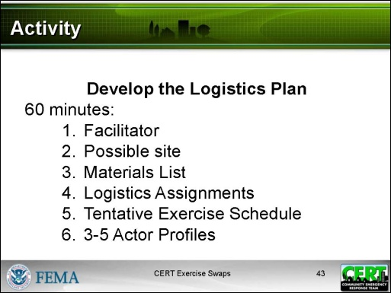  Display Slide 43  If possible, make enough copies of the Exercise Plan so each member of the team has one to refer to. | Activity: Develop the Logistics Plan  Say that, before an exercise can be conducted for a partner team, each team will have to develop a complete Logistics Plan. Each team can start putting that plan together now.  Purpose: The purpose of this activity is to begin to develop a Logistics Plan for the partner team.  Time: 75 minutes  - Activity: 60 minutes.  - Debrief: 15 minutes.
PM, P. 32  The worksheet is also on the following pages in the Instructor Guide. | Instructions:  - Assign each team to work as a group on this activity. Participants should move chairs or tables as necessary to do this.  - Tell participants to appoint someone to record the group’s answers on the Preliminary Logistics Planning Worksheet. Eventually the information will be transferred to the Logistics Plan.  - Have participants review the Exercise Plan to ensure the Logistics Plan supports the scenario, the objectives, and the events.  - Tell participants to turn to the Preliminary Logistics Planning Worksheet.
Circulate during the activity and provide assistance as needed. | - Ask each team to work together on the following. Complete as much as possible in the time allotted:  - Who the Lead Facilitator will be  - A possible site for the exercise  - Materials List  - Logistics Assignments  - Exercise Schedule  - 3-5 actor profiles  - Stop the activity after 60 minutes to conduct the debrief.
NOTE: This debrief is critical. Participants will need to have a list of what still needs to be done and when it will be done.  Emphasize this point. | Debrief:  - Discuss any questions participants have about planning the logistics for an exercise.  - Review what still needs to happen before the Logistics Plan is complete:  - The site needs to chosen and contact made.  - A final materials list needs to be prepared.  - The people who received logistics assignments need to complete them and report back.  - A final schedule needs to be developed.  - A map may be prepared, if needed.  - Exercise staff and volunteers (victims and actors) need to be recruited and briefed.  - The Player Briefing Guide, the Exercise Staff Briefing Guide, and the Lead Facilitator Guidelines need to be prepared.  - Remind each team that someone on the team must be responsible for creating a master Logistics Plan for the exercise.  - Tell participants that they should set a time for their next meeting before leaving the training. Note that more than one meeting may be needed to complete the Logistics Plan.

PM, P. 32 | Preliminary Logistics Planning Worksheet
Instructions: Complete what you can on this worksheet based on the knowledge and information that you have right now.

Lead Facilitator: ___________________________________________

Site Selection
These are potential sites for the exercise.
1.

2.

3.

Materials List
People
For what task? | How many? | Where can we recruit them?
Materials/Supplies
What? | How much? | Where can we get it?

Logistics Assignments
In addition to identifying the person responsible for each assignment, consider who would be a backup if that person is not available.
Rules of Play  (Develop rules of play.) | Person responsible:
Communication  (Identify needed communications, develop communications procedures.) | Person responsible:
Safety Considerations  (Identify safety concerns and procedures.) | Person responsible:
Refreshments  (Arrange for donations, setup distribution, clean up.) | Person responsible:
Restrooms  (Ensure that restrooms are available. May be portable.) | Person responsible:
Equipment and Materials  (Arrange for, set up, clean up.) | Person responsible:
Signs  (Arrange for, set up, clean up.) | Person responsible:
Scheduling  (Develop, coordinate deliveries, oversee sign-in.) | Person responsible:
Site Selection and Setup  (Interact with owner, ensure compliance with any requirements, clean up.) | Person responsible:

Role-Player Preparation  (Find volunteers, oversee moulage and placement.) | Person responsible:
Badges  (Arrange for, distribute.) | Person responsible:

Tentative Schedule
 | Exercise Date:
Time | Personnel | Activity
 | Exercise staff arrive at site | Exercise staff briefing
 | Selected exercise staff | Exercise site setup
 | Participants (players, actors, other volunteers) | Registration
 | Exercise staff | Communications check
 | Participants | Player briefing
 | All | Report to various locations
 | All | Start of exercise
 | All | End of exercise
 | Participants, exercise staff | Hot wash
 | Exercise staff | Event debriefing

Actor Profile Cards

Sample Actor Profile Card
You are a person from the neighborhood. You run up to one of the teams as they are searching a building. You are agitated. You insist that they have to come immediately to help you rescue your dog.

Actor Profile Card

Actor Profile Card

Actor Profile Card

Actor Profile Card

Actor Profile Card

Instructor guidance | Content
Transition to Step 4.
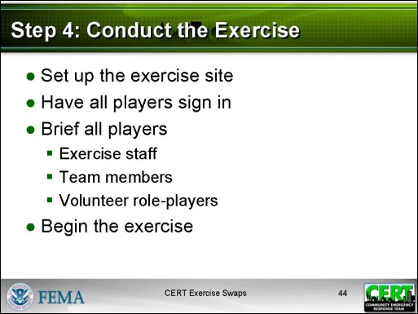  Display Slide 44  Appendix, Forms P. 1  Refer participants to the Forms section in the Appendix as you review how to conduct the exercise. | Step 4: Conduct the Exercise  Say that conducting the exercise involves implementing the Exercise Plan and the Logistics Plan. In an exercise swap, the exercise Design Team is responsible for conducting the entire exercise for its partner team.  Set Up  Explain that generally setup begins at least an hour before the players sign in.  Sign In  Say that typical pre-exercise activities include having players sign in, provide contact information, and submit a signed participation waiver.  See the following forms:  - Sign-In Sheet for CERT Members  - Sign-In Sheet for Volunteers  Explain that the Participant Waiver, Release, and Indemnity Agreement or a similar form will be provided by the local CERT program.
Briefing
Say that the Lead Facilitator will first disseminate the Exercise Staff Briefing Guide and will explain the following:
- Exercise staff roles
- Rules of play
- Communications procedures
- Exercise objectives
- Scenario
- Exercise schedule
- Events and Evaluation Form for Facilitator(s) and Evaluator(s) form
- Facilitator Feedback Form
- Strengths and Weaknesses
Explain that the Lead Facilitator will disseminate the Player Briefing Guide to the Player Team and will explain the following prior to the start of the exercise:
- The rules of play
- The communications procedures
- How to identify exercise staff (Facilitator, Evaluator, and Safety Officer)
- Participant Feedback Form
Exercise Begins
Say that the Lead Facilitator sets the stage by introducing the following.
- The scenario (with map) and exercise objectives
- Initial instructions
- Forms available
- Assignment Tracking Log (Command Post)
- Damage Assessment Form (all teams)
- General Message Form (all teams)
- Victim Treatment Area Record Form (medical treatment area)
- After Action Report Form
The Lead Facilitator describes the initial activities. For example:
- An Incident Commander is chosen along with other operations people who will serve at the Command Post.
- The team then sizes up the situation, forms functional teams, and assigns tasks to the functional teams, like conducting a search operation.
- The Lead Facilitator (and additional Facilitators) prompts player actions by describing or simulating events listed on the Lead Facilitator Guidelines.
- Activities are observed, monitored, and evaluated by exercise Facilitators.
Explain that the exercise ends when all objectives have been met or the time has expired. Participants and exercise staff receive feedback forms that are collected prior to the start of the hot wash.
Transition to Step 5.
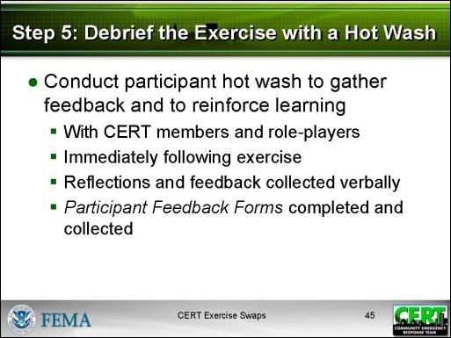  Display Slide 45 | Step 5: Debrief the Exercise with a Hot Wash  Say that the exercise is not over when the whistle blows. In order to get the most value from the exercise, the exercise planners should collect feedback from all the players. It is best to hold two sessions.  - Participant Hot Wash  - Purpose: to gather feedback and to reinforce learning  - Details:  - Conducted immediately following the exercise to guarantee that observations are fresh and participation is high  - Reflections and feedback collected verbally  - Participant Feedback Forms completed and collected
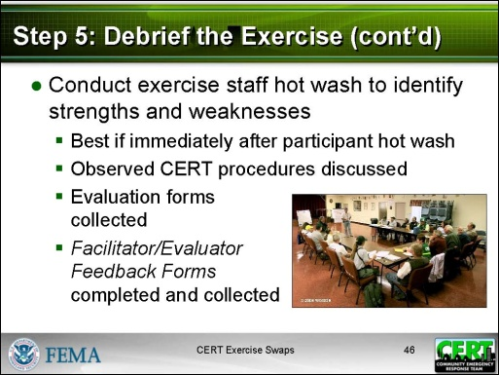  Display Slide 46 | - Exercise Staff Hot Wash  - Purpose: to gather feedback and to identify areas of focus for future exercises  - Details:  - Best if conducted immediately following the participant hot wash; fewer people may be able to attend if the hot wash is postponed  - Observed CERT procedures discussed in detail, including strengths and weaknesses  - Evaluation forms collected  - Facilitator/Evaluator Feedback Forms completed and collected
Transition to Step 6.
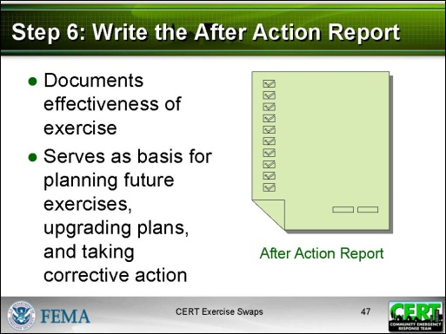  Display Slide 47  Appendix, final form, no page number  Refer participants to the Forms section in the Appendix as you review the After Action Report. | Step 6: Write the After Action Report  Say that, after the exercise, it is important to make time to document the effectiveness of the exercise. A main goal of the exercise is to test CERT procedures and identify areas in which the team needs additional training or improved plans. This report should help a CERT Program Manager plan for future training and skills practice.  Point out that the best practice is to have a few members from each of the teams that participated in the exercise swap contribute to the After Action Report.
Say that the After Action Report contains:
- Scope (from Exercise Plan)
- Scenario (from Exercise Plan)
- Objectives (from Exercise Plan)
- Number of Participants (from Sign-In Sheets)
- Exercise Events Synopsis
- Analysis of Critical Task Performance
- Conclusions
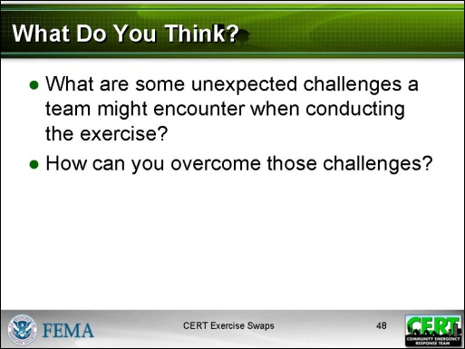  Display Slide 48  Conduct a short discussion based on these two questions. Some answers appear on the next slide. If the discussion yields challenges that are not addressed on the next slide, brainstorm solutions as a class. | Best Practices  What Do You Think?  Ask participants:  - What are some unexpected challenges a team might encounter when conducting the exercise?  - How can you overcome those challenges?
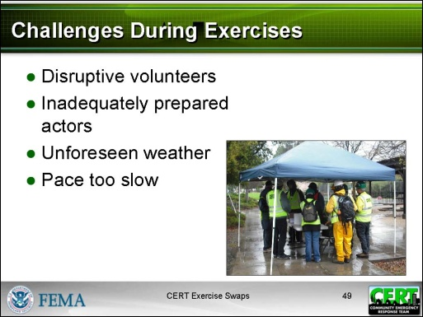  Display Slide 49 | Challenges During Exercises  Summarize the discussion by reviewing the slide and discussing ways to overcome each challenge.  Say that even the thorniest challenges can be expected and mitigated against.  - Disruptive volunteers: You can assume that most volunteers will be inexperienced. Setting clear expectations well in advance of the exercise can help. If you are working with young victim volunteers, you can explain during the briefing how important it is for them to remain “in character” during the exercise and that the exercise Facilitators and Evaluators are authorized to remove anyone who is disrupting the exercise.  - Inadequately prepared actors: Everyone participating in the exercise is playing a role. Having thoroughly developed role-playing instructions is important, but those experienced in conducting operations-based exercises should not be shy about coaching someone in his or her role.
- Unforeseen weather: An exercise can be hampered by unforeseen weather, yet even bad weather can be mitigated with shelters/tents and warm drinks. It may be smart to select a rain date in advance.
- Pace too slow: The average CERT full-scale operations-based exercise runs 3-6 hours. That time does not account for briefing, breaks, and hot wash. When all is accounted for, an exercise can take nearly a full day. A Facilitator is responsible for implementing the messages/events developed by the Design Team as well as deciding when to accelerate the speed of the exercise.
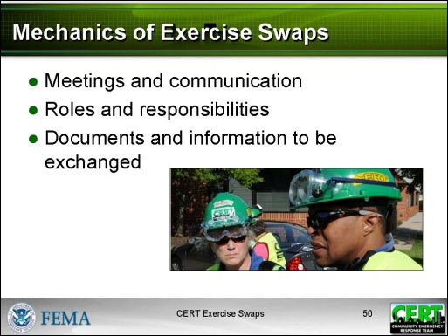  Display Slide 50  Identify who the individual assisting the Design Teams will be. It might be the CERT Program Manager or another CERT program representative. | Mechanics of Exercise Swaps  Explain that the progress made in this module on developing an exercise for a partner team is just part of the task.  Say that, going forward, the Design Teams will take the documentation developed in the module and continue to develop it. This will involve several more planning sessions for each team.  Emphasize that the CERT Program Manager or representative will assist by reviewing the exercise design and documentation and providing input and approval of the exercise plan, but it will be up to each Design Team to schedule its planning sessions.
PM, P. 44  Review with participants the list in the Participant Manual. | Say that several items need to be accomplished by the Design Team in consultation with the CERT Program Manager or representative:  - Scheduling of the exercise date, the facility or neighborhood area, equipment, refreshments, etc.  - Arranging for the facility or facilities to be part of exercise play. A neighborhood-based exercise could require contacting numerous households in the Player Team’s area to inform them of the exercise and get permission to stage exercise activities in the area.  - Assigning roles and responsibilities
Explain that other items may be accomplished with assistance from the CERT Program Manager or representative:
- Arranging for volunteer victims
- Conducting a tabletop walk-through of the exercise plan to plug holes
- Meeting with exercise staff, in particular Facilitators and Evaluators, prior to the exercise and on the day of the exercise
Emphasize that the Design Team can expect the CERT program to provide the following after content has been developed by the Design Team:
- Sending directions and instructions to players and volunteers
- Copying briefing guides and forms
- Preparing maps and signage
 | Be sure to specify other assistance, resources or materials that the CERT program will provide to Design Teams conducting an exercise for Player Teams.
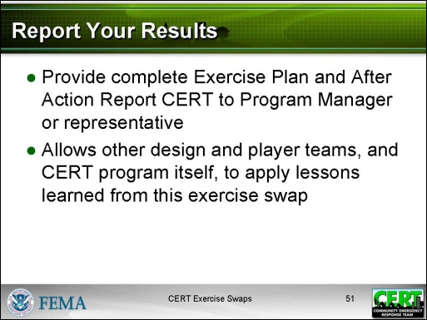  Display Slide 51 | Report Your Results  Say that the complete Exercise Plan and After Action Report in particular must be provided to the CERT Program Manager or representative. This will allow other design and player teams, and the CERT program itself, to apply lessons learned from this exercise swap.
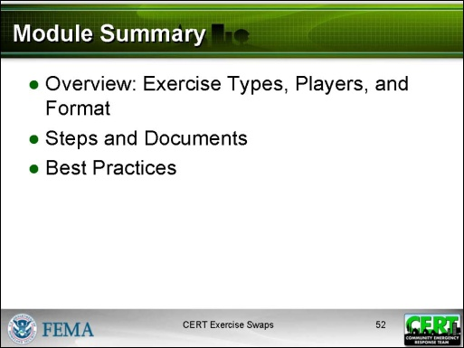  Display Slide 52 | Module Summary  Summarize the topics that were discussed in this module:  - Overview: Exercise Types, Players, and Format  - There are discussion-based exercises and operations-based exercises. The exercise swap is an operations-based (full-scale) exercise.  - Participants include exercise staff, CERT members/players, and volunteers.  - FEMA provides a framework for designing, conducting, and evaluating exercises in a systematic way.  - Designing for an identified need and evaluating actions based on specific objectives improves evaluation.  - A well-designed exercise addresses an identified training need, evaluates plans and procedures, and provides an opportunity for teams to practice their response.
- Steps and Documents
- Step 1: Assess Needs – with the Needs Assessment
- Step 2: Design an Exercise – with the Exercise Plan
- Step 3: Plan for the Exercise– with the Logistics Plan
- Step 4: Conduct the Exercise – with the briefing guides and forms
- Step 5: Debrief the Exercise with a Hot Wash – and collect feedback forms.
- Step 6: Write the After Action Report.
- Best Practices
- Anticipate possible challenges in advance of the exercise can prevent disruptions.
- Each Design Team will meet as needed to complete the Exercise Plan and related documentation, and will coordinate throughout the process with the CERT Program Manager or representative.
- Exercise Plans and other documentation, including the After Action Report, will be submitted to the CERT Program Manager or representative.

Closing
Recommend that each Design Team determine their next meeting date before leaving.
Emphasize that they need to contact the CERT Program Manager or representative as soon as they are ready to have their Exercise Plan reviewed and are ready to conduct the exercise.
Emphasize that they should also contact the CERT Program Manager or representative if questions arise and guidance is needed.
Remind participants of the date of the exercise, if a date is set, and any other upcoming CERT training or activities.
Present certificates to participants.

Thank participants for attending the session.

CERT Exercise Swaps

Appendix

Needs Assessment
Exercise Plan
Logistics Plan
Forms

[This page intentionally left blank]

Index of Appendix Contents

Needs Assessment
Exercise Plan
Exercise Objectives
Scope
Scenario
Events and Evaluation Form for Facilitator(s) and Evaluator(s)
Logistics Plan
Planning Considerations
Site Section and Setup
Materials List
Logistics Assignments
Schedule
Map(s)
Victim Injury Cards
Actor Profile Cards
Player Briefing Guide
Exercise Staff Briefing Guide
Lead Facilitator Guidelines
Forms
Sign-In Sheet for CERT Members
Sign-In Sheet for Volunteer Victims and Actors
Assignment Tracking Log
Damage Assessment Form
General Message Form
Victim Treatment Area Record Form
After Action Report Form

[This page intentionally left blank]

Needs Assessment

How to Use This Template
This document is used initially by one team to identify:
- The hazards in its own community
- The effects of those hazards
- The highest priority hazards
- The CERT operations or functions most in need of practice
This document also provides some information about the team:
- Guiding plans and procedures
- Partners/organizations
- Team profile
- Team map
This document is then used by another team (the “Design Team”) to design an exercise for its partner team – the team that provided the needs assessment (the “Player Team”).

Identify the various hazards in your community.

- Consider the following hazards as a starting point.

- Earthquake  - Fire  - Flood  - Heat  - Hurricane  - Landslide  - Terrorist target | - Thunderstorm  - Tornado  - Tsunami  - Volcano  - Winter Storm  - Nuclear Power Plant

- Of the hazards you identified, which are most likely to occur and have serious consequences?

Consider the following additional factors:
- Frequency of occurrence
- Predictability based on weather patterns and other data such as flood maps
- Location (affecting critical areas or infrastructure)
- Geographic extent
- Speed of onset and availability of warning
- Potential severity of consequences to people, critical facilities, community functions, and property

- Estimate the impact of the high-priority hazards.

Of the hazards that may occur, what are the impacts those disasters may have in your community? Use the following checklist as a starting point:

- Speed of onset and availability of warning
  - Communication system breakdown
- Location and geographic extent of damage affecting critical areas or infrastructure
  - Power outages
  - Transportation blockages
  - Business interruptions
- Potential severity of consequences to people, critical facilities, community functions, and property
  - Injured persons
  - Mass evacuations/displaced population
  - Missing persons
  - Overwhelmed medical/mortuary services
- Potential cascading events
  - E.g., damage to chemical processing plant or dam failure

2. Write down your two highest priority hazards.

Based on the hazards that may occur in your community, the likelihood of occurrence, and the potential impact, what are the highest priority hazards that CERTs would respond to in order to do the greatest good for the greatest number of people? And in what areas of the community is it most beneficial to concentrate this effort?
#1 Priority hazard

Physical location or geographic area of hazard:

Impact of the hazard:

#2 Priority hazard

Physical location or geographic area of hazard:

Impact of the hazard:

3. Identify the CERT capabilities or procedures most in need of rehearsal.

CERT Procedures and Capabilities: What CERT capabilities or procedures are most in need of rehearsal? (e.g., what functions have not been exercised recently, or where difficulties have occurred in the past)

You can use the following list to prompt your answer:
- Using the Incident Command System
- Communications
  - Between team members
  - CERT Command Post to field
  - Team to first responder
- Use of first extinguishers
- Identifying the presence of hazardous materials
- Shutting off gas at the meter
- Setting up a medical treatment area
- Medical triage
- Applying lifesaving interventions
- Splinting and bandaging
- Patient transport (carries)
- Search techniques – interior
- Search techniques – exterior
- Rescue procedures
- Effective documentation
- Dealing with spontaneous volunteers
- Sizeup
We need to practice these capabilities or procedures the most:

1.

2.

3.

4.
4. Provide additional details that will be useful to the Design Team.

- Guiding Plans and Procedures: What plans and procedures will guide your team’s response to an emergency? Examples include: CERT Basic Training procedures, local CERT operational plan, standard operating procedures (SOPs), and team’s activation/staging plan.

- Partners/Organizations: Who needs to participate or be simulated in the exercise? For example, who is designated for emergency management responsibility in your plans and procedures? With whom does your team need to coordinate in an emergency (e.g., Emergency Operations Center, nearest fire station, Neighborhood Watch volunteers)?

- Team Profile: Write a profile of your team. Include the information the Design Team would need to understand your team.
  - Number of active volunteers
  - Any special skills among your team members
  - Area resources
  - Obstacles to factor in
  - The environment
  - Whatever else would be helpful to the other team

- Team Map: Draw or provide a map of your team’s geographic area so that the partner team can identify the location of fire stations, hospitals, highways, parks, schools, etc.

[This page intentionally left blank]

Exercise Plan

Instructions:
Using the Needs Assessment completed by your partner team,
design a full-scale exercise.

Contents:
Exercise Objectives
Scope
Scenario
Events and Evaluation Form for Facilitator(s) and Evaluator(s)

Exercise Plan Contents

Exercise Objectives 3
Scope 5
Scenario 6
Evaluation Form for Facilitator(s) and Evaluator(s) 7

Exercise Objectives
- Develop one objective per capability to be exercised.
- Good verbs to use: Assess, evaluate, test, validate.

Example:
Identified capability: Communications
Objective that can be tested during an exercise: “Assess procedures for communication between the CERT Incident Commander and the teams in the field.”

Draft Objectives
1.

2.

3.

4.

Final Objectives

1.

2.

3.

4.

We accept these objectives:

(Signature of representative of Player Team)

_________________________________________
Scope
Complete this form with information from the Needs Assessment.

Hazard:
Location:
Capabilities to be practiced:

Participants/
Organizations:
Duration:
[Expected start and expected end]
Exercise type: | Full-scale exercise

Scenario
Write a scenario that is a full accounting of the details of the incident up to the point of CERT activation. A scenario should be one to three paragraphs long. It includes information on the hazard, affected area, number of potential victims, safety considerations, time, weather, proximity to resources, etc. The scenario should also say why the other response assets are not able to respond and therefore the CERT has been activated.

Events and Evaluation Form for Facilitator(s) and Evaluator(s)
Facilitator: Your role will be as facilitator, observer, and coach.
- Facilitate by providing messages that require the team to take action. The messages are included in this form.
- Observe to ensure safety for both victims and CERT members.
- Coach when necessary.
- Take notes on decisions made and actions taken so you can refer to them later.
Evaluator: Your role is to observe and assess the team’s implementation of plans and procedures. Take notes as needed on decisions made and actions taken so you can refer to them later.

Message/Event  (Completed prior to exercise) | Expected Action  (Completed prior to exercise) | Actual Observed  (To be filled in by Evaluators during the exercise)
Example of message:  Team member is incapacitated while not wearing PPE.  [Related objective: Assess application of search and rescue procedures.] | Example of expected action per CERT Basic Training and team’s procedures.  Team notifies CERT IC. IC assigns SAR group to rescue incapacitated member. | Time action completed: _____09:25_______  Completion:  No ____ Yes _X___ Partial ____  Notes: Action completed per protocol.
Example of event:  Neighbor arrives at Command Post to inform CERT IC that he or she is needed at home. A family member has been hurt.  [Related objective: Assess use of ICS] | Example of expected action per CERT Basic Training and team’s procedures.  CERT IC identifies another team member to become IC and discusses it with that person, then announces new IC to rest of Command Post before leaving for home. | Time action completed: ___10:10_________  Completion:  No ____ Yes ____ Partial __X__  Notes: Incoming IC wasn’t announced to rest of Command Post team.
Time action completed: ____________
Completion:
No ____ Yes ____ Partial ____
Notes:

Time action completed: ____________
Completion:
No ____ Yes ____ Partial ____
Notes:

Time action completed: ____________
Completion:
No ____ Yes ____ Partial ____
Notes:

Time action completed: ____________
Completion:
No ____ Yes ____ Partial ____
Notes:

Time action completed: ____________
Completion:
No ____ Yes ____ Partial ____
Notes:

Time action completed: ____________
Completion:
No ____ Yes ____ Partial ____
Notes:
Time action completed: ____________
Completion:
No ____ Yes ____ Partial ____
Notes:

Time action completed: ____________
Completion:
No ____ Yes ____ Partial ____
Notes:

Time action completed: ____________
Completion:
No ____ Yes ____ Partial ____
Notes:

Logistics Plan

Instructions:
Using the Exercise Plan completed for the partner team, develop the logistics for conducting the exercise.

Contents:
Planning Considerations
Site Section and Setup
Materials List
Logistics Assignments
Schedule
Map(s)
Victim Injury Cards
Actor Profile Cards
Player Briefing Guide
Exercise Staff Briefing Guide
Lead Facilitator Guidelines

Table of Contents

Planning Considerations 3
Lead Facilitator 5
Exercise Site 5
Materials List 6
Logistics Assignments 7
Schedule 8
Map(s) 9
Victim Injury Cards 10
Actor Profile Cards 13
Player Briefing Guide 14
Exercise Staff Briefing Guide 17
Lead Facilitator Guidelines 24

Planning Considerations
This table describes the factors that will need to be considered when planning the exercise.
Item | Factors to Consider
Time of year | - What will the temperature be?  - What is the weather likely to be?  - How many hours of daylight will you have?
Number of teams/people participating | - How many CERT members do you have? Are there enough for a good exercise?  - How many SAR groups do you want and how many people should be in each group?  - Do you want to mix members of different CERT programs?
Exercise site | - Does it have space for a Command Post, a medical treatment area, and one location for each SAR group?  - Is there a place to set up food and water?  - Is there a place to set up portable toilets?  - How many other people will you have to work around at the site?
Parking | - Where will participants park?  - Is there adequate capacity?  - Do you need parking lot assistants?
Food and water | - What will be provided?  - Who will provide it?  - Who will set it up, distribute it, and clean it up?
Exercise staff | - Can you get enough Facilitators, Evaluators, and Safety Officers to have one of each at each location (Command Post, medical treatment area, SAR group locations)?  - When will you schedule a pre-meeting with the Facilitators, Evaluators, and Safety Officers to brief them?
Victim volunteers | - How many volunteers do you need?  - Can you get enough volunteers, or will you have to substitute some mannequins or cutouts?  - Who will do moulage for the volunteer victims?
Exercise materials | [List the materials you will need. Here are some examples.]  - Wires and cables to simulate electrical hazards  - Labeled barrels, jugs, or oil drums to simulate chemical hazards  - Materials for splinting and bandaging  - Blankets or stretchers  - Chairs  - Levers and cribbing material  - Wood, furniture, and other materials to simulate interior damage to the buildings and trapped victims  - Clipboards: one for each Facilitator and Evaluator
Exercise documents | Make copies of the following:  - (List the forms and documents that you will need to have.)
Event clean-up | - Who will do it?  - Where will trash be taken?
Lead Facilitator
The exercise Lead Facilitator will be ________________________________________.
NOTE: There is a description of the Lead Facilitator responsibilities in the Exercise Staff Briefing Guide.

Exercise Site
Choose a site that has sufficient parking and space for all the staging locations. Obtain permission to use the site, including turning off utilities to simulate outages. Think about an alternative if that site is not available at the last moment.
Location: ________________________________________
Alternative: ______________________________________
Site contact information:

Materials List
Modify as appropriate to the scenario.
- Facilitators/Evaluators: CERT instructors or experienced CERT members – enough to observe all of the areas of action, e.g., Command Post, Search and Rescue (SAR) teams, medical treatment staff
- CERT Public Information Officer to handle media if invited
- Victim volunteers (3-5 per SAR team plus 3-5 additional spontaneous volunteers/community members)
- Facility with one or more buildings that can be used to simulate the disaster
- Materials to simulate a variety of hazards
    - Wires and cables to simulate electrical hazards
    - Barrels, jugs, or oil drums to simulate chemical hazards
- Materials for use in medical treatment
    - Splinting
    - Bandaging
- Materials for use in rescue operations
    - Blankets or stretchers
    - Chairs
    - Levers and cribbing material
- Wood, furniture, and other materials to simulate interior damage to the buildings Mannequins or simulated victims if needed
- Sample Victim Injury Cards
- Actor Profile Cards
- Moulage for victim volunteers
- Food/water for all participants, volunteers, and exercise staff
- Portable toilets
- Forms (these are examples)
  - CERT Member/Volunteer Victims and Actors Sign-In Sheets
  - Map
  - Assignment Tracking Log
  - Damage Assessment Form
  - General Message Form
  - Victim Treatment Area Record Form
Logistics Assignments
In addition to identifying the person responsible for each assignment, consider who would be a backup if that person is not available.
Rules of Play  (Develop rules of play.) | Person responsible:
Communication  (Identify needed communications, develop communications procedures.) | Person responsible:
Safety Considerations  (Identify safety concerns and procedures.) | Person responsible:
Refreshments  (Arrange for donations, setup distribution, clean up.) | Person responsible:
Restrooms  (Ensure that restrooms are available. May be portable.) | Person responsible:
Equipment and Materials  (Arrange for, set up, clean up.) | Person responsible:
Signs  (Arrange for, set up, clean up.) | Person responsible:
Scheduling  (Develop, coordinate deliveries, oversee sign-in.) | Person responsible:
Site Selection and Setup  (Interact with owner, ensure compliance with any requirements, clean up.) | Person responsible:
Role-Player Preparation  (Find volunteers, oversee moulage and placement.) | Person responsible:
Badges  (Arrange for, distribute.) | Person responsible:
Exercise Schedule
Modify as appropriate to the scenario.
 | Exercise Date:
Time | Personnel | Activity
0730 | Exercise staff arrive at site | Exercise staff briefing
0800 | Selected exercise staff | Exercise site setup
0830 | Participants (players, actors, other volunteers) | Registration
0835 | Actors/victims | Report for moulage
0830 | Exercise staff | Communications check
0845 | Participants | Player briefing
0900 | All | Report to various locations
0915 | All | Start of exercise
1200 | All | End of exercise
Immediately after the exercise | Participants, exercise staff | Hot wash
1300 | Exercise staff | Event debriefing

Map(s)
Draw one or more maps that show the area of play and the placement of all role-players and exercise staff.

Victim Injury Cards
These cards are intended to simplify the process of creating volunteer victims. They can be used in two ways.
      - If you have volunteer victims, use these descriptions to create roles for them. Brief the volunteers on the nature of their injuries, how they might behave, and any information you want them to share with the SAR team.
      - If you are using simulated victims, such as gingerbread cutouts, you can attach a label to each with one of the descriptions.
NOTE: Injury classification (Immediate, Delayed, Minor, Dead) is for your planning purposes. This information should not be shared with volunteer victims or included with the descriptions placed on simulated victims.

VICTIM #1 - Minor  Compound Fracture, Right Forearm  Breathing once every 3 seconds  Color returns to finger tips in less than 2 seconds  Responds to verbal commands | VICTIM #2 - Minor  Facial injuries  Knows name, date, and what happened  Color returns to finger tips in 2 seconds  Breathing once every 4 seconds
VICTIM #3 - Minor  Visibly pregnant, cuts on right arm  Color returns to finger tips in 1 second  Breathing once every 5 seconds  Note: This victim has first aid training. | VICTIM #4 - Minor  Numerous cuts and abrasions  Responds to verbal commands  Color returns to finger tips in 1 second  Breathing once every 3 seconds
VICTIM #5 - Minor  Bleeding from a scalp wound  Knows name, date, and what happened  Color returns to finger tips in less than 2 seconds  Breathing once every 4 seconds | VICTIM #6 - Minor  Right arm is deformed  Alert  Color returns to finger tips in 1 second  Breathing once every 5 seconds
VICTIM #7 - Delayed  Large piece of wood in left thigh  Breathing once every 3 seconds  Color returns to finger tips in less than 2 seconds  Alert | VICTIM #8 - Immediate  Bone projecting from right leg  Breathing once every 4 seconds  Knows name, date, and what happened  Color returns to finger tips in 3 seconds
VICTIM #9 – Delayed  Both legs deformed  Breathing once every 5 seconds  Knows name, date, and what happened  Color returns to finger tips in 1 second | VICTIM #10 - Delayed  Left ankle swollen and deformed  Breathing once every 4 seconds  Knows name, date, and what happened  Color returns to finger tips in 2 seconds
VICTIM #11 – Delayed  Both feet crushed by concrete block  Breathing once every 3 seconds  Knows name, date, and what happened  Color returns to finger tips in 1 second | VICTIM # 12 - Delayed  Back injury, unable to move  Breathing once every 4 seconds  Knows name, date, and what happened  Color returns to finger tips in 2 seconds
VICTIM #13 – Immediate  Right arm and leg are deformed  Breathing once every 3 seconds  Knows name, date, and what happened  Color returns to finger tips in 4 seconds | VICTIM #14 - Immediate  Large piece of wood in left thigh  Breathing once every 2 seconds  Alert and responsive  Color returns to finger tips in 3 seconds
VICTIM #15 - Immediate  Severe cut on right thigh, heavy bleeding  Breathing once every 5 seconds  Knows name, date, and what happened  Color returns to finger tips in 3 seconds | VICTIM #16 - Immediate  Both legs deformed  Breathing once every 1 second  Not responsive to questions  Color returns to finger tips in 3 seconds
VICTIM #17 - Immediate  Impaled object in abdomen; breathing difficulties  Breathing once every 3 seconds  Can’t remember what happened  Color returns to finger tips in 5 seconds | VICTIM #18 - Immediate  Amputated left arm, bleeding controlled  Breathing once every 4 seconds  Knows name, date, and what happened  Color returns to finger tips in 4 seconds
VICTIM #19 - Immediate  Severe bleeding from head wound  Breathing once every 2 seconds  Not responsive to questions  Color returns to finger tips in 4 seconds | VICTIM #20 - Immediate  Chest pain with possible broken ribs  Breathing once every second  Knows name, date, and what happened  Color returns to finger tips in 2 seconds
VICTIM #21 - Immediate  Severe head injury  Not breathing  Not responsive to questions  Color returns to finger tips in 4 seconds | VICTIM # 22 - Dead  Massive head injury  Not breathing after two attempts to open airway  Color does not return to finger tips
VICTIM #23 - Dead  Blood oozing from head wound  Chest not rising after two attempts to open airway  Finger tips blue/grey | VICTIM #24 - Dead  No visible injury, blank stare  Not breathing after two attempts to open airway  Color does not return to finger tips

Actor Profile Cards

Actor Profile Card Example
You are a person from the neighborhood. You run up to one of the teams as they are searching a building. You are agitated. You insist that they have to come immediately to help you rescue your dog.

Actor Profile Card

Actor Profile Card

Actor Profile Card

Player Briefing Guide
Player Guidance
As CERT volunteers, your task during this exercise is to apply what you learned in CERT Basic Training and respond as you would if this were a real emergency. Your only job is to respond as you would in a real emergency to the messages that you receive during the exercise. All of the decisions and actions of you and your team take place in real time and generate real responses and consequences from other players.

You should expect to participate in several activities related to the exercise:
- Attend a pre-exercise briefing.
- Participate in the exercise as instructed.
- Participate in the participant hot wash.
- Submit the Participant Feedback Form (in this guide) to the Facilitator.
Scenario
Reprint the scenario here.

Exercise Objectives
Reprint the exercise objectives here.
Rules of Play
Modify as appropriate to the scenario. Below are some common rules of play.
- Safety is our paramount concern. Follow your CERT training and remember that this is just an exercise. Be safe at all times. If you have questions about the exercise or potential actions, ask a member of the exercise staff. These will be people wearing (insert appropriate information here).
- The exercise will take place (Insert a description of the boundaries of the exercise area. Be very clear about what is in-bounds and what is out-of-bounds.)
- The exercise will begin (insert time) and will continue until either all victims have been rescued or time is up.
- The exercise will be terminated by THREE LONG WHISTLE BLASTS.
- The same signal will be used if we need to terminate the exercise early.
- Return to the (insert location) at the end of the exercise.
Communications Procedures
Modify as appropriate to the scenario. Below are some common policies.
- Use the procedures you learned during your training to communicate with each other during the exercise.
- If you need to communicate with staff, find a Facilitator or Evaluator.
- Should you need to communicate something outside the scope of the exercise, preface your statement with “REAL WORLD. . .” So, for example, if you have twisted your ankle, say “REAL WORLD. . . I’ve twisted my ankle and need medical attention.”
- If a Facilitator or Evaluator needs to communicate with you outside the scope of the exercise, he or she will say “FACILITATOR SAYS. . .” So, for example, if the Facilitator or Evaluator observed an unsafe carry technique, he or she would say “FACILITATOR SAYS STOP.”
- If the exercise needs to be called off, the signal will be THREE LONG BLASTS on a whistle. At this point, all players would return to the (insert proper location).

Participant Feedback Form
Exercise Name: | Exercise Date:
Name (Optional):
CERT/Organization:
- Please rate, on a scale of 1 to 5, your overall assessment of the exercise relative to the statements provided below, with 1 indicating strong disagreement with the statement and 5 indicating strong agreement.
Assessment Factor | Strongly  Disagree |  |  | Strongly Agree
The exercise was well structured and organized. | 1 | 2 | 3 |  | 4 | 5
The exercise scenario(s) was plausible and realistic. | 1 | 2 | 3 |  | 4 | 5
The exercise documentation provided to assist in preparing for and participating in the exercise was useful. | 1 | 2 | 3 |  | 4 | 5
This exercise allowed me to practice and improve priority capabilities. | 1 | 2 | 3 |  | 4 | 5
This exercise helped my CERT identify strengths and weaknesses in the execution of plans, protocols, and procedures | 1 | 2 | 3 |  | 4 | 5
After this exercise, I believe my CERT is better prepared to deal successfully with the scenario(s) that was exercised. | 1 | 2 | 3 |  | 4 | 5
- Based on today’s exercise, list observed key strengths and/or areas that need improvement.
Strengths: _____________________________________________________________
Areas for improvement: ___________________________________________________
- Please provide recommendations on how this exercise or future exercises could be improved or enhanced.
Exercise Staff Briefing Guide
Exercise Staff Roles
NOTE: Separate descriptions are provided for Facilitator, Evaluator, and Safety Officer. Manpower constraints may require that two of the roles be combined at a location. One person should NOT do all three roles.
There are two types of Facilitators:
- The Lead Facilitator will stay at the Command Post.
- Secondary Facilitators will monitor the other exercise locations, e.g., the medical treatment area and the SAR group locations.

- Lead Facilitator
The Lead Facilitator will play five roles for this exercise.
First, the Lead Facilitator will be part of the Design Team to plan the exercise. This includes assigning roles to exercise staff and briefing them on the details of the exercise.
Second, the Lead Facilitator will lead and guide the exercise by presenting information at the Command Post. He or she will follow the Lead Facilitator Guidelines to keep the exercise moving forward. He or she will provide messages to the exercise participants to ensure key decision points in the exercise are reached.
Third, the Lead Facilitator will observe and coach. In this role, he or she will observe the actions of exercise participants and be on the alert for potential safety issues. If the Lead Facilitator observes a safety concern, he or she may need to intervene and stop the exercise.
The Lead Facilitator may also intervene to help the team members at the Command Post clarify their decision making by asking questions about their thought process and the factors they considered in making choices.
Fourth, the Lead Facilitator will conduct a hot wash (debrief). The purpose of the hot wash is to reinforce learning by helping participants evaluate their own decision making. It is a balance between:
- Asking participants why they made the choices they did and what they learned.
- Providing additional information and coaching.
Bear in mind that, although the Lead Facilitator may have more experience and knowledge, participants will likely learn more if coached through their decision-making process than if they are told what they should have done.
During the hot wash and after the exercise, the Lead Facilitator has additional responsibilities including collecting feedback on the exercise and how beneficial it was for CERT participants, and providing input to improve future CERT exercises.
Fifth, the Lead Facilitator will wrap up the exercise, overseeing clean-up and ensuring that all players and volunteers are accounted for.
Please note that the Lead Facilitator is sometimes referred to as the Exercise Controller or Exercise Director.

- Additional Facilitators
Two of the additional Facilitator’s roles are similar to those of the Lead Facilitator, but they are carried out at the location of one of the SAR groups.
First, the Facilitator will set up his or her location. This includes placing the victims.
Second, the Facilitator will lead and guide the exercise by presenting information at the SAR group location. He or she will provide messages to the exercise participants to ensure key decision points in the exercise are reached.
Third, the Facilitator will observe and coach. In this role, he or she will observe the actions of exercise participants and be on the alert for potential safety issues. If the Facilitator observes a safety concern, he or she may need to intervene and stop the exercise.
The Facilitator may also intervene to help the team members at the SAR group location clarify their decision making by asking questions about their thought process and the factors they considered in making choices.
Fourth, the Facilitator will collect any victim volunteers at the conclusion of the exercise and invite them to attend the hot wash.

- Evaluator
The primary responsibility of the Evaluator is to assess the exercise based on the events and expected actions listed on the Evaluation Form. The Evaluator typically has a passive role and does not interfere with the exercise unless he or she is also playing the role of Facilitator.

- Safety Officer
Every location (Command Post, medical treatment area, SAR group location) should have a Safety Officer.

- Victim Volunteers
Victim volunteers are needed.
- 3-5 victims per SAR group (mannequins can be used for these)
- 5 additional volunteers to act as neighbors who show up at the Command Post

Rules of Play
Modify as appropriate to the scenario. Below are some common rules of play.
- Safety is our paramount concern. Follow your CERT training and remember that this is just an exercise. Be safe at all times. If people have questions about the exercise or potential actions, they will ask you.
- The exercise will take place (Insert a description of the boundaries of the exercise area. Be very clear about what is in-bounds and what is out-of-bounds.)
- The exercise will begin (insert time) and will continue until either all victims have been rescued or time is up.
- The exercise will be terminated by THREE LONG WHISTLE BLASTS.
- The same signal will be used if we need to terminate the exercise early.
- Return to the (insert location) at the end of the exercise.

Communication Procedures
All communications about the exercise start and end with “This is an exercise.”
Emergency Communication
Should you need to communicate emergency information to players, begin by clearly stating “FACILITATOR SAYS. . .”
For example, if you were to observe players carrying a victim in an unsafe manner, you would say: “FACILITATOR SAYS STOP.” You would then address the safety issue.
Emergency Call-Off
If the exercise needs to be called off due to an emergency, the signal will be THREE LONG WHISTLE BLASTS.

Exercise Objectives
Reprint the objectives here.

Scenario
Reprint the scenario here.

Exercise Schedule
Reprint the Exercise Schedule here.

Events and Evaluation Form for Facilitator(s) and Evaluator(s)
Insert the Evaluation Form for Facilitator(s) and Evaluator(s) from the Exercise Plan.

Facilitator/Evaluator Feedback Form
Exercise Name: | Exercise Date:
Name (Optional): | Role (Optional):
CERT/Organization:
- Please rate, on a scale of 1 to 5, your overall assessment of the exercise relative to the following statements, with 1 indicating strong disagreement with the statement and 5 indicating strong agreement.
Assessment Factor | Strongly  Disagree |  |  | Strongly Agree
The exercise was well structured and organized. | 1 | 2 | 3 |  | 4 | 5
The exercise scenario(s) was plausible and realistic. | 1 | 2 | 3 |  | 4 | 5
The Facilitator(s) was knowledgeable about the area of play and kept the exercise on target. | 1 | 2 | 3 |  | 4 | 5
The exercise documentation provided to assist in preparing for and participating in the exercise was useful. | 1 | 2 | 3 |  | 4 | 5
This exercise allowed the CERT to practice and improve priority capabilities. | 1 | 2 | 3 |  | 4 | 5
This exercise helped the CERT identify strengths and weaknesses in the execution of plans, protocols, and procedures. | 1 | 2 | 3 |  | 4 | 5
- Based on today’s exercise, list observed key strengths and/or areas that need improvement.
Strengths: _____________________________________________________________
Areas for improvement: ____________________________________________________
- Please provide recommendations on how this exercise or future exercises could be improved or enhanced.
Lead Facilitator Guidelines
Tasks
As the Lead Facilitator for this exercise, you supervise the overall conduct of the exercise, making certain that it proceeds as planned and that objectives are reached. You must be able to view the exercise as a whole and to think quickly on your feet. Players often make unanticipated decisions and you must be able to respond to these.
Here are the tasks for the Lead Facilitator.
Step | Action | What to Say/Do
1 | Prepare for the exercise. | - See the Planning Considerations section for details.  - Have exercise staff, victims, and disaster props in place.
2 | Introduce the exercise. Explain the purpose of the exercise to all participants. | Explain that the purpose of the exercise is:  - To provide an opportunity to practice specific skills in a realistic simulated environment  - To improve CERT’s operational performance by practicing and validating policies, plans, procedures, and training in the risk-free environment of an exercise
3 | Review the goals of the exercise with all participants. | Explain the goals of the exercise:  (insert exercise objectives here)
4 | Provide the rules of play and the communications procedures. Point out the Facilitators, Evaluators, and Safety Officers. | (insert the rules of play and communications procedures you have developed)
5 | Present the scenario to all participants.  NOTE: timing and weather can be adjusted for local conditions. | (insert scenario here)
6 | Hand out copies of the local map. | If a map was prepared in advance, hand it out. If not, the team may want to construct a map of its own.
7 | Provide initial instructions. | Instruct the group to:  (Modify as appropriate to the scenario.)  - Establish a command structure, choose the location for a medical treatment area if necessary, and develop a plan to respond to the situation, including defined roles and assigned tasks.  - The group should then develop a plan which, depending upon the scenario, may include searching the buildings, locating and triaging victims, rescuing and transporting victims, and providing emergency medical treatment.  - Care should be taken to document actions taken at each step of the operation.
8 | Conduct the exercise. | - Your role in this exercise will be to:  - Monitor the exercise.  - Provide messages per the Evaluation Form for Facilitator(s) and Evaluator(s).  - Make decisions in the event of unanticipated actions or resource requirements.  - Adjust the pace of the exercise when needed, such as inserting more messages when it drags and discarding messages when the pace is too frantic.
9 | Observe/evaluate the exercise. | - Be alert for potential safety issues, and be prepared to step in if necessary.  - Take notes on decisions made and actions taken so you can refer to them later.

Step | Action | What to Say/Do
10 | Terminate the exercise. | - When all victims have been rescued, or the time has run out, terminate the exercise.  - Make sure that all victim volunteers have been accounted for and that all CERT members are present.  - Thank and dismiss the victim volunteers unless they are invited to the hot wash.
11 | Conduct the hot wash with all participants and staff members. | - When the exercise has run its course, conduct the hot wash. The purpose of the hot wash is to reinforce learning by helping participants evaluate their own decision making. To do this, it is best to balance asking participants why they made the choices they did and what they learned, and providing additional information and coaching.  - Participants will learn more if you coach them through their decision-making process rather than if you tell them what they should have done.  - NOTE: You may want to consider having the victim volunteers participate in the hot wash. They have a unique perspective on the exercise and can provide useful insights to the process.  - Questions you may want to bring up to the group include:  - What challenges did Incident Command face at the beginning of the exercise? How were they addressed?  - As the exercise progressed, did Incident Command face any additional challenges?  - What challenges did functional teams face?  - What worked well? What could have been done better?

Step | Action | What to Say/Do
11  (Contd.) |  | - Since documentation is a key part of every CERT response, ask specific questions during the hot wash that would likely require the Incident Commander to refer to documentation for answers. Questions might include:  - Whom did you assign?  - When did they do this?  - What conditions did they find?  - What did you do next?  - How did you manage accountability?  - How did you track victims?  - How did the medical treatment area Team Leader communicate with the team Incident Commander?  - How were citizens controlled or used?  - How were needs communicated to Accountability?  - How did you interface with the Fire Department?  NOTE: documentation may be done in a variety of ways – from structured forms, to notes on scrap cardboard, to writing on the back of a hand. The format isn’t important, but retaining the information is.
12 | Ask participants to complete and turn in the Participant Feedback Form.  Wrap up the exercise for players and victims/actors. | This is located in the Player Briefing Guide (Logistics Plan).  Thank the players and victims/actors for their participation.

Step | Action | What to Do/Say
13 | Debrief the Facilitators and Evaluators. Ask them to complete the Facilitator/Evaluator Feedback Form. | This is located in the Exercise Staff Briefing Guide (Logistics Plan).
14 | Collect the Exercise Staff Briefing Guides.  Wrap up the exercise for the staff/design team. | This will give you both the Feedback Form and the Evaluation Form (that has their observations from the exercise).  Thank the exercise staff/design team.
15 | After the event, complete the After Action Report. | Sample report is located in the Forms section.

Hot Wash Note-Taking Space

[This page intentionally left blank]

Forms

Instructions:
These forms are used to conduct and process the exercise.

Contents:
Sign-In Sheet for CERT Members
Sign-In Sheet for Volunteer Victims and Actors
Assignment Tracking Log
Damage Assessment Form
General Message Form
Victim Treatment Area Record Form
After Action Report Form

[This page intentionally left blank]

Exercise Forms

NOTE: Procure the number of copies of each form required for your exercise. Be sure to contact the CERT Program Manager or representative to arrange for copying the forms.
- CERT Member/Volunteer Victim and Actor Sign-In Sheets (2 pages each), to be used by Facilitators before the exercise
- Assignment Tracking Log (1 page), to be distributed to the Player Team prior to the exercise
- Damage Assessment Form (1 page), to be distributed to the Player Team prior to the exercise
- General Message Form (1 page), to be distributed to the Lead Facilitator and the Player Team prior to the exercise
- Victim Treatment Area Record Form (1 page), to be distributed to the Player Team prior to the exercise
- After Action Report Form (6 pages), completed by the Lead Facilitator after the exercise
The Participant Waiver, Release, and Indemnity Agreement or similar form must be provided by the local CERT program.

[This page intentionally left blank]

Sign-In Sheet for CERT Members
Name | Team | Phone Numbers | In | Out
Cell:
Emergency:
Cell:
Emergency:
Cell:
Emergency:
Cell:
Emergency:
Cell:
Emergency:
Cell:
Emergency:
Cell:
Emergency:
Cell:
Emergency:
Cell:
Emergency:
Cell:
Emergency:
Cell:
Emergency:
Sign-In Sheet for CERT Members
Name | Team | Phone Numbers | In | Out
Cell:
Emergency:
Cell:
Emergency:
Cell:
Emergency:
Cell:
Emergency:
Cell:
Emergency:
Cell:
Emergency:
Cell:
Emergency:
Cell:
Emergency:
Cell:
Emergency:
Cell:
Emergency:
Cell:
Emergency:

Sign-In Sheet for Volunteer Victims and Actors
Name | Phone Numbers | Time In
Cell:
Emergency:
Cell:
Emergency:
Cell:
Emergency:
Cell:
Emergency:
Cell:
Emergency:
Cell:
Emergency:
Cell:
Emergency:
Cell:
Emergency:
Cell:
Emergency:
Cell:
Emergency:
Cell:
Emergency:
Sign-In Sheet for Volunteer Victims and Actors
Name | Phone Numbers | Time In
Cell:
Emergency:
Cell:
Emergency:
Cell:
Emergency:
Cell:
Emergency:
Cell:
Emergency:
Cell:
Emergency:
Cell:
Emergency:
Cell:
Emergency:
Cell:
Emergency:
Cell:
Emergency:
Cell:
Emergency:

Assignment Tracking Log |  | CERT |  |  |  | DATE
assignment |  | assignment |  | assignment |  |  | assignment
location |  | location |  | location |  |  | location
TEAM |  | TEAM |  | TEAM |  |  | TEAM
TEAM LEADER/CONTACT # |  | TEAM LEADER/CONTACT # |  | TEAM LEADER/CONTACT # |  |  | TEAM LEADER/CONTACT #
START TIME | END TIME | START TIME | END TIME | START TIME | END TIME |  | START TIME | END TIME
1 |  | 1 |  | 1 |  |  | 1
2 |  | 2 |  | 2 |  |  | 2
3 |  | 3 |  | 3 |  |  | 3
4 |  | 4 |  | 4 |  |  | 4
5 |  | 5 |  | 5 |  |  | 5
OBJECTIVES |  | OBJECTIVES |  | OBJECTIVES |  |  | OBJECTIVES
RESULTS |  | RESULTS |  | RESULTS |  |  | RESULTS
CERT LEADER/ INCIDENT COMMANDER |  |  |  |  |  | PAGE ___ OF ___
SCRIBE(S)

[This page intentionally left blank]

Damage Assessment |  |  |  |  | CERT |  |  |  |  |  | DATE
LOCATION

SIZE UP
(check if applicable)
Fires |  | Hazards |  |  |  | Structure |  | PEOPLE |  |  |  | Roads |  | ANIMALS
BURNING | OUT | GAS LEAK | H20 LEAK | ELECTRIC | CHEMICAL | DAMAGED | COLLAPSED | INJURED | TRAPPED | DEAD |  | ACCESS | NO ACCESS | Injured | trapped | ROAMING
oBSERVATIONS
CERT Member |  |  |  |  |  |  |  |  |  |  | page _1___ of __1___

[This page intentionally left blank]

General Message
TO |  |  | POSITION
FROM |  |  | POSITION
SUBJECT |  |  | DATE |  | TIME
MESSAGE
SIGNATURE |  |  |  | POSITION
REPLY
DATE | TIME | SIGNATURE/POSITION

[This page intentionally left blank]

Victim Treatment Area Record |  | CERT |  |  | date
treatment area location
time in | name or description |  | triage tag  (circle) | condition/treatment  (update as needed) |  |  | moved to | time out
Immed
Delay
Minor
Immed
Delay
Minor
Immed
Delay
Minor
scribe(S) |  |  |  |  |  | page ___ of ____

[This page intentionally left blank]

After Action Report

Exercise Name:

Exercise Date:

Lead Facilitator:

Scope

Hazard:
Location:
Capabilities:

Participants/Organizations:
Duration:
Exercise type:

Scenario
Reprint the scenario here.

Objectives
Reprint objectives here.
Number of Participants

Team members: ________

Victim and actor volunteers: ________

Facilitators/Evaluators: ________

Exercise Events Synopsis
The “Exercise Events Synopsis” section should provide an overview of the scenario and the actions taken by the players to respond to the simulated event.

Analysis of Critical Task Performance
Samples in italics.
Task  (Describe the task) | Performance  (What did the team do correctly? What needed improvement?) | Recommendation  (What should the team do differently in the future?)
Established Incident Command | Team was initially unsure who should assume role of Incident Commander. | First person on scene should always begin as Incident Commander. The role may be transferred as more experienced members arrive.
Communication between team and IC | Team members and Command Post Team communicated well. More frequent communication could have been maintained with the Fire Department. | Incident Commander could have established a periodic phone call to talk with Fire Department Officer.
Sizeup for structural search | Team failed to take a lap around the building to assess structural damage. | Take a lap around the building. This will be emphasized in hot wash and upcoming training.
Triage | Most victims triaged appropriately; however two victims were not tagged. | Tag every victim.
Head-tilt/chin-lift | Team performed head-tilt/chin-lift to open obstructed airway of mannequin. | N/A
Perform two-person carry | Team properly performed carry as trained. | N/A
Managed scene safety | Team properly directed bystanders away from disaster area. A safety officer, however, was not established. | Each team should always have a safety officer.

Conclusions
Summarize what needs to happen to improve performance and the steps that should be taken to ensure improvement.

