CERT Animal Response I

In this module, you will learn about:
- Animal Issues in Emergency Management: Why animal response is an essential component of emergency preparedness
- Animal-Related Emergency Management Functions: Emergency management functions that require handling, containing, or managing animals
- Disaster Planning for Animals: How to prepare disaster supplies and a disaster plan for animals
- General Animal Behavior: Behavior patterns of predator and prey animals, domesticated animals, and specific species, including wild and exotic animals
- Preview of CERT Roles in Animal Response: Introduction to the CERT Animal Response II module.
Table of Contents

Page
Introduction 1
Animal Issues in Emergency Management 4
Animal-Related Emergency Management Functions 7
Disaster Planning for Your Animals 9
General Animal Behavior 22
Preview of CERT Animal Response II 41
Module Summary 42
Sources 43

Introduction
Module Purpose
This module is the first of two modules that make up the CERT Animal Response training. The purpose of this module is to teach CERT members emergency preparedness for animal owners and how to recognize specific animal behaviors.
The CERT supplemental training on animals is meant to support the disaster response training that you have already received in the CERT Basic Training course. In terms of disaster response, the focus of this module and CERT Animal Response II will be preparation for situations involving animals that you may encounter when performing broader CERT response functions.
This training is different from training for volunteer response teams such as County or Community Animal Response Teams (CARTs), State Animal Response Teams (SARTs), or Disaster Animal Response Teams (DARTs). The mission of these types of teams is specifically animal response and rescue during disasters.
This training is insufficient to make you a competent professional animal handler.

What You Will Learn
This module will cover the following topics:
- Animal Issues in Emergency Management
- Animal-Related Emergency Management Functions
- Disaster Planning for Animals
- General Animal Behavior
- Preview of CERT Animal Response II

Introduction (Continued)

Module Objectives
At the end of this module, you will be able to:
- Explain why animal issues are an important consideration in emergency management
- Demonstrate knowledge of animal-related emergency management functions
- Explain emergency preparedness for animal owners
- Describe general guidelines for handling animals

Animal Categories
The material in this module and CERT Animal Response II is intended to generally cover six categories of animals:
- Household pets, domesticated animals such as a dog, cat, bird, rabbit, rodent, or turtle that is kept in the home for pleasure rather than commercial purposes
- Service animals, trained to assist people with disabilities, etc.
- For-profit animals, including livestock and commercial animals such as those bred and/or trained for sale or other profit
- Non-commercial livestock such as horses kept for personal recreation
- Wildlife, those wild animals indigenous to an area
- Exotic animals, which may be pets
Note that service animals are a category defined by the Americans with Disabilities Act (ADA) and that they require special consideration by emergency responders.
- A service animal is any animal that is individually trained to provide assistance to a person with a disability.
- Most people are familiar with dogs that guide people who are blind or have low vision, but there are many other functions that service animals perform for people with a variety of disabilities. Examples include:
Introduction (Continued)
- Alerting people who are deaf or hard of hearing to sounds
- Pulling wheelchairs; carrying or retrieving items for people with mobility disabilities or limited use of arms or hands
- Assisting people with disabilities to maintain their balance or stability
- Alerting people to and protecting them during medical events such as seizures
Service animals may require certain considerations:
- During emergencies many emergency shelters do not allow residents or volunteers to bring their pets or other animals inside, but shelters must make exceptions to allow people with disabilities to be accompanied by their service animals.
- Service animals must be provided with essential services at human shelters.
- Be careful to avoid touching or speaking to any service animal while it is working.

Animal Issues in Emergency Management
Importance of Animal Issues
The issues listed on the following pages explain why animal concerns are an important factor in disaster response:
Public Safety
- Animal owners are more likely to comply with public safety measures during an emergency if their animals are also safe. Without detracting from the evacuation and care of humans, a successful response should include the protection of animal populations.
- Some people may not evacuate if they cannot bring their animals with them.
- Some people may not shelter-in-place quickly enough if they cannot locate a pet that is outside.
- Concentrated animal populations may escape during a disaster and endanger people.
- Many communities have large populations of animals at facilities such as kennels, zoos, and livestock farms.
- A disaster may destroy buildings or fences that separate animals from the public.
- Some disasters, such as forest fires, may force wild animals out of their natural habitat and into residential communities or urban areas.
Federal Law and Policy
- Pet Evacuation and Transportation Standards (PETS) Act and Post-Katrina Emergency Management Reform Act
- Mandates that states and local communities incorporate provisions in their emergency plans for people with household pets and service animals
- Provides FEMA with the authority to set standards for pet plans, mobilize Federal resources in support of pet response, and assist states and local communities with the cost of pet response in certain Federally declared disasters

Animal Issues in Emergency Management (Continued)
- Homeland Security Presidential Directive (HSPD-9)
- States that agricultural and food systems are critical infrastructures
- Directs Federal agencies to protect food and agricultural systems in specific ways
- National Response Framework (NRF)
- Directs individuals and families to develop emergency plans for their own pets and service animals
- Gives the local appointed official responsibility for ensuring that local emergency plans account for individuals with service animals and household pets
- Makes local, tribal, and State jurisdictions responsible for activating a veterinarian or animal response team during an incident
- Requires the State to consider those with pets or service animals if evacuation is ordered
- Designates a function that is responsible for supporting and coordinating animal response and relief activities during a Federal response to an incident (Emergency Support Function [ESF] #11 – Agriculture and Natural Resources)
Public Health
- Some disease or bioterrorism attacks could affect animals in numbers large enough to cause public health concerns for humans or impact food supplies.
- Some bioterrorism attacks (anthrax, plague, etc.) could infect animals as well as people, and animal cases could spread to people.
- In some disease emergencies, such as a West Nile virus outbreak, the disease may be discovered first in animal populations.
- Zoonotic diseases (diseases that can spread between animals and people) may spread more easily during times of disaster.
- For example, floodwaters may carry a zoonotic disease such as Salmonella from farm animal manure and affect those who have contact with the water.

Animal Issues in Emergency Management (Continued)
Economic Impact
- Animal agriculture is a critical part of our economy.
- If livestock and other animal farms are not protected during a disaster, the interruption of animal agriculture will spread to other aspects of the economy.
- A large portion of the U.S. economy depends on animal agriculture.
- Many U.S. jobs are connected to animal agriculture.
- Interruption of animal agriculture will create a loss in gross domestic product.
Environmental concerns
- Protecting wildlife is essential to maintaining the local natural environment.
- Disaster can cause the spread of biological and toxic contaminants, harming trees and plants and affecting water supplies.
Safety of First Responders
- First responders may encounter animals during the course of their emergency response duties.
- First responders may have direct responsibilities related to the care or management of animals during a disaster.
- The safety of first responders requires preparation, knowledge, and equipment to manage and handle animals.

Animal-Related Emergency Management Functions
The following emergency management functions require handling, containing or managing animals.
- Performing needs assessment
- Assessing the effect of disaster on animal facilities, zoos, livestock farms, etc.
- Managing animal populations
  - Displaced animals
  - Animal Control
  - Management of strays
- Evacuating animals
  - Household pets
  - Service animals
- Transporting animals
  - Out of the disaster area
  - Between home and shelters
- Managing emergency animal shelters
- Animal search and rescue
  - Reuniting animals and owners
  - Providing veterinary care
- Triage and clinical care
- Biological risk management (infection control, disease management, animal congregate facilities)
- Public health support (zoonotic disease control during veterinary interaction)

Animal-Related Emergency Management Functions (Continued)
- Decontaminating animals
- Managing wildlife populations
- Dealing with deceased animals
- Responding to disease emergencies
- Animal disease
- Zoonotic disease
- Carrying out other functions not primarily associated with animal response, e.g., CERTs managing encounters with animals that need assistance when conducting primary CERT activities

Disaster Planning for Your Animals
Recall the Federal law and policies relating to animals in disasters that were mentioned earlier. Local jurisdictions, as well as organizations such as local humane societies, should also have plans in place to address animal issues during disasters.
Preparing for a Disaster
You should prepare for disasters by:
- Identifying potential hazards
- Mitigating the impact of hazards
- Creating a disaster plan
- Developing a disaster supply kit
- Participating in training and exercises
- Knowing your community’s disaster response plan
Identifying Potential Hazards
The first step in preparing for a disaster is identifying potential hazards. Think about what types of disasters are likely to occur in your area and how they could affect the animal populations in your area.
Mitigating the Impacts of Hazards
Hazard mitigation means taking steps to reduce or eliminate the impact of disasters, such as making changes to protect property and facilities.
Some examples of hazard mitigation are:
- Encouraging animal facilities to relocate out of disaster-prone areas or to take other mitigation actions such as creating defensible space for fire mitigation
- Encouraging animal facilities to have emergency plans, including evacuation plans
- Encouraging livestock owners to develop plans to remove animals from flood plains when flooding is a threat
It is important to reduce the potential impact of a disaster. One of the best ways to do this is to create a disaster plan and a disaster supply kit before an emergency occurs.

Disaster Planning for Your Animals (Continued)

Creating a Disaster Plan for Pets
Disaster planning for animals includes a number of elements:
- Preparing to evacuate your pets or service animals
- Preparing to stay at home with your pets or service animals during a disaster
- Caring for pets and service animals after a disaster
- Making preparations for livestock
- Special considerations for exotic animals
Preparing to Evacuate Your Pet or Service Animal
The following considerations apply to both pets and service animals even though they are distinct categories of animals. Consider the following when preparing to evacuate your pet or service animal:
- There are many reasons to prepare for evacuation:
- You may have to evacuate at any time – whenever you feel unsafe or are instructed to evacuate by local authorities.
- It may be unsafe for you to shelter at home during certain disasters.
- Evacuating with animals takes more time.
- Preparing in advance will help you evacuate more quickly and give you more options.
- Identify where you will stay if evacuated.
Because space for animals in public shelters may be limited, you should find private accommodation for you and your pets if possible.
- Make arrangements with family or friends outside your area.
- Find out which motels and hotels in the area you plan to evacuate to allow pets. There may be guides that list hotels/motels for that area that permit pets.

Disaster Planning for Your Animals (Continued)
- Boarding kennels and veterinary facilities may be able to accommodate your pets during a disaster as well. Find out in advance where pet boarding facilities are located. Be sure to research some outside your local area in case local facilities are at capacity or closed during an emergency.
- Many communities are working to establish emergency animal shelters that are either centrally located (such as at the local animal shelter) or are co-located in proximity to an evacuation shelter for people. Such co-located shelters often require that the owners provide care and exercise for their own pets.
- Most boarding kennels, veterinarians, and animal shelters will need your pet's medical records to make sure all vaccinations are current. Include copies in your pet disaster supply kit along with a photo of your pet.
- Include your local animal control agency, animal shelter, and veterinarian in your list of emergency phone numbers. They may be able to provide information and assistance concerning pets during a disaster.
- Plan your evacuation routes.
- Plan at least two routes to your prearranged location.
- Consider evacuation traffic, fuel availability, distance, and time of day.
- Keep cars and trucks at least half full of gas whenever possible; ensure that gas tanks are full before major storms.
- Remember that a battery-powered radio will be the most reliable way to get alerts and news about evacuations during the emergency.
- Update vaccinations and identification tags.
- Make sure vaccinations and medical records are current, and be sure to bring copies with you. Many locations will not accept pets without proof of current vaccinations.
- Make sure identification tags are up to date and securely fastened to your pet's collar. If possible, attach the address and/or phone number of your evacuation site. If your pet gets lost, its tag is its ticket home. Make sure you have a current photo of your pet for identification purposes.
- Another method of pet identification is an I.D. microchip. This tiny device is implanted under the skin and, when scanned, will provide a unique number that can be traced back to your registration information. Consult your veterinarian about I.D. microchips for pets.

Disaster Planning for Your Animals (Continued)
- Gather evacuation supplies.
- Having supplies for your pet or service animal already collected in an easy-to-grab kit will make your evacuation faster and easier.
- Disaster supply kits for animals will be covered in more detail in a later section.
- Make a plan for evacuating without your pet.
If you have no alternative but to leave your pet at home, there are some precautions you must take, but remember that leaving your pet at home alone can place your animal in great danger.
- Plan for confining your pet to a safe area inside. Leave your pet loose inside your home with food and plenty of water. NEVER leave your pet chained outside.
- In addition to leaving lots of water, you can raise the lid and seat of the toilet bowl and brace the bathroom door open so your pet can drink.
- Place a notice outside in a visible area, advising what types of pets are in the house and where they are located. Provide a phone number where you or a contact can be reached as well as the name and number of your vet.
Preparing to Stay at Home with Pets or Service Animals During a Disaster
When sheltering your pets during a disaster:
- Bring your pets inside immediately.
- Have newspapers on hand for sanitary purposes.
- Feed your pets moist or canned food so they will need less water to drink.
- Remember that animals have instincts about severe weather changes and will often isolate themselves if they are afraid. Bringing them inside early can stop them from running away. Never leave a pet outside or tied up during a storm. If dogs are very afraid of severe weather, confining them to an appropriately sized airline crate may help calm them down and keep them from causing damage.
- Separate dogs and cats. Even if your dogs and cats normally get along, the anxiety of an emergency situation can cause pets to act irrationally.
- Keep smaller pets, such as gerbils and birds, away from cats and dogs.

Disaster Planning for Your Animals (Continued)
Caring for Pets or Service Animals After a Disaster
- The behavior of your pets may change after an emergency. Normally quiet and friendly pets may become fearful, aggressive, or defensive. Watch animals closely.
- In the first few days after the disaster, be prepared to leash your pets when they go outside. Always maintain close contact. Familiar scents and landmarks may be altered, and your pet may become confused and lost.
- Snakes and other wildlife may be displaced and end up in residential or urban areas during and after a disaster. They may pose a threat to pets.
- Downed power lines are another hazard, along with disaster debris.
Making Preparations for Livestock
If you have large animals such as horses, cattle, sheep, goats, or pigs on your property, there are some unique considerations for disaster preparedness:
- Ensure that all animals have some form of identification, e.g., brand, ear tag, or chip, to facilitate their return.
- In flooding or wildfire situations, evacuation may mean moving herds to nearby higher ground or pastures in fire-resistant areas.
- If livestock evacuation requires relocation via truck or trailer, owners need to make advance arrangements for transportation, including routes and destination sheltering sites. Alternate routes should be mapped out in case the planned route is inaccessible.
- The site you evacuate to should have or be able to readily obtain food, water, veterinary care, handling equipment, and facilities.
- If evacuation is not possible, a decision must be made whether to move large animals to available shelter or turn them outside. This decision should be made based on the type of disaster and the soundness and location of the shelter (structure).

Disaster Planning for Your Animals (Continued)
Livestock producers must also take the following precautions for severe winter weather:
- When temperatures plunge below zero, livestock need extra attention. Action must be taken to prevent hypothermia, frostbite, and other cold-weather injuries in livestock.
- Make sure your livestock have the following help to prevent cold-weather maladies:
- Shelter
- Plenty of dry bedding to insulate vulnerable udders, genitals, and legs from the frozen ground and frigid winds
- Windbreaks to keep animals safe from frigid conditions
- Plenty of food and drinkable (not frozen) water
- Take extra time to observe livestock, looking for early signs of disease and injury. Severe cold-weather injuries or death primarily occur in the very young or in animals that are already debilitated.
- Cases of cold weather-related sudden death in calves often result when cattle are suffering from undetected infection, particularly pneumonia.
- Sudden, unexplained livestock deaths and illnesses should be investigated quickly so that a cause can be identified and steps can be taken to protect remaining animals.
- Animals suffering from frostbite don’t exhibit pain. It may be up to two weeks before the injury becomes evident as freeze-damaged tissue starts to slough away. At that point, a veterinarian should be consulted.

Disaster Planning for Your Animals (Continued)
Special Considerations for Exotic Animals
- For large exotic wildlife (lions, large snakes, etc.), owners should have a plan for keeping animals secure during emergencies to avoid release of animals.
- For small exotic pet species (e.g., birds, small non-poisonous reptiles, etc.), you may need to provide special environments for sheltering and care. Many of these species need appropriate temperatures, humidity, and low-noise environments. Zoos and veterinary hospitals may be better able to provide the specialized care needed for these pets
- Certain types of exotic animals are difficult to maintain in emergency shelters and may need to be separated due to liability issues.
- Certain types of exotic animals may need to be registered with authorities.
If you own or are otherwise concerned about regulation of exotic pets, consult your State laws and local ordinances.
Assembling Disaster Supplies for Animals
An important part of disaster planning is to assemble and maintain disaster supplies for animals: A disaster evacuation kit or “go kit” that will sustain your animals for 72 hours and stay-at-home supplies that will sustain your animals for up to two weeks.
It is also very important to post contact and animal information on your property if you evacuate without your animal(s). This will assist emergency personnel who arrive on the scene.
Details of what should be included can be found in the Disaster Supply Checklists on the following pages.

Disaster Planning for Your Animals (Continued)
Evacuation Checklist for Pets or Service Animals
- Carriers/airline kennels (one per animal)
Note: pillowcases may be used to transport cats in emergencies.
- Collars (with tags), leashes, harnesses, muzzles
- Registration papers, vaccination records, veterinarian’s contact information
- Bowls (food dishes and larger water dishes or dispensers)
- Blankets or bedding
- Paper towels, spray cleaner, trash bags
- Litter box, litter
- Medications, first aid kit
- Water for three days
- Dry food, canned food for three days
- Treats and toys
Stay-at-Home Checklist for Pets and Service Animals
- Flashlights or lantern, extra batteries
- For aquariums, battery-operated air pump with extra batteries
- Medications
- Snow shovel, snow shoes, cold-weather gear where appropriate
- Pet food for two weeks
- Stored water for two weeks
Disaster Planning for Your Animals (Continued)
Evacuation Checklist for Livestock
- Halters and lead ropes
- Registration, brand inspection papers, veterinarian’s contact information, and medical records
- Saddles, pads, bridles, hoof pick, hoof knives, rasp, brushes, rope, lunge line
- Water buckets, grain pans
- Medications, first aid kit
- Water source
- Hay and grain
Stay-at-Home Checklist for Livestock
- Flashlights or lantern, extra batteries
- Camp stove and 2 or more gallons fuel for melting ice or snow for water or a generator and fuel to power a well
- Medications
- Winter gear (boots, coats, coveralls, gloves) where appropriate
- Maintain 1-2 weeks supply of hay/grain at all times
- Water for 1-2 weeks (include considerations for extreme heat)
Disaster Planning for Your Animals (Continued)
Information to Post for Emergency Personnel on Your Property if You Are Leaving Your Pets or Livestock Behind
- Your contact information (landline/cell phone number, other emergency contacts)
- Vet contact information
- Number of pets (including location, basic description, and name[s])
- Number of livestock (including location and basic description)
- Location of animal emergency supplies
- Permission for emergency personnel to evacuate your animal(s) in your absence

Disaster Planning for Your Animals (Continued)
Exercise: Design a Disaster Plan
Purpose: This exercise allows participants to leave the class with a concrete plan for preparing their own animals for a disaster.
Instructions:
- Refer to the disaster planning guidance and emergency supply checklists on pages 9-17 of this manual.
- Use these plans as a blueprint to write out a disaster plan for your own animals or animals you know. Be sure to note any elements in the plan that require more information.
- Your plan should include:
- Shelter options
- Evacuation supplies (for 72 hours)
- Shelter-in-place supplies (for 1-2 weeks)
- Emergency contact information
- Description of animals
Conclusion: Now that you have started the process of preparing your animals for a disaster, follow through by researching any missing details, making the preparations outlined in your plan, and gathering emergency animal supplies as part of your family disaster supplies.

Disaster Planning for Your Animals (Continued)
Design Your Own Animal Disaster Plan

Disaster Planning for Your Animals (Continued)
Design Your Own Animal Disaster Plan (Continued)
General Animal Behavior
Grouping Predator Animals
Dogs, bears, cats, foxes, birds of prey, and wolves are all predator animals.
Characteristics of Predator Animals
Predators share the following characteristics:
- Vision
- Binocular
- Excellent depth perception
- Eyes facing forward
- Feet
- Claws or nails
- Teeth
- Built for penetration, biting, tearing
- Instincts
- Hunt
- Chase
- Kill
General Animal Behavior (Continued)
Grouping Prey Animals
Sheep, deer, horses, goats, alpaca’s, and llamas are all prey animals.
Characteristics of Prey Animals
Prey animals share the following characteristics:
- Vision
- Wide field of vision
- Eyes typically face to the side
- Feet
- Hooves for running and pawing
- Teeth
- Built for grazing, grinding
- Instincts
- Escape
- Run

Animal Domestication
Animal domestication means breeding species for desired physical and behavioral characteristics. Animals are usually bred for characteristics that increase food and milk production or work and service abilities or for companion traits.
Domesticated animals often exhibit compliance, trust in people, and a calm, non-aggressive demeanor.
Domesticated animals may revert to instinctive behavior during stressful situations. Predator animals may revert to chasing and attacking, while prey animals may run or hide. Domesticated predator animals such as dogs may even attack prey animals such as livestock if fences have been torn down and there is nothing to separate the animals.
General Animal Behavior (Continued)
Responders should be mindful of instinctive predator and prey behaviors when trying to herd, handle, or manage animals during emergency situations.
Species Specific Behavior and Body Language
Exercise: Dog and Cat Behavior Game
Purpose: This exercise allows you to test your knowledge of animal behavior and share information with other participants.
Instructions:
- Divide into two teams.
- Close this manual for the game. You may open it after the game to write in the answers.
- Rules of the game:
- After the instructor asks a question, rings the bell if you know the answer.
- The participant who rings the bell first gets to answer the question. If the participant answers correctly, his or her team receives 100 points.
- If the participant answers incorrectly, another participant from the same team can try to answer the same question. If the second participant answers correctly, his or her team receives 100 points.
- If he or she answers incorrectly, 50 points will be subtracted from the team’s score.
General Animal Behavior (Continued)
Game Questions and Answers
- A dog may bite if it is feeling: (Name three reasons.)

- A dog confronted by a stranger may react in what ways? (Name three.)

- You can use a dog’s facial expressions, body language, and vocalizations to predict its ____________________.

- You can read a dog’s facial expression by paying attention to the dog’s ____________________.

- True or false: The best way to meet a dog is to ignore it and let it approach you.

- If you do approach a new dog, how should you position your body?

- What do these dog expressions have in common? Ears pinned to the head, ears forward and stiff, tail straight up, tail tucked under body, direct stare, showing whites of the eyes, licking lips, yawning, body tension, and end of tail-wagging?

- What types of body language should you avoid when dealing with an unknown dog? List three.

General Animal Behavior (Continued)
- True or false: The proper behavior for approaching and controlling an unknown dog is to use a soft voice, look 45 degrees to the left or right of the dog and avoid meeting the dog’s eyes, move slowly, and squat down.

- Does the following behavior describe a cat or a dog? Prefers privacy, is quick to defend itself, will not normally approach strangers, needs time to feel comfortable in a new environment.

- True or false: Cats and dogs are behaviorally similar.

- What kind of vocalization might you hear from an aggressive cat?

- What are other signs of aggression in a cat? (List two.)

- Crouching low to the ground, fluffing hair along back, pulling tail to the side, dilating pupils, and flattening ears all signal what behavioral state in a cat?

- Is it normally easier to read the behavior of a dog or a cat?

- A cat that feels threatened may climb anything, even people and walls, to ____________________.

Conclusion: Recognizing the facial expressions and body language of dogs and cats will prepare you for handling these animals correctly during emergency response. The next section will cover animal behavior and body language in more detail.

General Animal Behavior (Continued)
Dog Facial Expressions
The first set of pictures below illustrates the facial expressions of a dog that is becoming increasingly aggressive.
The second set of pictures below illustrates the facial expressions of a dog that is becoming increasingly fearful.

Increasing Aggression
Increasing Fear

General Animal Behavior (Continued)
Dog Body Language
Review the body language of the dogs pictured on the following six pages.

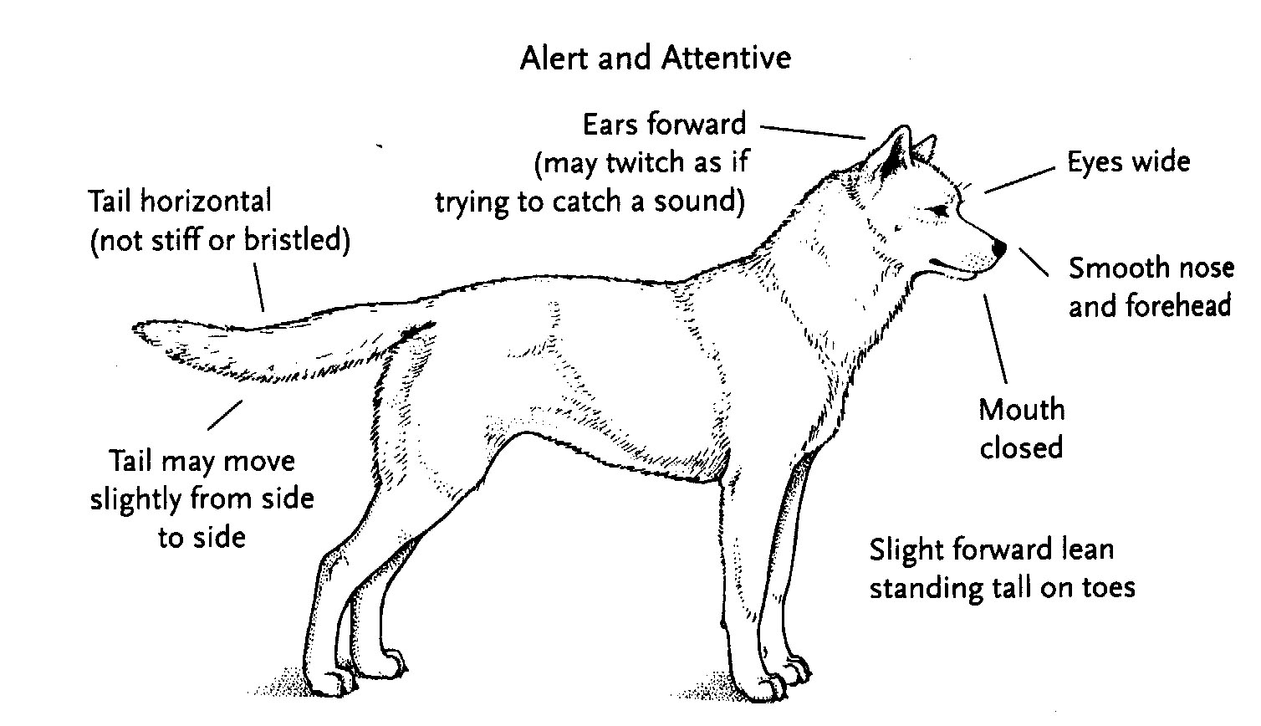

General Animal Behavior (Continued)
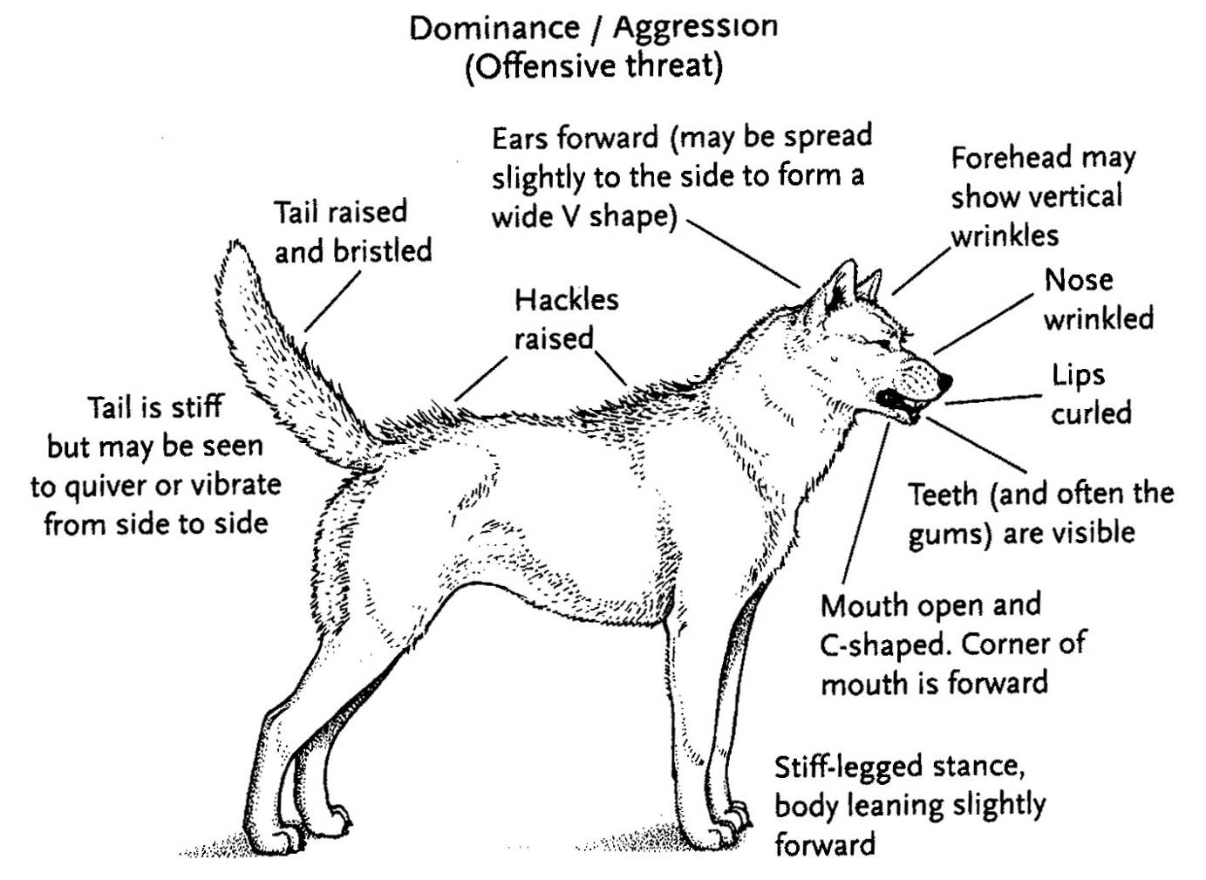
General Animal Behavior (Continued)
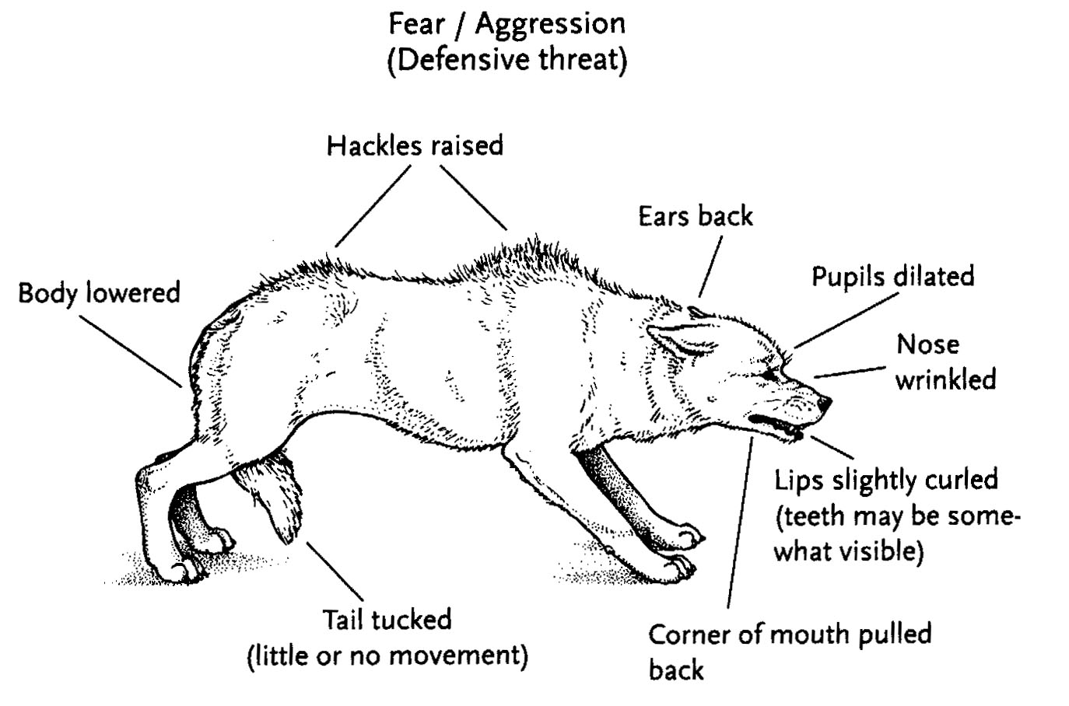

General Animal Behavior (Continued)
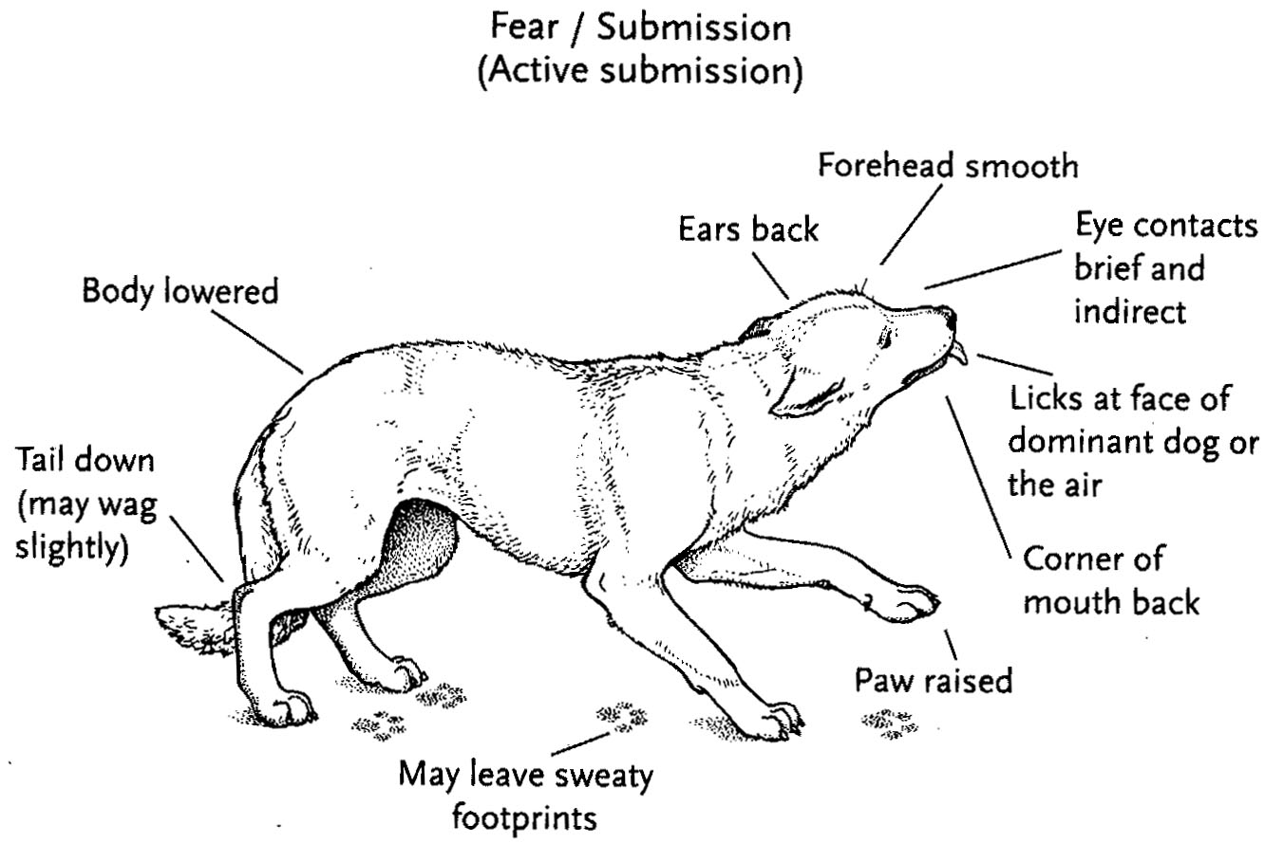

General Animal Behavior (Continued)
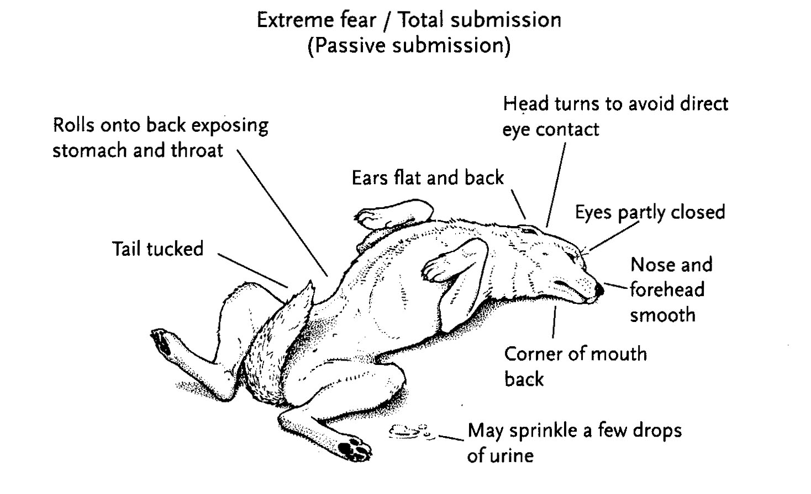

General Animal Behavior (Continued)
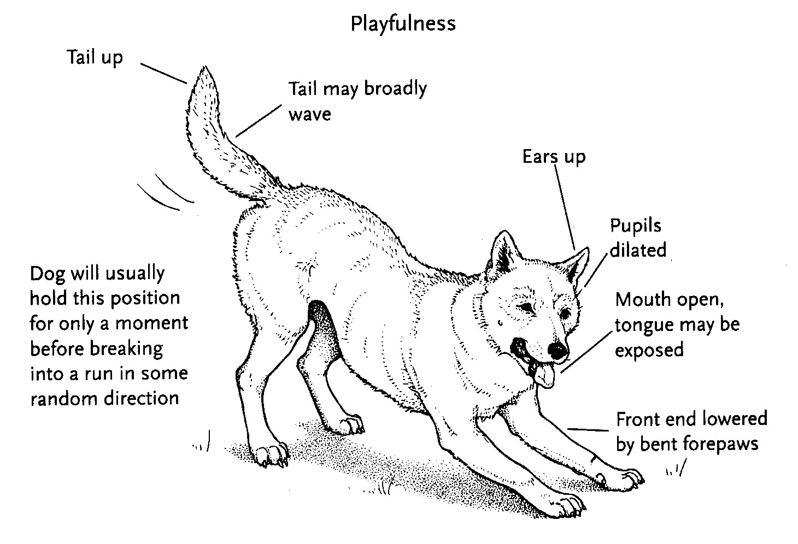

General Animal Behavior (Continued)
Cat Body Language

This picture illustrates the characteristics of an aggressive cat:
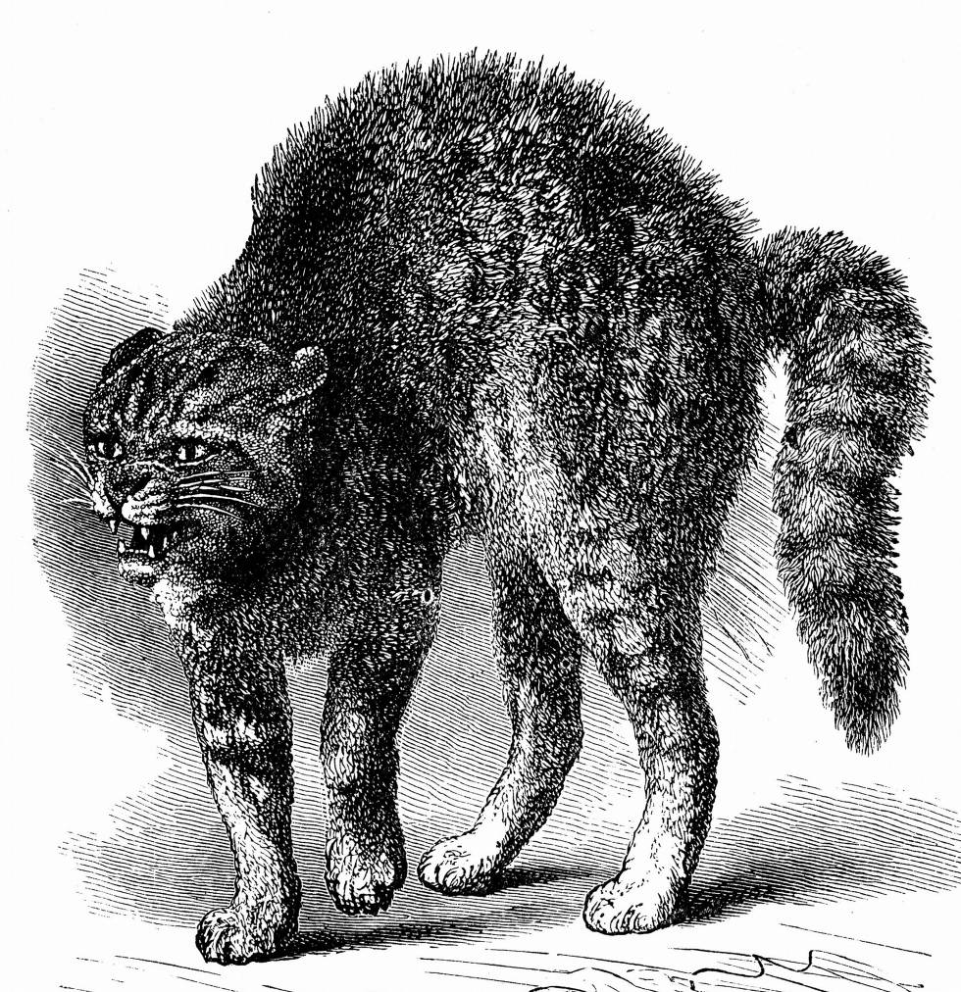

Characteristics of an aggressive cat include:
- Standing with rear higher than front
- Tail down
- Ears out to side of head
- Direct eye contact
- Raised hair on back
General Animal Behavior (Continued)

This picture illustrates the characteristics of a relaxed cat:



Characteristics of a relaxed cat include:
- Relaxed posture
- Relaxed tail
- Ears pointing up and out
- Claws retracted

General Animal Behavior (Continued)
Horses, Cattle, and Swine
Horses
- Instincts
- Herd animals
- Prey animals
- Fear the unknown
- Run away when frightened
- Use hooves and teeth for protection
- Senses
- Have excellent hearing and vision, though close vision in front of the face is limited
- Have an excellent sense of smell, which may cause heightened fear of smoke and fire
- Can hear in all directions
- Are sensitive to human moods and attitudes and can sense fear or agitation in others
- Are sensitive to atmospheric changes
- Behavior
- Horses should always be kept calm.
- Even a small horse or a pony can overpower an adult when frightened.
- Most horses trust humans and see them as the dominant animal of the herd.
- Horses will generally cooperate when approached calmly and quietly.
- Horses become more skittish in windy weather.

General Animal Behavior (Continued)
Horses (Continued)
- Body Language
- Ears: Mobile, expressive, move independently, point toward items of interest
- If ears are pointed back, this could mean the horse feels angry or aggressive or is listening to sounds from behind.
- If ears are pointed back and out, the horse may be bored.
- Ears pointing forward indicate interest. If interest is directed toward another horse, you may need to control or deflect the encounter.
- Ears flat to the neck are a warning sign: Watch out!
- Body
- A raised head and tail may be an invitation to play.
- Head-shaking and tail-swishing may indicate aggression or annoyance, or the horse may be trying to rid itself of flies.
- Head
- A high head indicates that the horse is about to take action; the horse may be stressed or curious.
- A stiff, lowered head may mean the horse is stressed or has fallen asleep.
              - Legs: An un-weighted hoof may mean the horse is relaxed or cocked and ready to use that hoof. Look at other stress indicators to decide.
              - Understanding horse body language requires practical, hands-on experience.
General Animal Behavior (Continued)
Identifying Animal Behavior
Identify the behavior of the animals presented in the following eight photos. Write down the correct behavior in the blank space provided beside each picture.
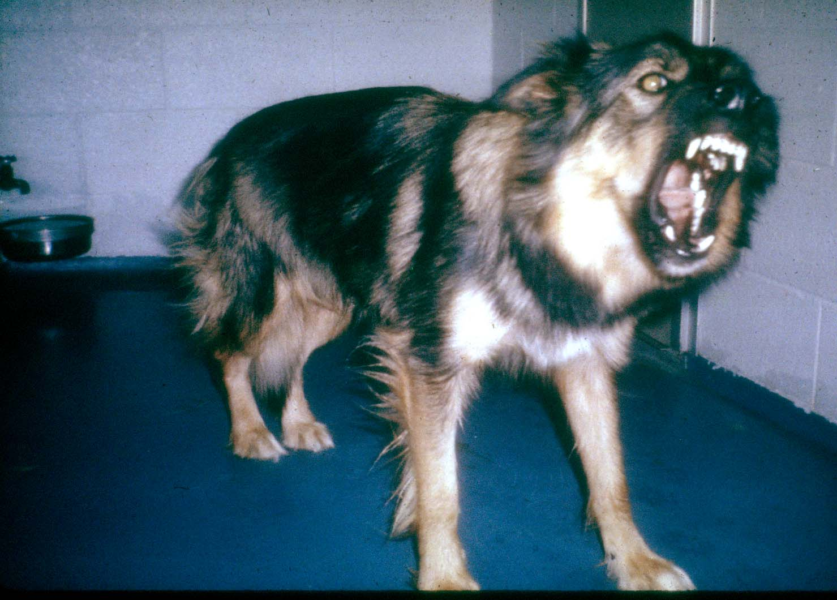

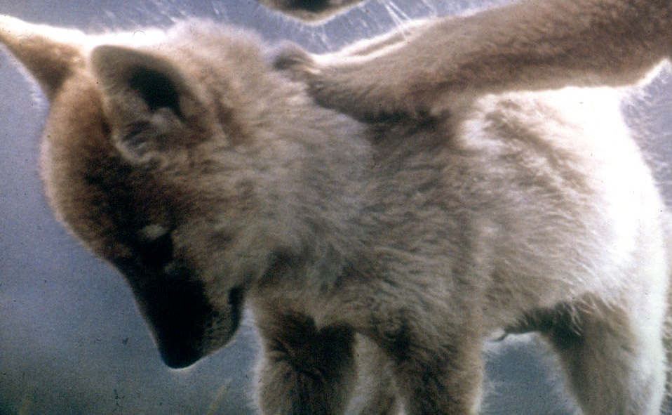
General Animal Behavior (Continued)
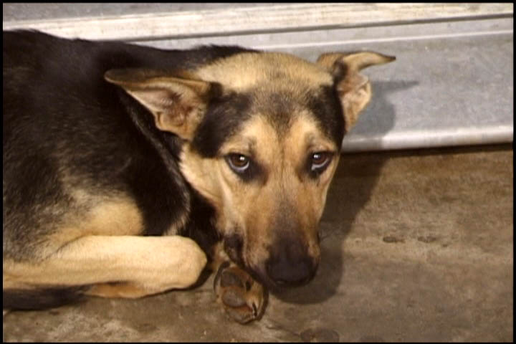


General Animal Behavior (Continued)
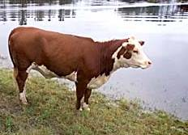



Preview of CERT Animal Response II
Topics Covered in CERT Animal Response II
- Your role as a CERT member responding to issues involving animals
- Protecting your own safety when dealing with animals, including:
- General response when encountering animals
- Avoiding transmission of zoonotic disease
- Basic care for injuries involving animals
- Knowledge and skills you’ll need for CERT functions involving animals, including:
- Cleaning and disinfection
- General animal care
- Basic animal handling
- Dealing with injured animals
- Communicating with animal owners and caretakers
- Animal identification and tracking
Module Summary
Animal Issues in Emergency Management
Animals are a significant component of disaster preparedness and emergency response. The management of disasters must include a plan for issues affecting animals.
Animal-Related Emergency Management Functions
Animal issues will need to be addressed in almost every emergency management function. During the course of your responsibilities as a CERT volunteer, you may be asked to assist in animal-related tasks. You may also encounter animals while performing other emergency duties.
Disaster Planning for Animals
You have now started to develop a disaster plan and an emergency supply checklist to take home with you. Start assembling your animal disaster kit as soon as you can, and place it with your family emergency kit.
General Animal Behavior
Disaster response may include numerous animal-related tasks. You can protect yourself when handling or managing the care of animals by preparing in advance for animal encounters.

Sources
- The Humane Society of the United States Disaster Animal Response Training Personal Planning Instructor Guide
- The Humane Society of the United States Disaster Animal Response Training Animal Facility Planning Instructor Guide
- The Humane Society of the United States Disaster Animal Response Training Small Animal Behavior Instructor Guide
- The Humane Society of the United States Disaster Animal Response Training Exotic Animal Handling Instructor Guide
- The Humane Society of the United States Disaster Animal Response Training Large Animal Handling Instructor Guide
- The Humane Society of the United States Disaster Animal Response Training Animal First Aid Instructor Guide
- Colorado Veterinary Medical Foundation Community Animal Response Training Consolidated Units 1-5 Instructor Guide
- Colorado Veterinary Medical Foundation Community Animal Response Training Unit 6 Animal Handling Instructor Guide
- Federal Emergency Management Agency (FEMA) Information for Pet Owners and Information for Livestock Owners

